APPROVALS | DATE | REV | DCN NO. | BY | CHECK | DCC | DATE
AUTHOR: Billingsley | 03/10/10 | V3 | E0900397-v1
CHECKED: Torrie
APPROVED:Torrie
DCC RELEASE

Scope
aLIGO optic containers are used to ship specific aLIGO optics. There is one container and one shipping case per optic. This procedure covers disassembly, installation of an optic, and assembly.

Applicable Documents
D0902146-v2 Assembly, ETM, COC Optic Container, Advanced LIGO
D0902120-v2 Assembly, FM, COC Optic Container, Advanced LIGO
D0902001-v6 Assembly, CP, COC Optic Container, Advanced LIGO
D0902138-v2 Assembly, R, COC Optic Container, Advanced LIGO

Environment
Optic Containers should only be opened in a clean environment, preferably a clean room. Use clean room protocol, tools should be wiped with methanol, use powder-free gloves for handling. Find the LIGO accepted clean room gloves here.

Disassembly
All numbers ( ) reference Figure 1.
- Remove the optic container from the shipping case using the top handles only. MUST USE a two man lift or a crane if the optic is inside the container. Set the container down gently, preferably onto a rubber cushioned surface. Wipe the outside of the optic container using a lint free rag and methanol. Transport to a clean area.
- Loosen the hex nut in the center of the top plate and screw wedge plate clamp (12) up using ¼” hex on top.
- Unscrew the three socket head bolts on the top cover (3).
- Remove the top cover, turn the cover over when setting it down, so that it rests on the handle.
- Using the side handles (26) remove the outer sleeve.
- Using the handles (1), lift the wedgeplate off of the top of the optic. Turn the wedgeplate over when setting it down, so that it rests on the handles, not on the O-ring.
- Remove the locating sleeves (18).
- Unscrew the locating shafts (17) and set aside.
- If the optic is a Test Mass, remove the blocks and screws (10, 11, 24).

Assembly
Ship the following optics only in the associated container.

Optic Type | Container type | Container Drawing number
ETM, ITM | ETM | D0902146
FM, BS | FM | D0902120
CP | CP | D0902001
PR3, F-PR3, SR3 | R | D0902138

- Wipe the O-rings with a clean, lint-free cloth and isopropanol. See LIGO document T1000105 for the full o-ring cleaning procedure. Do not use acetone to clean the o-rings.
- Insert two of the three locating shafts (17).
- Cover the two locating shafts with locating sleeves (18).
- Locate the arrow on the barrel of the optic, this points to side one.
- Using the two locating sleeves as a guide, insert the optic, SIDE ONE DOWN, snugly up against the two sleeves.
- Insert the third locating shaft (17)
- Select a locating sleeve (18) from the assortment that fits snugly against the optic.
- If the container is being shipped empty, install the shipping sleeves (20) over the locating sleeves (18).
- If the optic is a Test Mass, install the blocks and screws (10, 11, 24) snugly.
- Wipe the o-ring on the wedgeplate with a clean, lint-free cloth and isopropanol.
- Install the wedgeplate.
- Install the outer sleeve.
- Loosen the clamp on the top cover (12)
- Install the top cover, fully tighten the three bolts which hold it in place.
- Tighten the clamp on the top cover, ¼ turn past first contact.
- Tighten the locking nut on the clamp.
- Install in the shipping case, being sure to include any tools that the container shipped with as well as the three shipping sleeves, three extra locating sleeves (different sleeve widths allow for best fit for optic during shipping) and the three alignment knobs.

Alternate Assembly Method
Alignment knobs may be used instead of using the two locating shafts and sleeves to guide the optic into the correct position. The alignment knobs must be removed and locating shafts and sleeves installed before installing the wedgeplate.

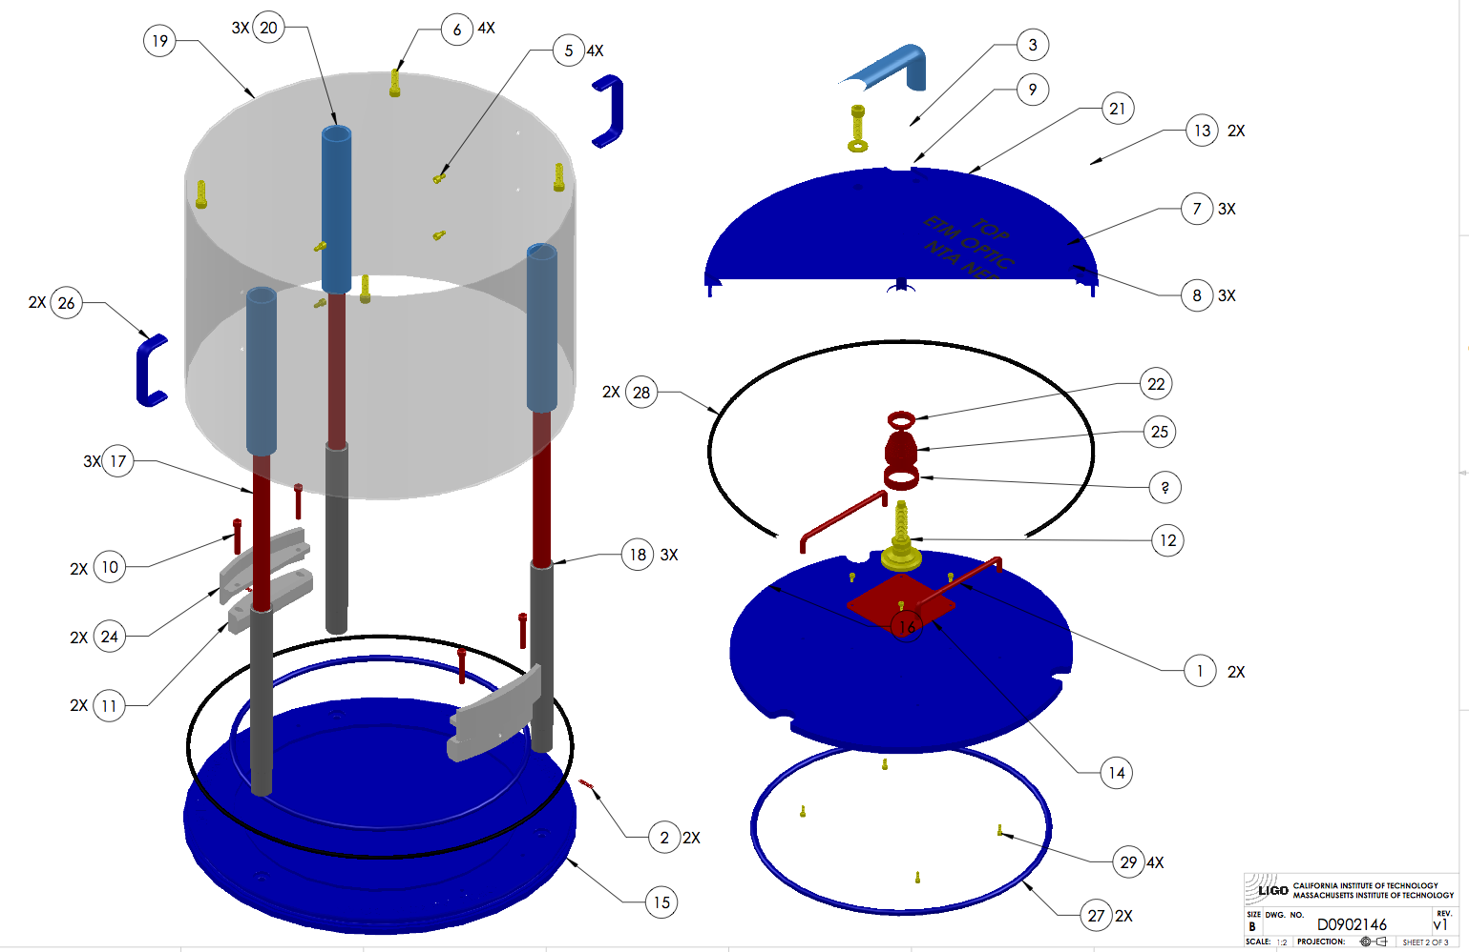
Figure 1. ETM container assembly.



