AOSEM Initial Electrical Test Results
LIGO-T0900443-v1
R. Abbott, Caltech
22 September, 2009

- Overview
A series of measurements has been taken on the new PEEK Advanced LIGO OSEM to record the induced photocurrent produced by a fixed current through the LED, as a function of distance. The initial results seem to imply a low collection efficiency of the light emitted by the LED.

- Test Description
As shown in figure 1, the AOSEM circuit boards are a hybrid of a flexible Kapton circuit board bonded to an alumina stiffener. During the test described in this note, a photodiode was soldered on one end of the flexible circuit board, and an LED was soldered to the other end.

A fixed bias of 50mA+/- 5% was applied to the LED, and the induced photocurrent was read from the photodiode by use of a true transimpedance amplifier (665 ohms) with negligible input impedance. The photodiode was reverse biased at 10VDC.

The circuit board was folded such that the two white alumina arms were parallel, then fixed thickness shims were used as spacers to explore the induced photocurrent as a function of arm separation distance. For each measurement, small adjustments in relative position were made to the arms to maximize the resultant photocurrent while maintaining parallelism. The maximum current readings were recorded as a function of arm separation.

Figure 1
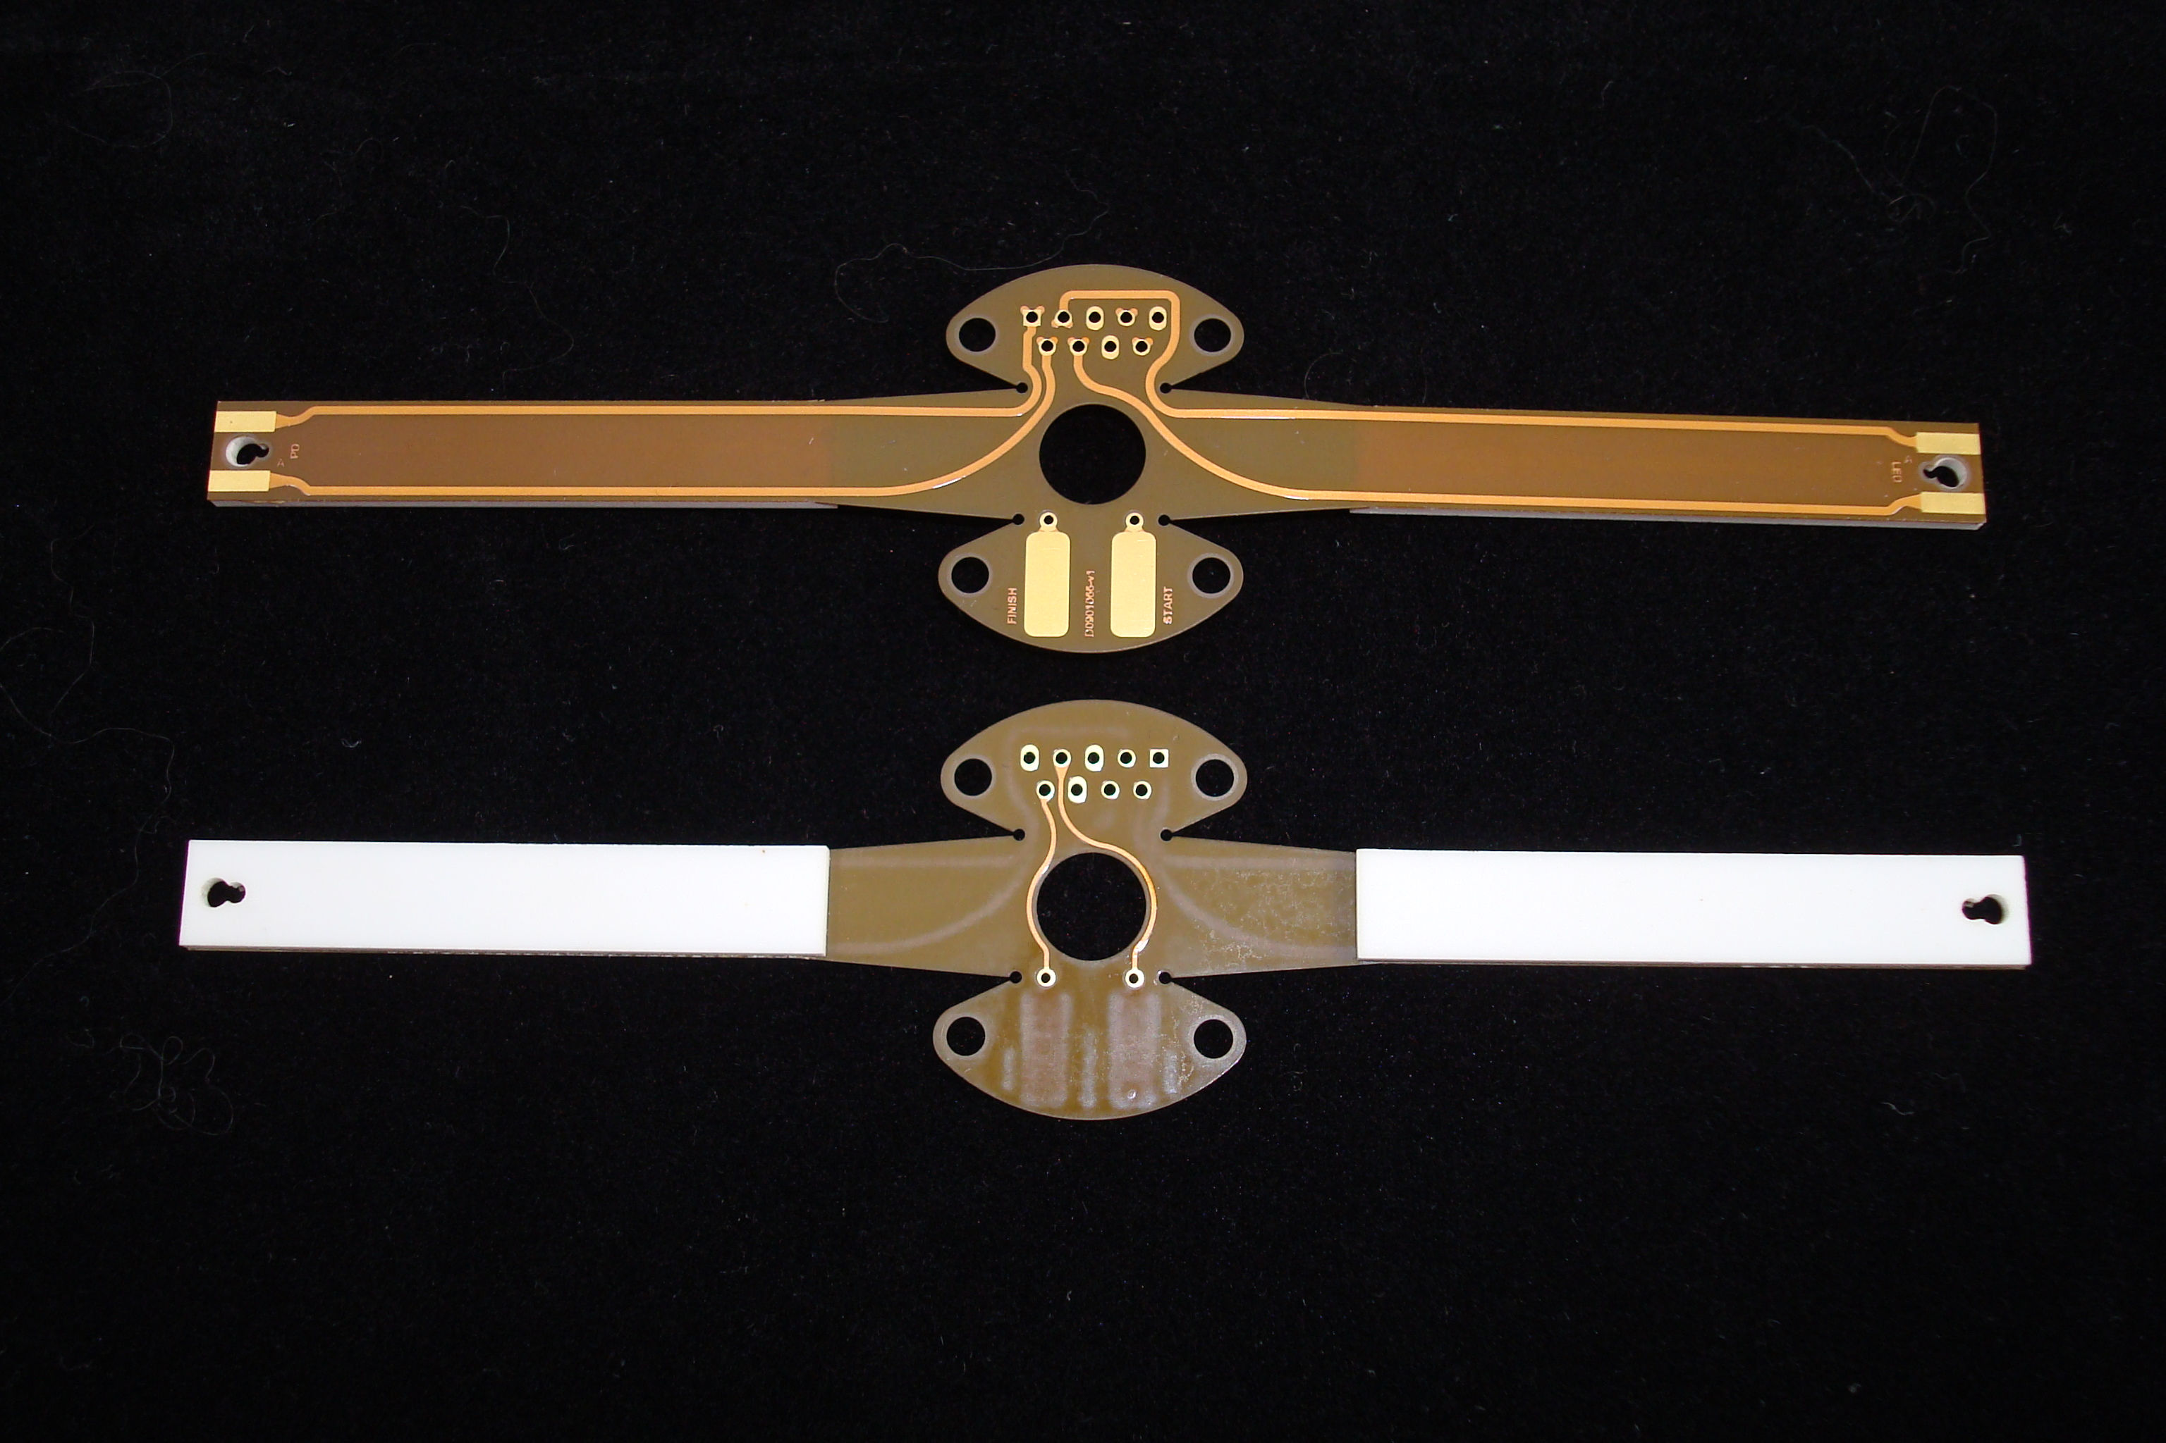

- Test Results
Table 1 shows the numerical results of various arm-to-arm separations. For reference, I measured the initial LIGO OSEMs arm-to-arm internal spacing (the free bore) of approximately 0.210 inches, and the AOSEM spacing to be 0.204 inches. Both spacings are well represented by the test data.

Table 1
Arm-to-arm Separation (inches) | Maximum Measured I/V voltage | Photocurrent (microamperes)
0.242 | 0.041 | 61.65413534
0.201 | 0.054 | 81.20300752
0.196 | 0.053 | 79.69924812
0.192 | 0.054 | 81.20300752
0.189 | 0.054 | 81.20300752
0.182 | 0.058 | 87.21804511
0.122 | 0.085 | 127.8195489
0.061 | 0.124 | 186.4661654
0 | 0.189 | 284.2105263

To the best of my knowledge, the specification for the required photocurrent from the initial LIGO versions of the OSEM was >90uA photocurrent for 50mA LED current. Figure 2 graphs the data in table 1, and superimposes a quadratic fit. The fit seems to overlay fairly well.

Figure 2
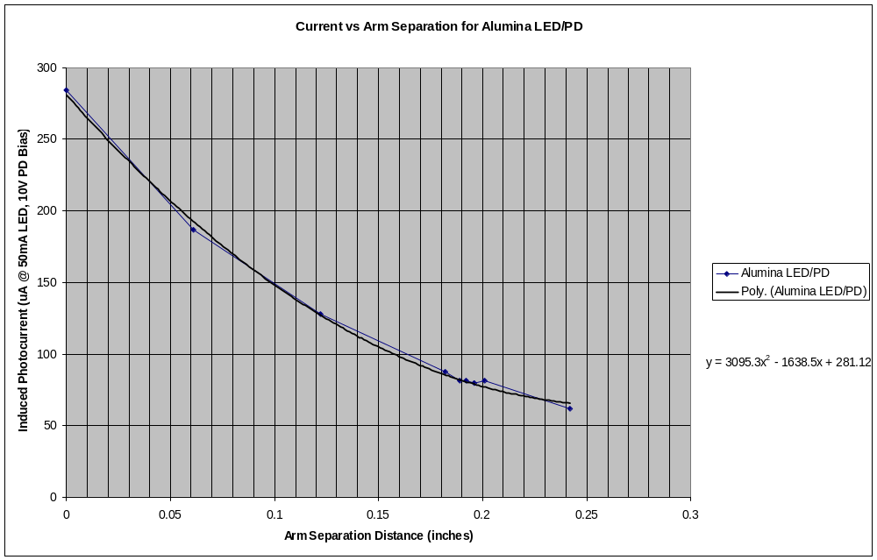

- Conclusion
At this point, I don’t understand why the photocurrent is lower in the AOSEM design as compared to the ILIGO design. I changed the LED to no avail, and was generally quite careful in my measurement.

