APPROVALS | DATE | REV | DCN NO. | BY | CHECK | DCC | DATE
AUTHOR: Dave Reitze and Luke Williams
CHECKED:
CHECKED:
APPROVED:
DCC RELEASE

SCOPE

This document presents the assembly and certification procedures for the IOO Faraday Rotator. It is intended primarily for the IOO group, and also for the AdvLIGO detector group

APPLICABLE DRAWINGS

D070463 | IO FI Hard Aperture
D070464 | IO FI Calcite Mount
D070465 | IO FI 1” Optics Mount
D070466 | IO FI FR Dust Shield
D070467 | IO FI FR NG TGG Holder
D070468 | IO FI FR Sleeve Lock
D070469 | IO FI FR Stand
D070470 | IO FI FR Thick Strap
D070471 | IO FI 1” Optics Lock Ring
D070472 | IO FI FR Positioning Screw
D070473 | IO FI FR TGG Cap
D070474 | IO FI FR Quartz Holder
D070475 | IO FI FR Quartz Cap
D070492 | IO LHO FR Magnet Can
D070493 | IO LHO FR End Cap
D070528 | IO FI LHO FR Thin Shim
D070529 | IO FI LHO FR Thick Shim
D070530 | IO LHO FR Dust Shield
D070531 | IO FI Hard Aperture Insert
D070532 | IO FI Hard Aperture Lock Ring
D070533 | IO FI Hard Aperture Riser
D080154 | ALIGO FI TGG Crystal

A MATERIALS AND TOOLS

- Clean optical table
- IPG Photonics 100 W laser
- Assorted optics, lenses, opto-mechanical mount
- Power meter for measuring both 100 W powers and nW – mW power levels
- Clean tool kit, including non-magnetic allen wrenches and ball drivers.

B FARADAY ISOLATOR PREPARATION

- Inspect all of the optical and mechanical sub-assembly components to insure that they are clean and undamaged.
- Clean all of the mechanical parts in an ultrasonic acetone bath for 45 minutes, followed by a methanol rinse and clean air (or nitrogen) dry off.
- Assemble the TGG holders and quartz holders.
- Assemble the Faraday Rotator.

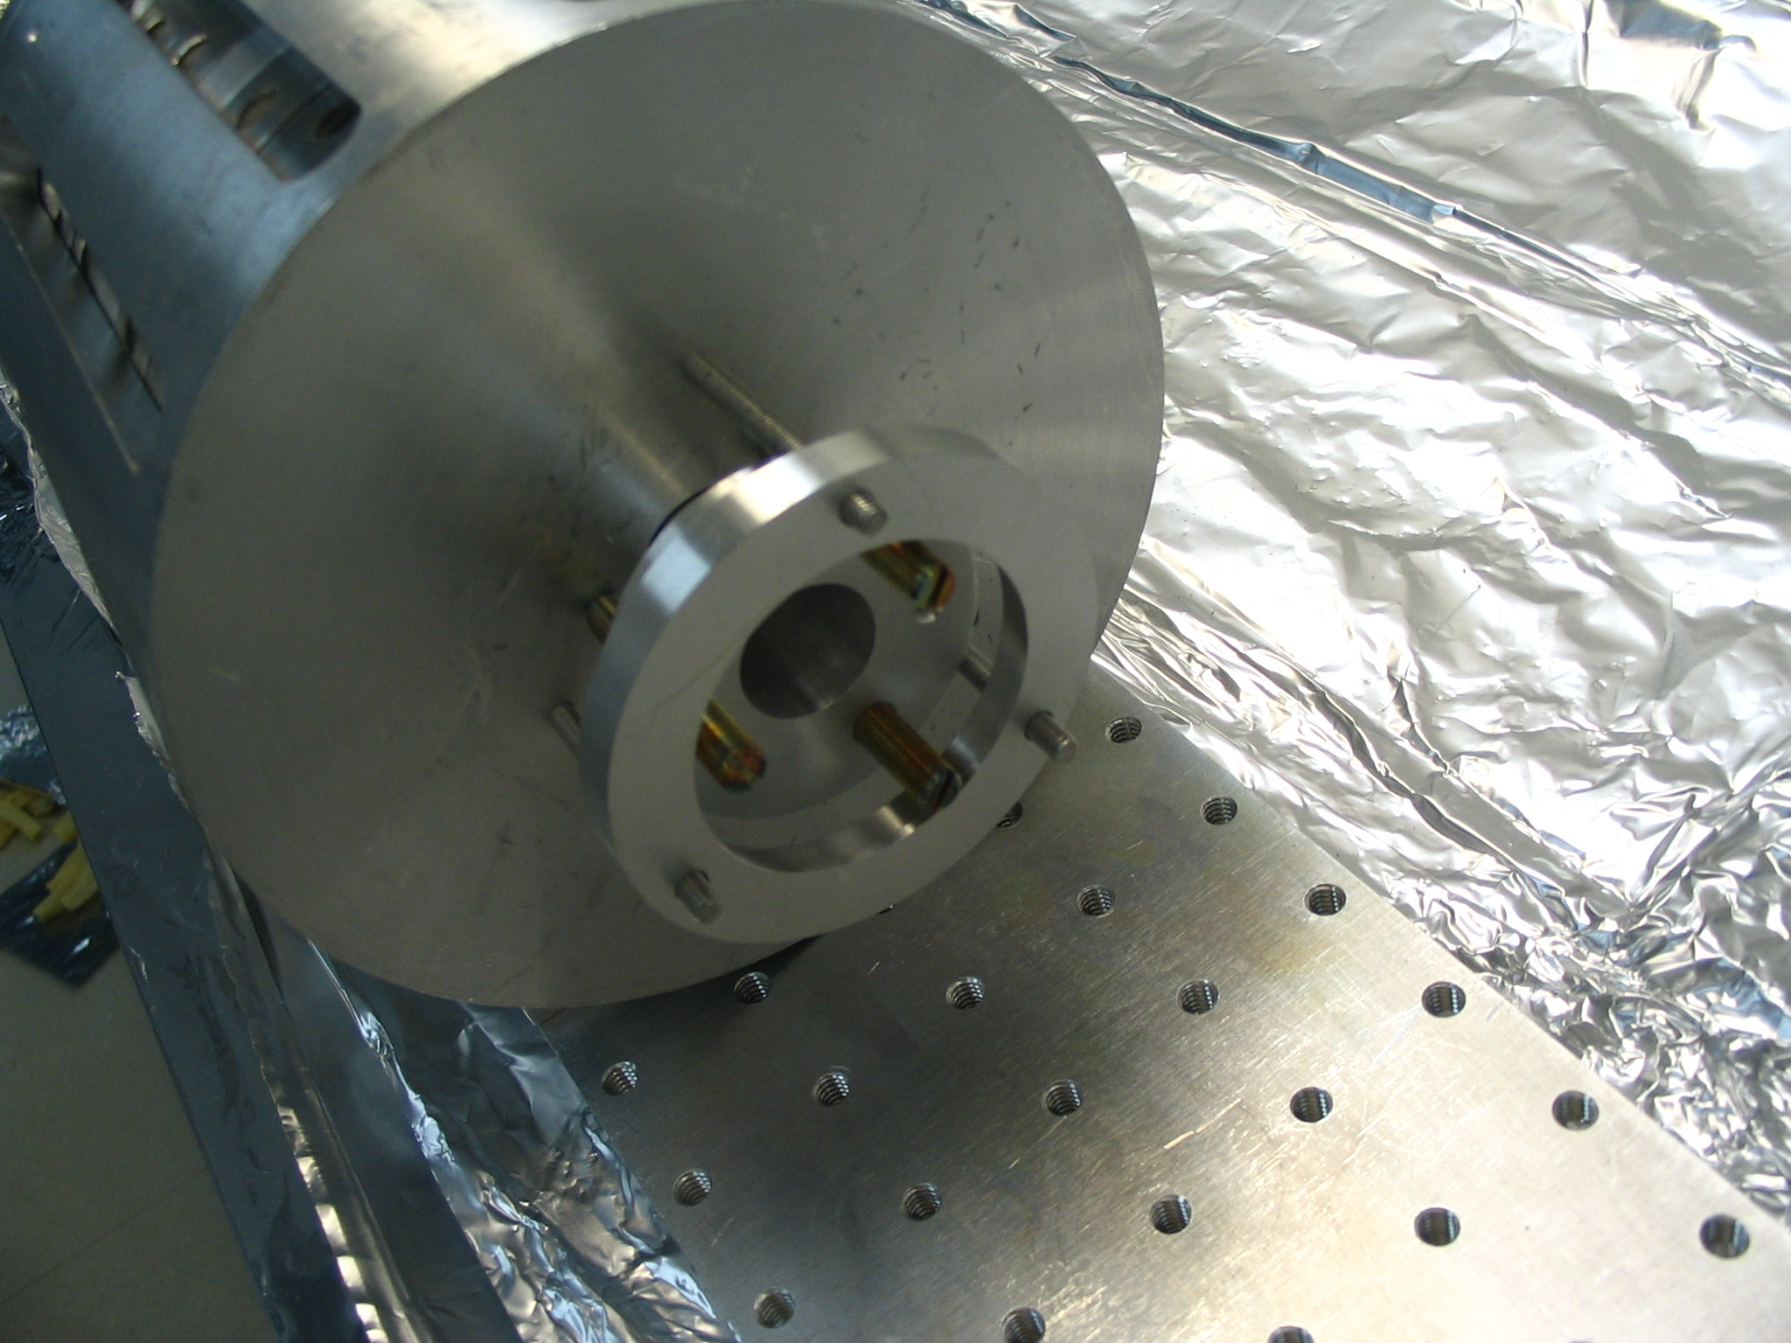

- Install protective covers over the input and output ports.
- Assemble the hard apertures HA1 and HA2 in their mounts.
- Assemble the two calcite wedge polarizers in their mounts.
- Assemble the DKDP components in their mounts.
- Assemble the waveplate components in their individual mounts.
- Assemble the TFP components in their mounts.
- Assemble aligment irises.

Faraday Isolator alignment in the clean optics lab

- Raise the laser to 5.5 inches (139.7 mm) above the optical table. Install a λ/2 waveplate and a thin film polarizer to control the power level of the IPG laser. Set the IPG laser at 50 W and adjust the waveplate to obtain 0.5 W output power.
- The beam size of the IPG laser is 4.8 mm. Use two lenses (f1 = + 20 cm and f2 = -15 cm, separated by ~ 71 mm) to reduce the beam size to ~ 3.3 mm in the TGG crystals located ~ 74 inches (1880 mm) from the lens 2. Install two turning mirrors after the two lenses to provide beam alignment for the Faraday isolator.
- Place an iris diaphragm at a distance of 5 inches (127 mm) from the last turning mirror. The height of the iris center is 5.514 inches (140.05 mm) above the optical table. Install a second iris at a distance of 48.28 inches (1226 mm) from the last turning mirror. The height of the second iris center is 5.634 inches (143.1 mm) above the optical table.
- Adjust the waveplate of the power control to obtain ~ 0.5 W. Observe the IR laser beam with an infrared viewer, and adjust the tilt of the last turning mirror so that it passes through the center of both irises.
- Block the laser beam upstream of the lenses.
- Fix the FI breadboard with dog clamps.
- Place a λ/2 plate between the power control and the two lenses. Adjust the waveplate so that the the polarization is ‘p’, ie, horizontal with the electric field of the laser parallel to the surface of the table. Put an additional TFP if necessary.
- Install the first calcite wedge polarizer (CWP1) on the breadboard.
- Unblock the beam and place a power meter behind the calcite wedge polarizer at a distance where both polarized beams are enough separated. Block the high power polarized beam with a beam block and slightly rotate the half-wave plate until minimum power transmission is obtained for the low power polarized beam.
- Increase the output power to 20.6 W and check the half-wave plate rotation for minimum power transmission. Record this power: P_CWP1_MIN = 2.5 mW.
- Block the laser beam again and install the second calcite wedge polarizer (CWP2).
- Unblock the laser beam and minimize the low power polarized beam leaving CWP2. Adjust only the orientation of CWP2 to obtain the minimum transmission, and make sure that the beams exiting CWP2 to remain parallel to the surface of the table. Record this power: P_CWP2_MIN = 10 μW (P_inc= 2W) , 110 μW (P_inc=20.5 W).
- Compute the extinction ratio: ER in dB = 10 log (P_INC_CWP1/ P_CWP2_MIN): 53, 53.1. This value should be at least 50.
- POLARIZATION CHECK: Insure that the bright polarization leaving CWP2 is ‘p’.
- Reset the power to ~ 0.5 W and block the laser beam.
- Install the TFP at roughly the Brewster’s angle at the location shown in the FI assembly drawing. Place an HR retro-reflecting mirror on the optical table downstream of the breadboard.
- Unblock the beam and align this mirror for normal incidence (retro-reflection) by forcing the beam back through the irises. Place a power meter to measure the reflected beam from the TFP. Block the two backreflected beams leaking through the first calcite wedge polarizer. Reset the laser power to 25 W and adjust the TFP until maximum power reflection is obtained at 25 W incident power.
- Block the beam.
- Place the Faraday rotator base on the breadboard in the position shown in the drawing and loosely clamp it down. Place the shims and the assembled FR on the base. Note that the thick shims go on the FR base on the downstream side, and the thin shims go on the upstream side. Clamp the FR on the base.
- Unblock the beam and rotate the FR base such that the beam passes freely through the center of both TGG crystals. Carefully check the alignment and block the laser beam.
- Install the half waveplate on the breadboard at the location shown in the FI assembly drawing.
- Reset the power to 25W, unblock the beam, and check that it goes through the center of the waveplate.
- Adjust the rotation angle of the waveplate to minimize the power exiting CWP2 as in step A20 above. You will have to adjust the picomotor screw as well as the DLC mount to achieve the minimum. Record the minimum power P_CWP2_MIN = _____ ( P_inc= ___ ), ____ mW (P_inc=____ W).
- Reset the power to ~ 0.5 W and block the laser beam.
- Block the beam.
- Install the DKDP at the location shown in the FI assembly drawing and adjust its position so that the beam is centered. Check the transmitted power through CWP2 in the wrong polarization and verify that it is minimized. Adjust the pitch and yaw of the DKDP to minimize the power.
- Adjust the lateral position of the second calcite wedge polarizer, if necessary.
- Adjust the waveplate of the power control to obtain 25 W. Measure the isolation ratio (IR= 10 log( P_{in}/P_{t,backward}) ) of the Faraday Isolator, where P_{in} is the power incident on the first calcite wedge polarizer and P_{t,backward} is the transmitted power of the backreflected beam leaked through the first calcite wedge polarizer. Rotate/adjust the half-wave plate and the TGG crystals until maximum IR is obtained.
- Measure the isolation ratio for six different incident powers:
● P_{in}: 1 W, 5 W, 10 W, 15 W, 20 W, 25 W.
● P_{t,backward}: __ mW, ___ mW, ___ mW, 5.13 mW, ____ mW, ____ mW.
● Isolation ratio: _____ dB, ____ dB, _____ dB, _____ dB, ____ dB, ____ dB.
- Measure the transmission for five different incident powers (5 W, 10 W, 15 W, 20 W, 25W):
● P_{in}: 1 W, 5 W, 10 W, 15 W, 20 W, 25 W.
● P_{transmitted}: ___ W, ____ W, _____ W, ____ W, ____ W, ____ W.
- Install HA1 and HA2.

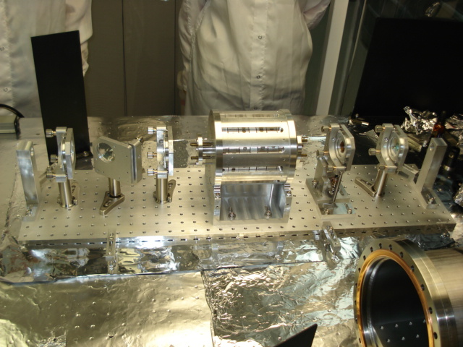

- Block the retro-reflecting mirror until later use.

