LIGO Laboratory / LIGO Scientific Collaboration

LIGO-T0900409-v1 LIGO 08/31/2009

Underground Seismic Studies for 3rd Generation Gravitational Wave Interferometric Detectors at the Former Homestake Mine in Lead, South Dakota
Luca Naticchioni

Distribution of this document:
LIGO Science Collaboration

This is an internal working note
of the LIGO Project.

California Institute of Technology  LIGO Project – MS 18-34  1200 E. California Blvd.  Pasadena, CA 91125  Phone (626) 395-2129  Fax (626) 304-9834  E-mail: info@ligo.caltech.edu | Massachusetts Institute of Technology  LIGO Project – NW17-161  175 Albany St  Cambridge, MA 02139  Phone (617) 253-4824  Fax (617) 253-7014  E-mail: info@ligo.mit.edu
LIGO Hanford Observatory  P.O. Box 1970  Mail Stop S9-02  Richland WA 99352  Phone 509-372-8106  Fax 509-372-8137 | LIGO Livingston Observatory  P.O. Box 940  Livingston, LA 70754  Phone 225-686-3100  Fax 225-686-7189
http://www.ligo.caltech.edu/

Abstract
Deep underground seismic studies are required in order to find a way to reduce the Newtonian noise in frequency range below 10Hz in third generation underground gravitational-wave interferometric detector data. A very promising site for such studies was located in the former Homestake mine in Lead, SD. A brief description of geology and infrastructure of the site is given. Between June and July 2009 five new seismometer stations were built in the Sanford Underground Laboratory in addition to the pre-existent three stations, realizing the present day array of eight stations. The construction of the new stations required stabilization and insulation of the seismometer sites, monitoring of environmental conditions and development of the network. Correlation measurements between neighboring stations would provide the most relevant results for the evaluation of the Newtonian noise subtraction technique. Finally preliminary results from the comparison between seismic data from Homestake deep underground and the LIGO Hanford site are presented.

I. Introduction
Future gravitational wave interferometric detectors (GWID from now on) will likely probe frequencies below 10 Hz, which is the detection limit for 2nd generation surface-based GWID. In this range of frequencies the seismic noise is dominant: while in principle it is possible to filter the mechanical noise from Earth’s crust motion due to tidal stresses, seismic activity and ocean dynamics as well as human activities noise with an adequate chain to suspend the test masses, it is impossible to filter the Newtonian Noise (gravity gradient noise, GGN from now on) which is random motion directly induced on the test mass by Earth’s fluctuating gravity field bypassing all the attenuation stages of the filter-chain. Time variations of the gravity field around the test mass are caused by seismic and atmospheric density variations.
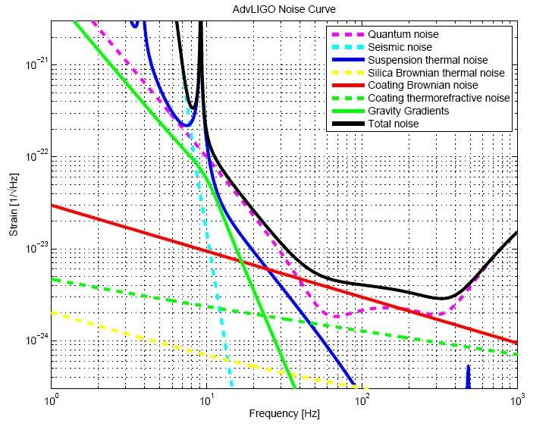
Figure 1: noise sources for Advanced LIGO; the green solid line shows the behavior of the gravity gradient noise (i.e. Newtonian Noise) depending on frequency ⁽¹⁾.

A first step to suppress the GGN is to find a low seismicity site, then it is needed to avoid as much as possible density fluctuations and surface modes: this objective can be achieved in a deep underground site; moreover the human activities noise is more controllable underground rather than in surface. Advantages of an underground site is the exponential reduction of the surface seismic noise with depth as well as a much longer correlation length: this implies correlation of the gravity gradients across the entire GWID and a smaller number of instruments needed for an active suppression. The knowledge of the wave propagation in the underground rock strata and the development of an appropriate theoretical model will lead to a noise-subtraction technique to be used in a future underground GWID: to achieve this goal first of all we will need a three-dimensional underground seismometers array with an extremely good timing between all stations.
The former Homestake gold mine in Lead, South Dakota, was chosen as an ideal low gravitational-background environment to build an underground seismometers array: it is situated in a low seismic area in the middle of the continent far away from the Atlantic, Pacific and Arctic Ocean, and it has the deepest reaching tunnels in North America (the deepest level is 2.4 km underground, for overall 600 km of tunnels).

Figure 2: the Homestake site in the North American continent is shown by a star
In 2002 the gold mine was closed and donated to the State of South Dakota, and it is being transformed into an underground laboratory controlled by the SDSTA (South Dakota Science and Technology Authority) supported by a private gift from Mr. Sanford. After him it was named Sanford Underground Laboratory. Homestake former mine was also chosen to host the DUSEL facility (Deep Underground Science and Engineering Laboratory) involving astroparticle, biology and geology experiments.
During the summer of 2008 three seismometers stations were built at three different levels (90m, 240m, 610m) for a first seismic survey ⁽²⁾. Between June 9th and July 31st we fixed the configuration of this three old stations, and we built five new stations: two at 610m and three at 1250m. The seismometers network now consists of one Güralp CMG-40T (at 90m), five Trillium 240 (one at 240m, three at 610m and one at 1250m) and two STS-2 (both at 1250m).
In the next section the Homestake geology is outlined; in sections III and IV a description of the Sanford Laboratory infrastructure, safety rules and working condition are presented. Sections V and VI deal with the construction of the new five stations joining the seismometers array, the instruments used as well as data acquisition. Finally, in section VII preliminary results are shown with a comparison between the seismic data acquired in August from the LIGO Hanford Observatory.
II. Homestake geology
The former Homestake mine is located in the so-called Lead Window, in the northern Black Hills; the oldest rocks are dated back to the Precambrian, approximately two billion years old. The gold mine develops in a block of the Early Proterozoic Earth’s crust, that is approximately 2.7 x 3 x 5 km, the Lead-Deadwood Dome.
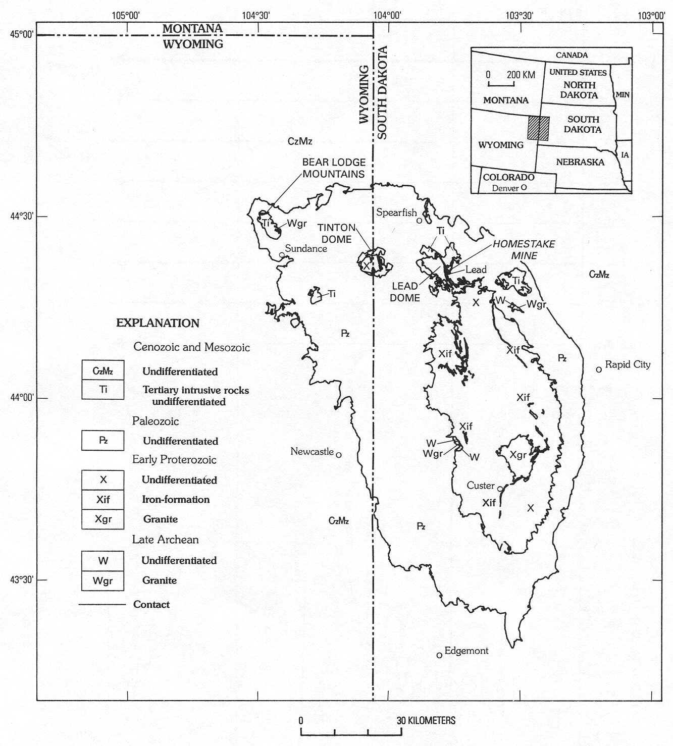
Figure 3: location of the Lead-Deadwood Dome hosting the former Homestake mine ⁽³⁾
The current rock formations are the result of stratification, folding and metamorphism events, with two principal uplifts: a first event occurred about 2 billion years ago during the Trans-Hudson orogeny, exposing a sequence of Archean and early Proterozoic strata, accompanied by regional metamorphosis of the early Proterozoic sedimentary and volcanic rocks into lower-greenschist to middle-amphibolite facies. The Paleozoic and Mesozoic era were characterized by relative tectonic quiescence with sedimentary deposits. The second uplift occurred in the Tertiary period about 60 million years ago during the Laramide orogeny, followed by alkalic igneous intrusion of laccoliths, dikes and sills into the pre-existing rock strata. During this phase of deformation a network of fractures was formed, facilitating meteoric water intrusion. The tunnels excavated during the mining activity intersected the watercourses (usually 45°C to 85°C, low to high pressure), and also the open cut (figure 6) acts like a funnel, hence the underground levels of the Homestake mine are accessible only with a constant water drain.
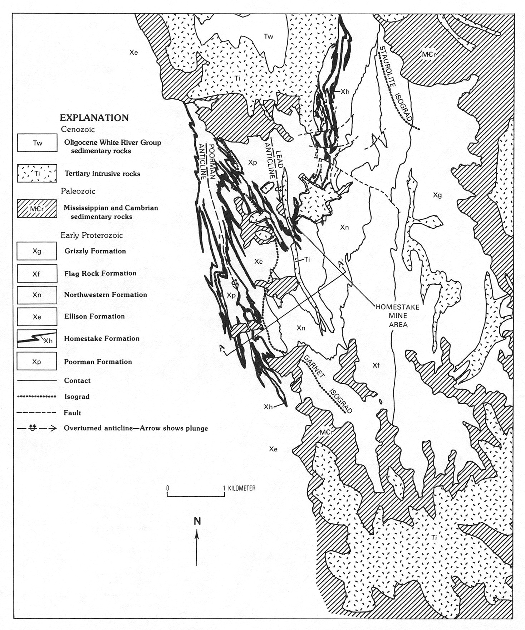
Figure 4: rock formations in the Lead Window: the principal formations are Poorman, Homestake and Ellison ⁽³⁾
Homestake metamorphic rock types are divided in three principal units, listed from oldest to youngest ⁽³⁾: Poorman, Homestake, and Ellison formations. The base of the Poorman Formation consists of metamorphosed tholeiitic basalt with possible back-arc basin affinities in addition to metasediments composed by a complex succession of rock types, mostly deriving from chemical precipitates dominated by Ca and Mg carbonates admixed with fine-grained terrigenous detrital material followed by input from seafloor volcanic exhalative activity and minor volcanic ash. This metasedimentary sequence was followed by a transition to Fe and Mg carbonate chemical precipitation and iron formation near the top of the Poorman Formation and into the Homestake Formation. Carbonate facies iron formation interlayered with marl are common throughout this formation. Finally, the superjacent Ellison Formation is interpreted as a metaclastic sequence dominated by feldspathic litharenite with abundant shale, siltstone, and tuffaceous units, result of tecnonism in the area and deep marine fans. The entire rock package was subjected to several periods of deformation during the Precambrian: regional prograde metamorphism was overprinted by a metamorphic event that is related to the emplacement of granite. These deformations led to complex fold patterns and localized shear zones. This system of smaller-scale synclines and anticlines imprinted on the Homestake formation is showed in figure 5: the folds are called ledges and are numbered from East to West. Two of the first synclines have their own name: the Main Ledge and Caledonia Ledge. The first one was mined underground and in an aforesaid open cut producing most of the gold from Homestake mine.

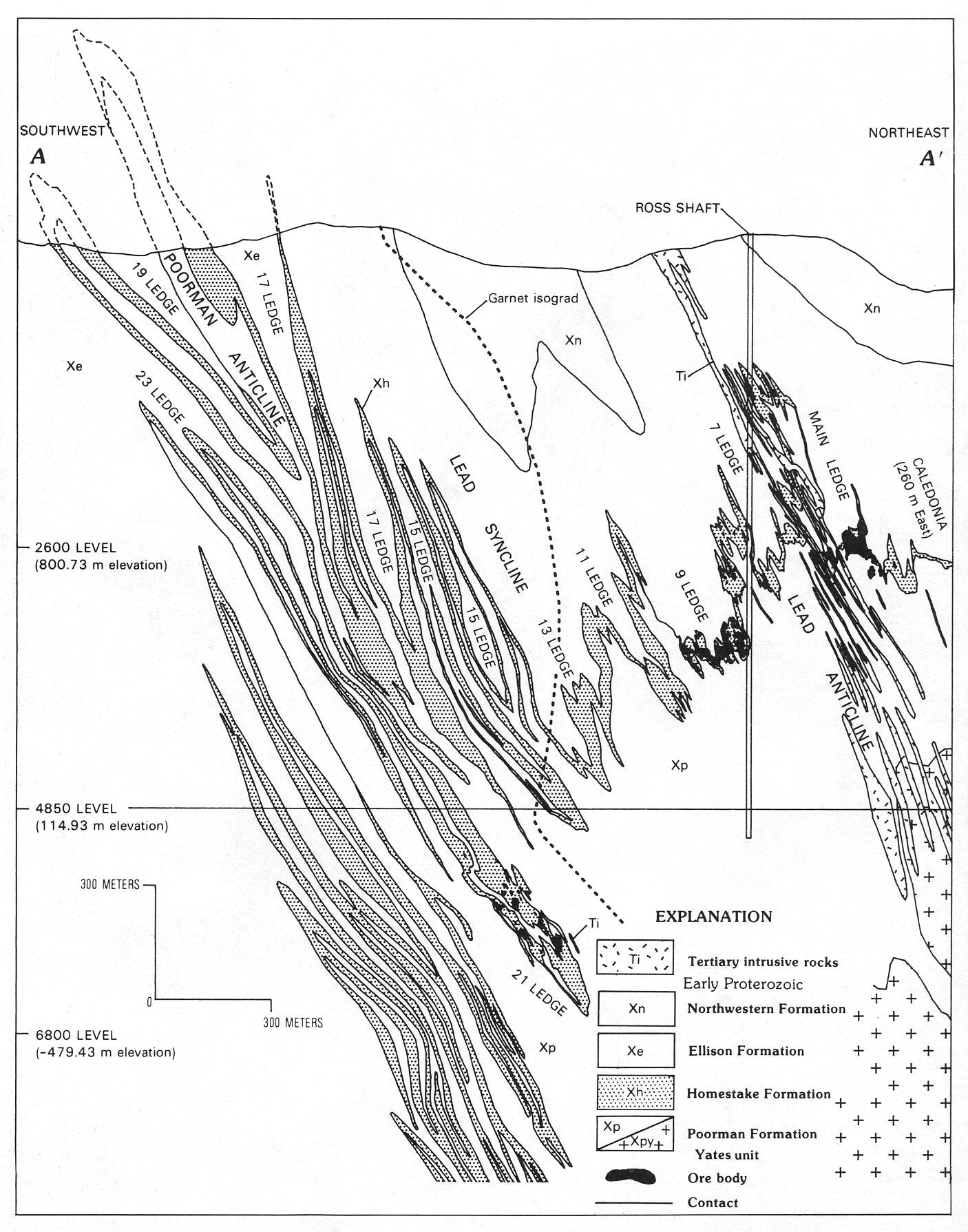
Figure 5: the cross section of the Lead Dome shows synclines (ledges) and anticlines ⁽³⁾
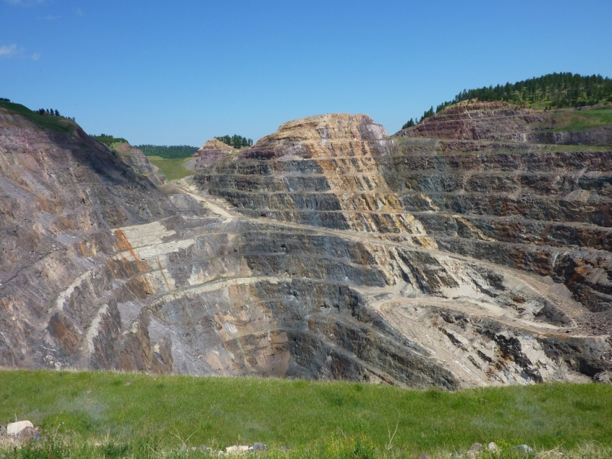
Ore mineralization consists of pyrrhotite, arsenopyrite, pyrite, and native gold associated with chlorite group minerals, quartz, siderite, ankerite, and biotite. This Precambrian mineralization is intimately associated with a specific stage of quartz veining and ductile shear zones. Individual ore bodies are relatively undeformed. Ninety-five percent of the gold mineralization is hosted in the Homestake Formation with the remainder in the Poorman Formation and to a much lesser extent, the Ellison Formation.
Figure 6: the mined open cut of Homestake in Lead, SD

Over a million kilograms of gold were produced from all of the ledges that were mined during the 126 year history of this gold deposit that is the prototype for Precambrian iron formation-hosted gold deposits across the world.
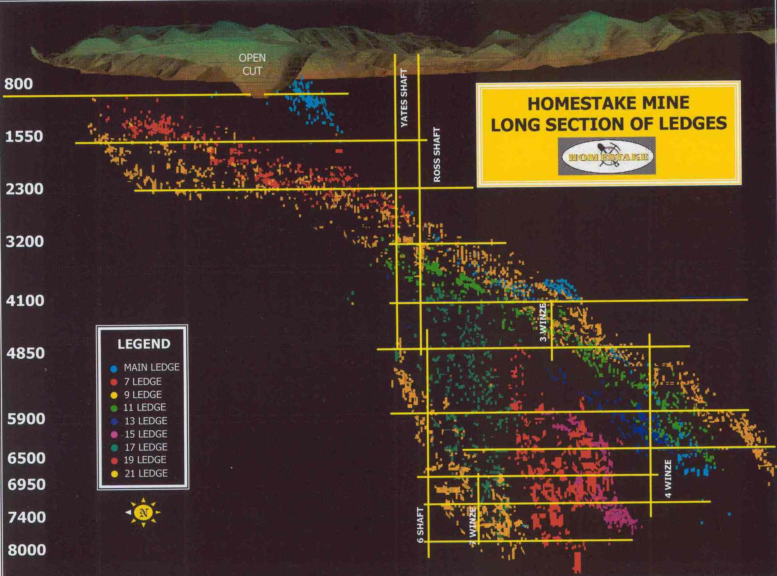
All the aforesaid geological processes clearly led to a sequence of discontinuities between original and intrusive rocks with density variations to be considered when studying the seismic wave propagation underground and correlating the data provided by a 3-D network of seismometers. The Sanford Laboratory owns an extensive database of rock samples which can be used to calculate the profiles of rock density at various levels.
Figure 7: long section of ledges intersected by mine tunnels ⁽³⁾

III. Homestake - Sanford Underground Laboratory infrastructure
The fundamental units of the former Homestake mine are the tunnels. Vertical tunnels are called shafts (if connected to the surface) or winzes (if connected only between underground levels); Horizontal tunnels are called drifts (if parallel to the rock fabric) and or cross-cuts. Stopes are mined-out ore bodies and are usually refilled with waste rock in order to stabilize the mine structure. In figure 8 a cross section of the upper levels of the Homestake mine is shown.
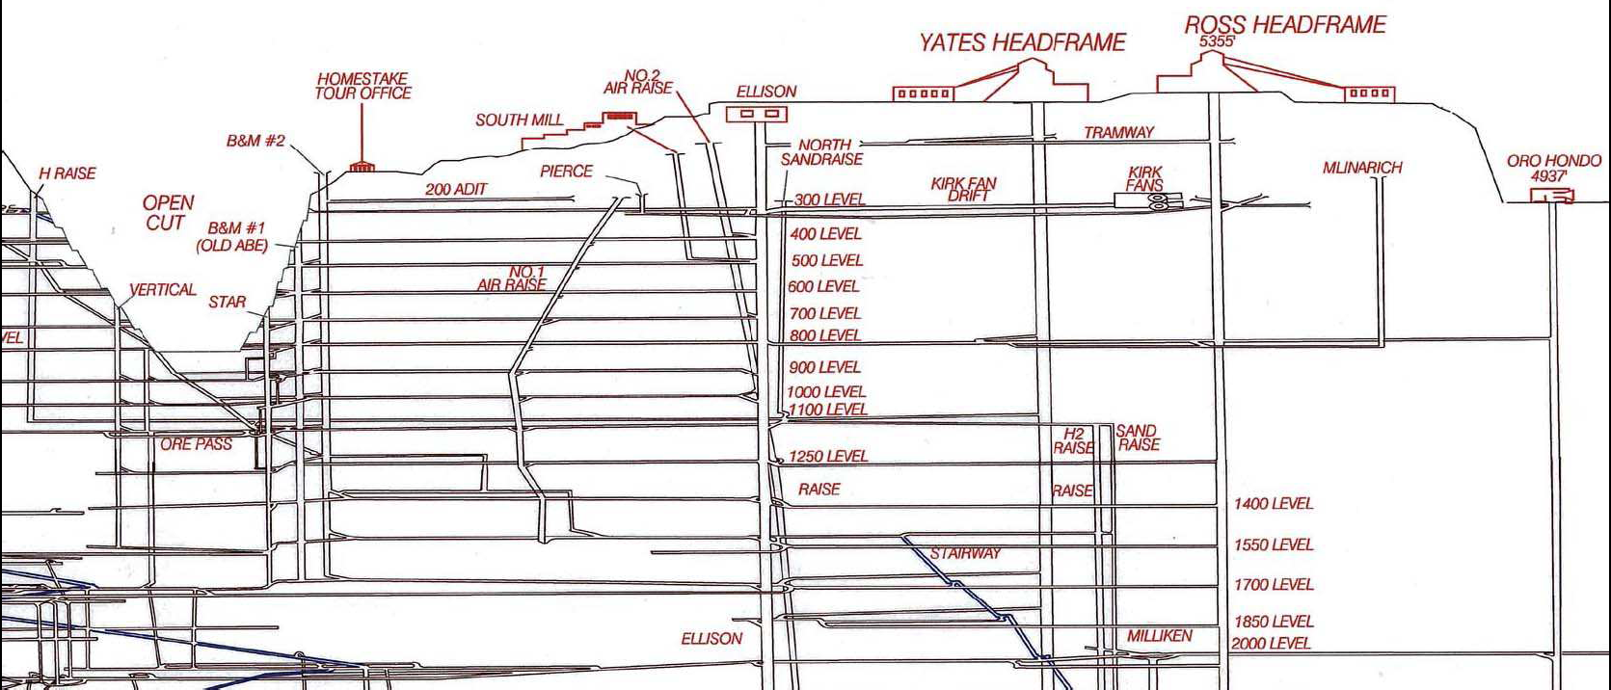
Figure 8: cross section of the upper levels of the Homestake mine onto a vertical plane whose normal is oriented towards the North-East direction ⁽²⁾
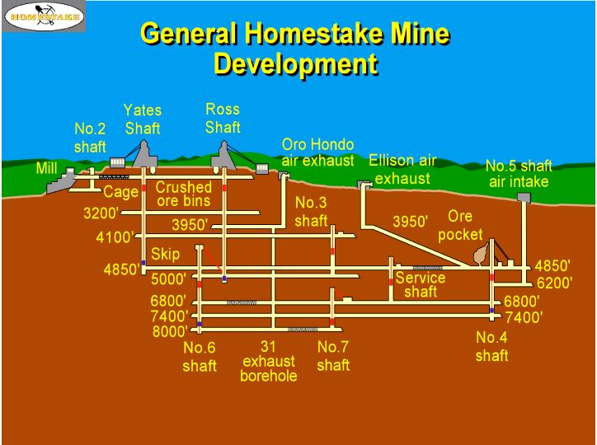
On July 2009 the deepest accessible level was the 4850 ft (1470 m). We were able to build the deepest stations at the 4100 ft (1250 m) level. The only shaft currently available to access the underground levels is the “Ross”; the reactivation of the “Yates” is ongoing, exchanging the partially wooden support structure with a metal structure. A cage (figure 11) grants the link between the underground levels through the shafts. The 5400 ft (1646 m) level correspond to the sea level.
Figure 9: Sketch of development of all Homestake underground levels ⁽³⁾

SDSTA is providing power and network connections in the accessible underground levels up to some electric boxes. The main office building is situated next to the Yates shaft, a bus provided by SDSTA transports people from the Yates building to the Ross shaft for the underground scientific activities.

IV. Working conditions and safety rules
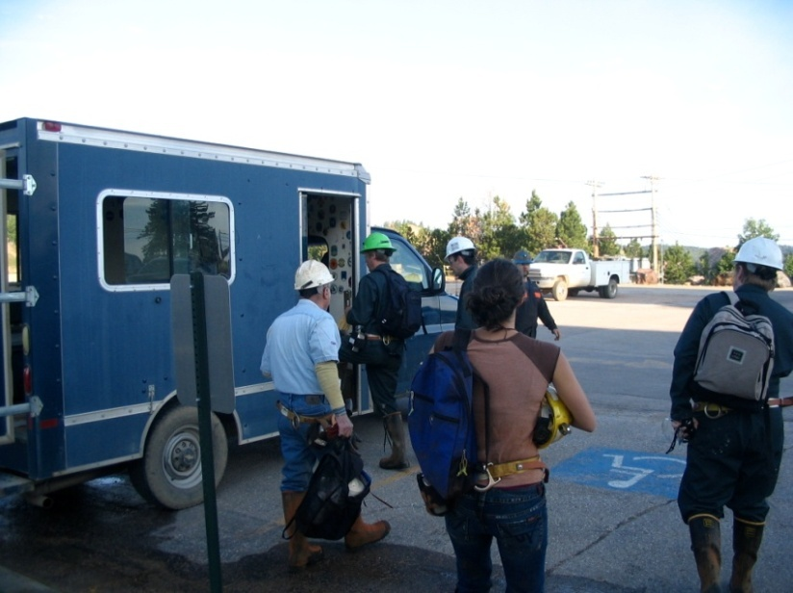
Safety rules are an important part of the work at Homestake. Scientists who plan to work underground in the Sanford Laboratory have to attend a safety class and a specific training. Although before being accessible to scientific work a site is secured by removing dangerous rocks and constructing supporting structures, during the work may be needed to scale the rock by removing loose rock with a scaling bar. These loose rocks are generated by some processes, the most important are oxidation and physical stresses due to moon tides and temperature drifts.
Figure 10: Scientists preparing to go to Ross Shaft with their safety equipment

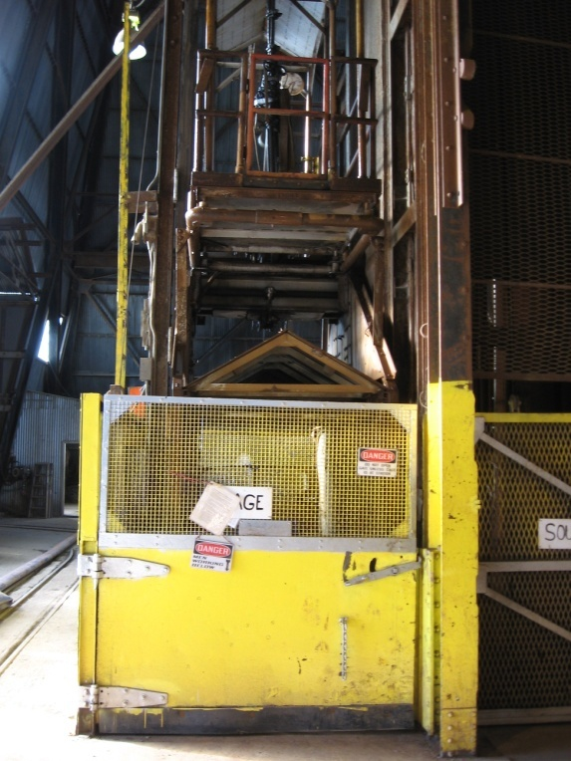
According to the policy of Sanford Laboratory, scientific teams must be accompanied by an experienced miner. This summer Tom Trancynger (geologist), Jaret Heise (science-liaison director) and Reggie Walters (geologist) lead our team underground and helped us in our work.
Daily work usually starts at the Yates office building where the team picks up the safety and work equipment and take the bus to the Ross shaft (figure 11) in order to be ready to cage at the Ross shaft at 7:00 a.m.; scientists can work underground until noon or 4:30 p.m., and every activity must be scheduled before in the daily action plan. Team members also have to tag-in, which means to pick a numbered metal plate and leave a copy at surface, with ones name and plate number on the daily action plan, in order to know always who is underground and where to look for if something happens, and also in order to identify maimed or burned bodies by the metal plate. Scientific teams have to be on time to get a cage as general rule, coming late would mean to delay the work of other teams in the mine, or a long wait for a next cage opportunity.
Figure 11: the Ross Shaft cage at surface level
The mine train in the underground levels was not available this summer: all the necessary scientific and construction equipment previously prepared in the office building were carried by hand and with a “stretcher”.

V. Construction of the new stations
Our work begun on June, 9th and lasted until July, 31st. In this period we started a collaboration with the ET group of Jo Van den Brand and Mark Beker: they joined our team for about a week and provided two seismometers Trillium 240 for our new stations. Our first goal was to fix the old stations’ configuration ⁽²⁾: we did it by connecting all the three stations at the internet network via fiber-optic, by exchanging the old sensor boards with the new ones we prepared, and also changing the seismometers’ allocations: in the final configuration the less accurate seismometer Güralp was located at the higher level (90 m), while two Trillium 240 are located in the old stations at 240 m and 610 m levels (for sensor boards and instruments see section VI).
The 610 m level was chosen to host the first sub-array consisting of the old station and two new stations, separated from each other by about 350 m. The 1250 m level was chosen for another sub-array consisting of three new stations, located about 90 m from each other. The final configuration of our three dimensional seismic array is shown in figure 12.

Figure 12: map of the Homestake seismic array at August 2009. Lines and spots represent tunnels and stations; brown for the 300 ft level, green for the 800 ft level, blue for the 2000 ft level and red for the 4100 ft level. Brown, green and central blue spots are the old stations, the two sideward blue and the red spots represent the new stations
V.1. construction of the new stations at the 610 m level
The first new station we built was the 2000ft-B. It is located in a free area along a side of the tunnel at the 2000ft level. This level is relatively dry, with approximately stable temperature of 20°C, but environmental conditions may change due to ventilation and excavation works in the level. An electric box provides a 110V AC power supply and a optical-cable connection to internet.

A pre-existent concrete platform remaining from an old charging station and connected to the bedrock was used as base for the computer and instrument huts. The computer hut hosts also DC power supply, UPS unit and DAQ with signal amplifier (see section VI).
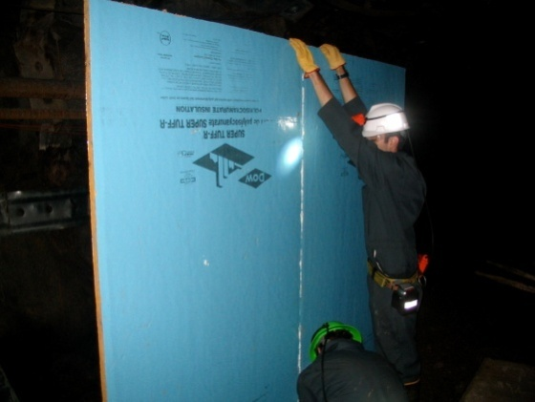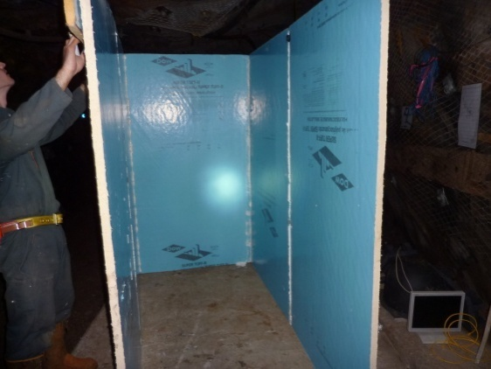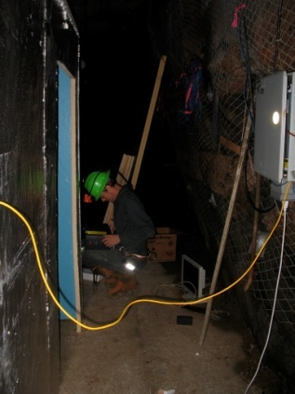
Figure 13,14,15: building and wiring the computer hut; in the right of figure 15 is observable an electric box of Sanford Lab
This hut was built for two reasons: first of all, we wanted a protection from humidity and debris for the electronics; in second instance and maybe the most important, we wanted to reduce outside as much as possible the acoustic and thermal noises emissions produced by the computer itself and power supplies. We used polyisocyanurate single-layer (1-inch) panels, linked by tape and polyurethane foam glue: the glue initially used for this hut was not suitable also for the instrument hut since it is very slow to dry out and not strong enough, therefore we chose another polyurethane foam glue which proved adequate for our purposes for all other huts and boxes. The computer hut has a closable polyisocyanurate door on the back and was cabled to the electric box provided by Sanford Laboratory (figure 15).
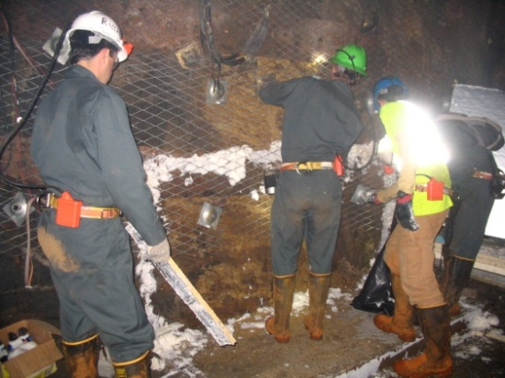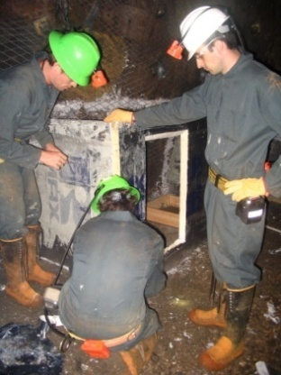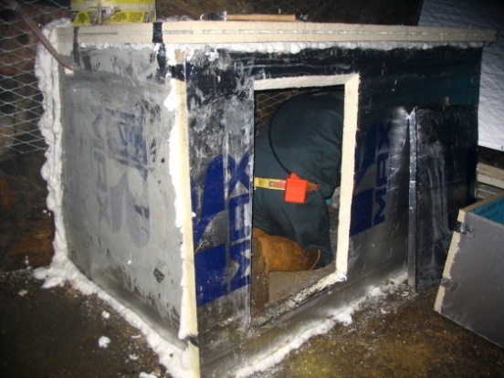
Figure 16,17,18: building the instrument hut: Insulating panels are well connected to the rock with polyurethane foam glue
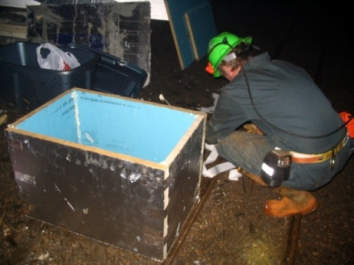
The instrument hut was built next to computer hut and along a side of the tunnel, on the top of a concrete platform: the insulation from humidity, temperature oscillations and noise sources is granted by polyisocyanurate panels (with a double-layer 2-inch top panel) merged with polyurethane foam glue; a closable door was carved in the front side. An inner instrument box for the seismometer was built with the same insulating panels (figure 19).
Figure 19: the inner box
In the instrument hut site we prepared a square concrete plinth using as a mold a square wood frame we made there. On the top of this plinth we placed, leveled and cemented a square granite tile as base for the seismometer. A wire connection between the huts provide the DC power supply for the seismometer and the sensor board, and the read-out. At the end the station was operative and connected to the network.
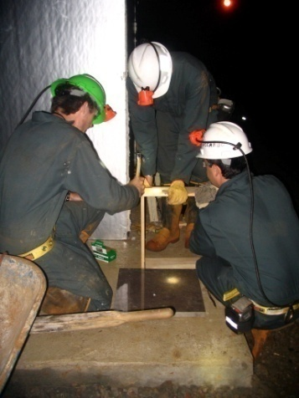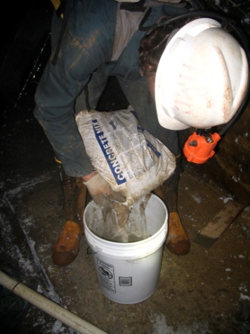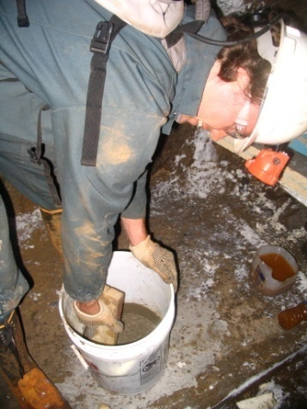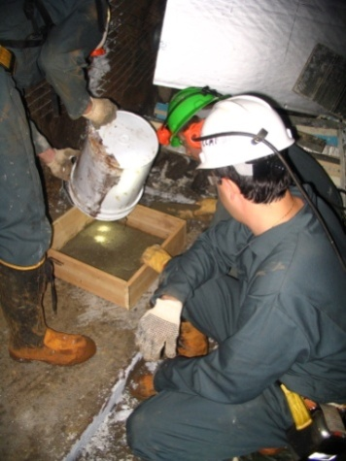
Figure 20,21,22,23: preparing the concrete plinth for the seismometer; in the center of figure 20 a granite tile is shown before it was placed on the concrete plinth inside the instrument hut
The other new station at the 610 m level was built inside a tunnel located after the old station, coming from the Ross shaft. First we wired the tunnel from a electric box to the new station site in order to have the AC power supply and the internet connection. Then we began to prepare the site digging and shoveling loose rocks and debris. Once the bedrock was reached we sounded it in order to make certain that there were no rock fractures at the base of this site. A concrete base well connected to the bedrock was prepared, and a square granite tile placed and cemented on it.
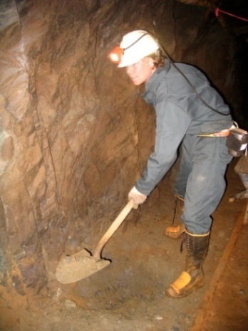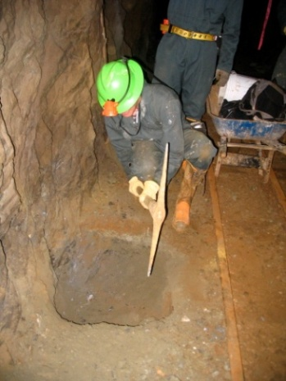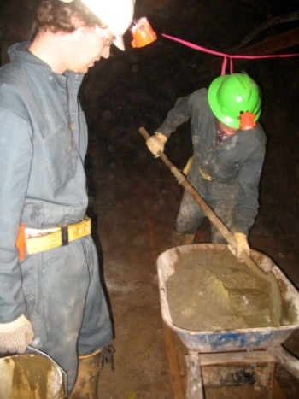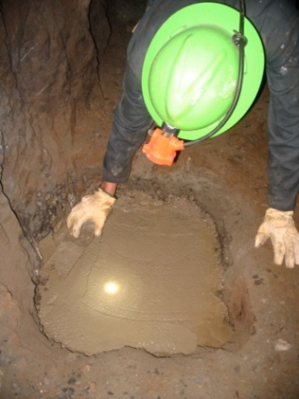
Figure 24,25,26,27: digging and shoveling loose rocks, and preparing the concrete base for the third 2000ft station
A single-layer cubic polyisocyanurate hut merged with polyurethane foam glue was built to host the computer and the DC power supply (figure 28). Since this part of the level is warmer and more wet, a better insulation was required: along a side of the tunnel a double-layer hut was built to host the seismometer; polyurethane foam glue was used to merge two polyisocyanurate layers for each side of the hut. As for the other new station, an inner box was built with the same panels (figure 29). Closable doors were carved for each hut. Once hut and boxes were completed, instruments were placed in the site, wired and connected to the network.

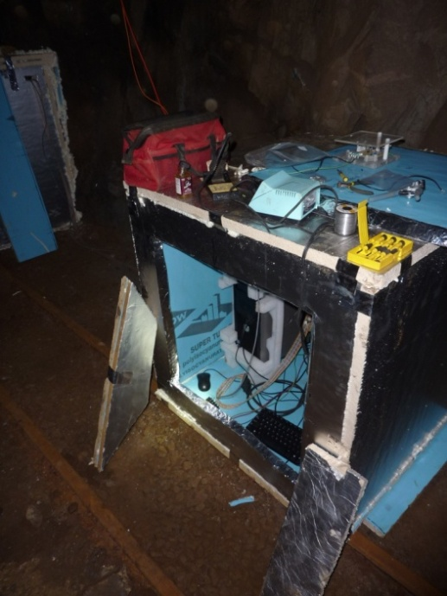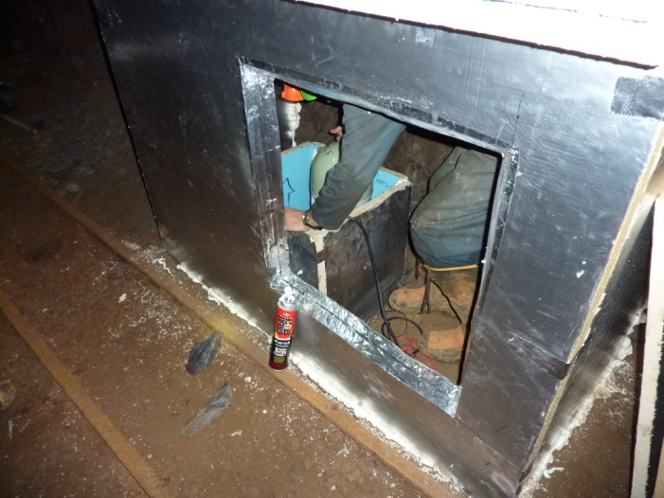
Figure 28,29: computer and instrument huts at 2000ft; figure 29 shows the double-layer structure and the inner instrument box
The sub-array at 610 m level is completed by the old station, located between the two new stations and made-up by a computer hut and an instrument cave insulated by polyisocyanurate panels ⁽²⁾ (figure 30, 31).
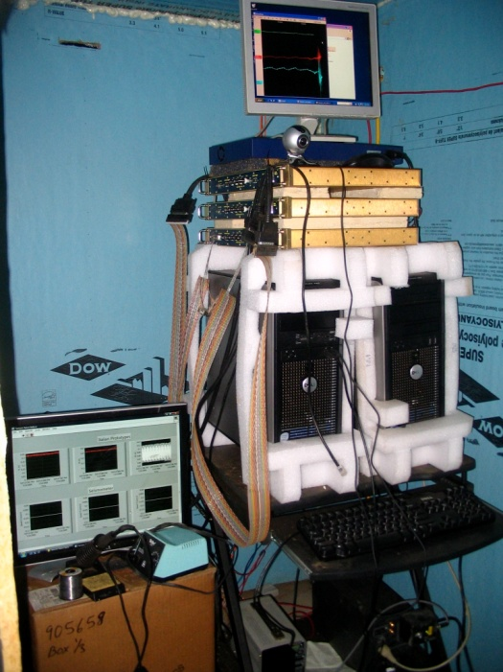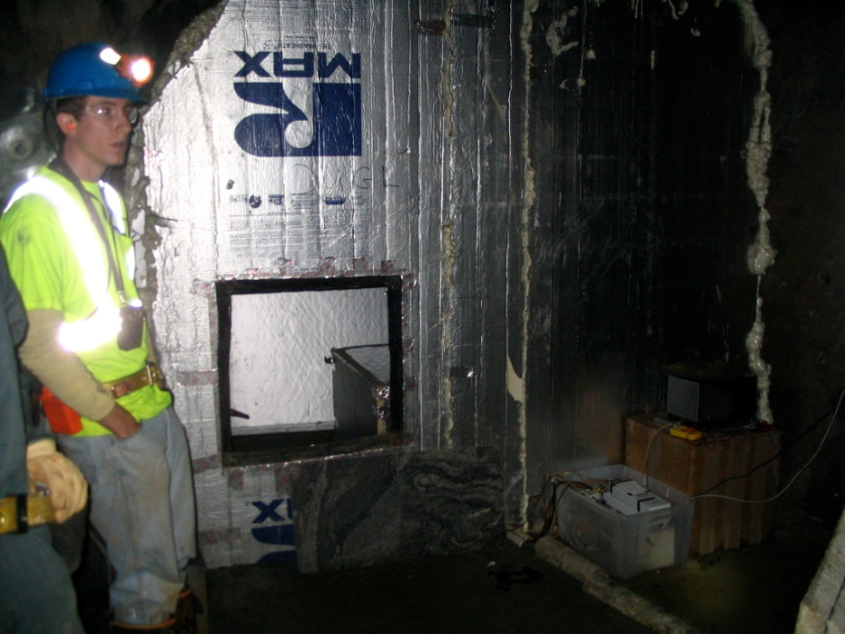
Figure 30,31: the old station at 2000ft; on the right inside view of the computer hut, on the left the insulated cave for instruments
V.2. construction of the new stations at the 1250 m level
The 4100 ft sub-array was made by three stations 90 m distant from each other. The level is warmer than others and there is a water flow along the opposite side of the tunnel respect to the stations. The site for the first new station was located in a former deposit consisting of two contiguous “rooms” carved into the side of the tunnel with a concrete base and grating doors. In the instrument room we prepared two main boxes and covers made by polyisocyanurate panels merged with polyurethane foam glue. Inside these boxes we cemented seven square leveled granite tiles as bases for instruments.
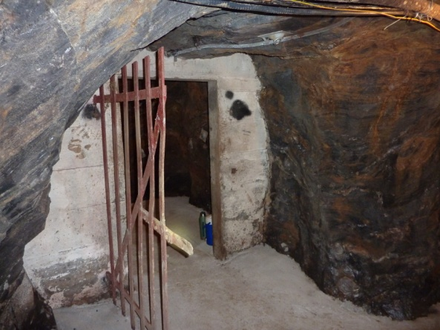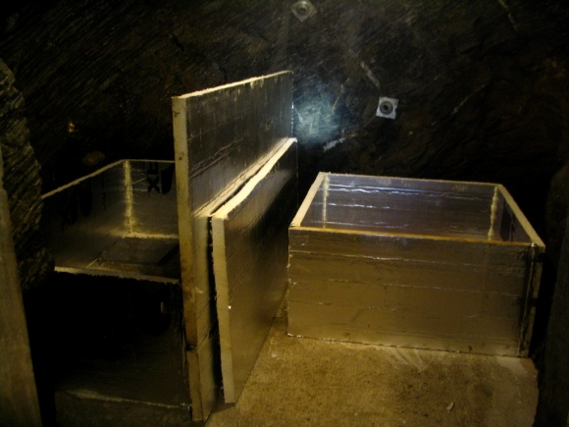
Figure 32,33: 4100 ft first station during the construction. In the left figure the former deposit used as computer room is shown; in the right figure the two instrument polyisocyanurate boxes are shown: the seismometer was placed in the single-tile box on the right.
In the computer room we built a wood table for the computer, DC power supply, UPS, DAQ with signal amplifier. Two polyisocyanurate doors were built in order to grant a good insulation. The two rooms were wired one to each other and to the electric and network box provided by Sanford Laboratory. The station is connected and operative.
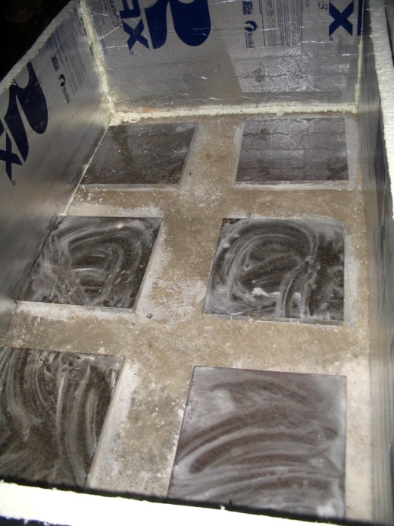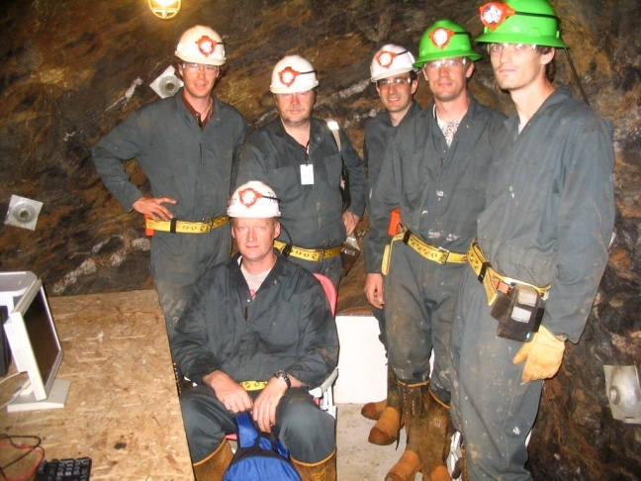
Figure 34,35: granite tiles placed inside the additional instrument box; DUGL team in the computer room, left to right: Mark Beker and Jo van den Brand (Nikhef, Netherlands), Luca Naticchioni (Sapienza-INFN, Italy), Jan Harms (University of Minnesota), Thomas O’Keefe (Saint Louis University), seated Guido Muller (University of Florida)
The other two new stations at 4100 ft were placed in two former airlocks along the tunnel. For both we needed to scale and shovel away rocks from above the tunnel and inside the airlocks. Once the sites were clear, we placed and cemented one square granite tiles inside each airlock. We closed the former doors of these rooms with double-layer polyisocyanurate panels insulated and merged with polyurethane foam glue, and we carved a closable door in each one. For both the stations we constructed an external cubic computer hut using the insulating panels. At August 2009 the network connection in these two sites was still under development by Sanford Laboratory. However the stations were wired, waiting for the network connection in the electric boxes.
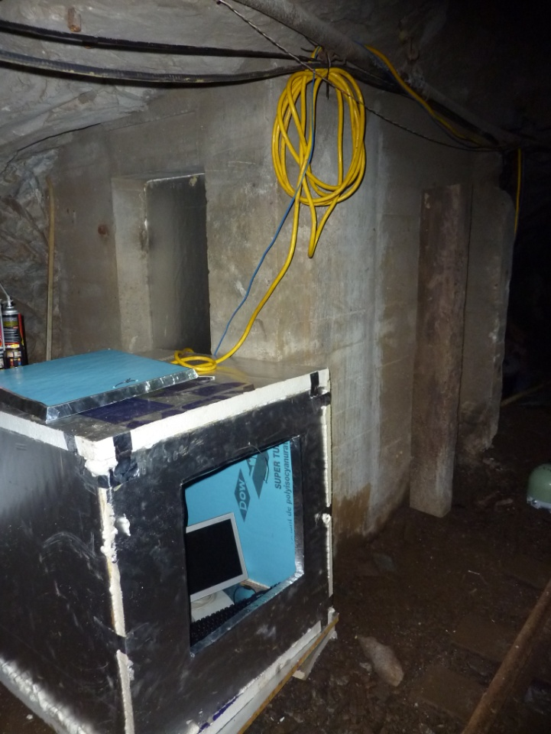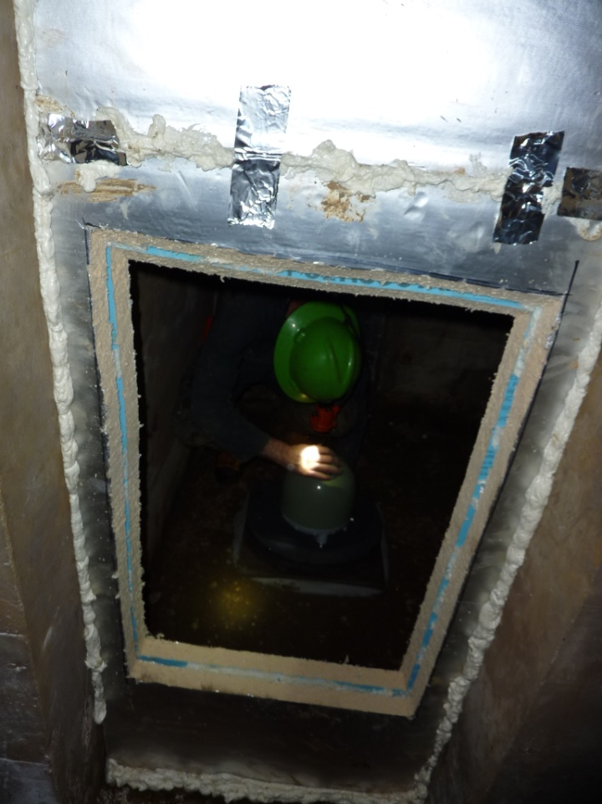
Figure 36,37: two of the new 4100ft stations are similar and located in two former airlocks; figure 36 shows the external cubic computer hut, in figure 37 the double-layer Polyisocyanurate insulation for the instrument room is shown
The array of seismometer stations is completed by the old stations at 90 m and 240 m, built in 2008 ⁽²⁾: at these levels humidity is high and water intrusion is significant; huts and boxes were made with the same insulating panels we used for the new stations. We fixed the configuration of these stations placing one Güralp seismometer at 90 m, one Trillium 240 at 240 m and replacing the sensor boards.
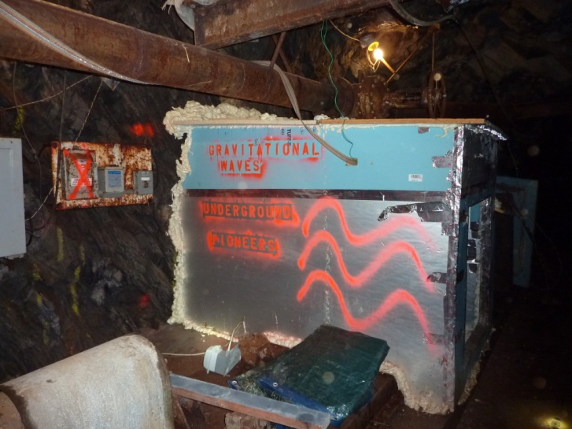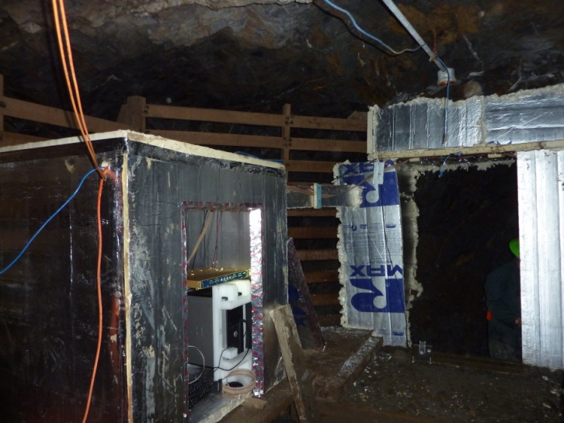
Figure 38,39: the old stations at 90m and 240m levels

VI. Instruments and seismometers
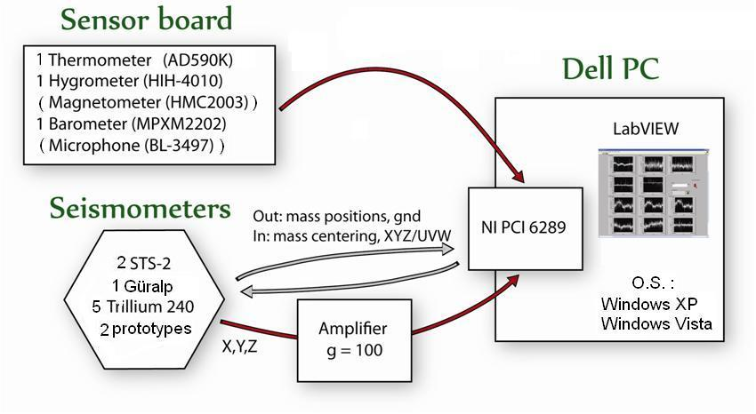
Figure 40: Sketch of instruments used at each underground station. Circuit design allows also a magnetometer, a microphone and an additional thermometer although these components were not used.
VI.1. Sensor boards
In old stations environmental conditions were monitored by sensor boards, each one consisting of one thermometer, one hygrometer, one magnetometer, one barometer and one microphone for acoustic noise. This year we built new sensor boards for all the stations of the array, removing from the design the magnetometer and the microphone: however the new design would allow a microphone to be installed in the future if necessary. Sensor boards are powered by a DC power supplies and connected to some channels of the same data acquisition used for the seismometers (see section VI.4).
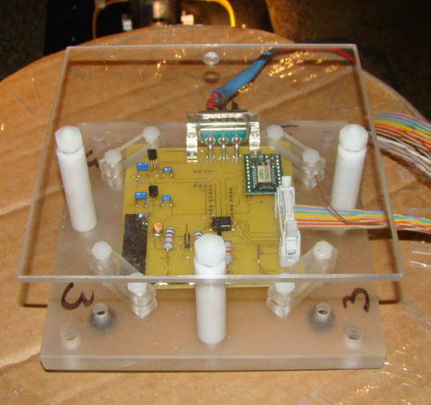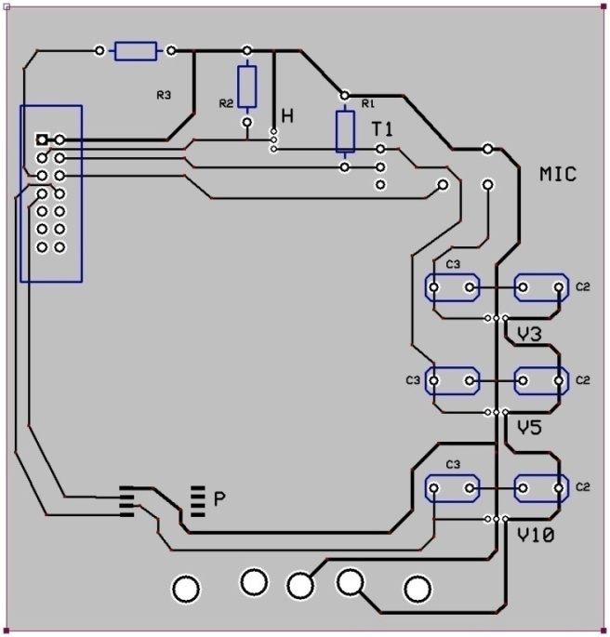
Figure 41,42: the old sensor board design (left) and the new design (right) we used assembling new sensor boards
Humidity in the underground levels is usually high (up to 100%), but with a good insulation it can be controlled in a range of 80-90%. At low frequencies strong magnetic fields would affect seismometers (especially STS-2 and Trillium 240) but the dominant source of noise for the seismometers comes from temperature fluctuations: indeed the pass-band sensitivity of any seismometer which is based on NdFeB magnet decreases by 0.12% depending on temperature. Sound and pressure fluctuation could be correlated (directly or indirectly) with seismic data: water pumping and ventilation are significant sources of noise (with resonance peaks in frequencies spectra) that should be better studied and kept under control with the sensor boards.
VI.2. Seismometers
In our stations we used three different seismometers: 2 STS-2 (at 1250 m), 5 Trillium 240 (one at 240 m, three at 610 m and one at 1250 m) and one Güralp (at 90 m)
Both STS-2 and the Trillium 240 operate in a low frequency range from about 10 mHz to 10 Hz and are sensitive to magnetic fields (mostly at lowest frequencies) and to temperature; mass centering is needed during the installation of these instruments and again after at least 12 hours, when the seismometer reaches a stable thermal equilibrium. An additional rubber foam cover protect these seismometers once installed (figure 45). STS-2 and Trillium 240 use a coordinate system u,v,w and a rotation is needed in order to obtain the ground velocities in the x,y,z coordinates:
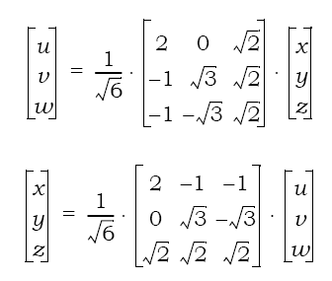
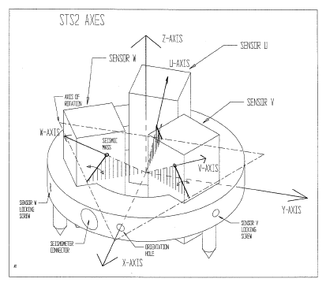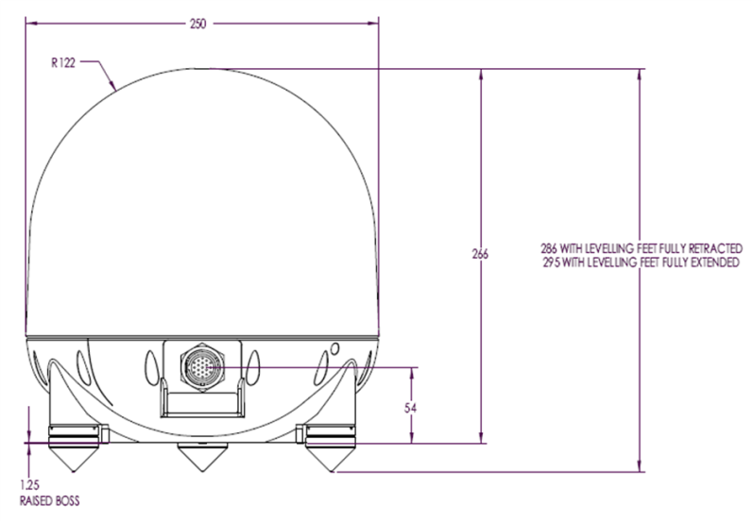
Figure 43,44: schemes of STS-2 (left) and Trillium 240 (right) seismometers
The complex response function and models used analyzing the data from STS-2 and Trillium, instruments self-noise and susceptibility to magnetic fields as well as a comparison between absolute values and phase of the relative transfer function of these seismometers are thoroughly discussed in reference 2. All Trillium are operative and connected in our stations, the two STS-2 located at 4100 ft still need to be connected to the network.
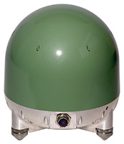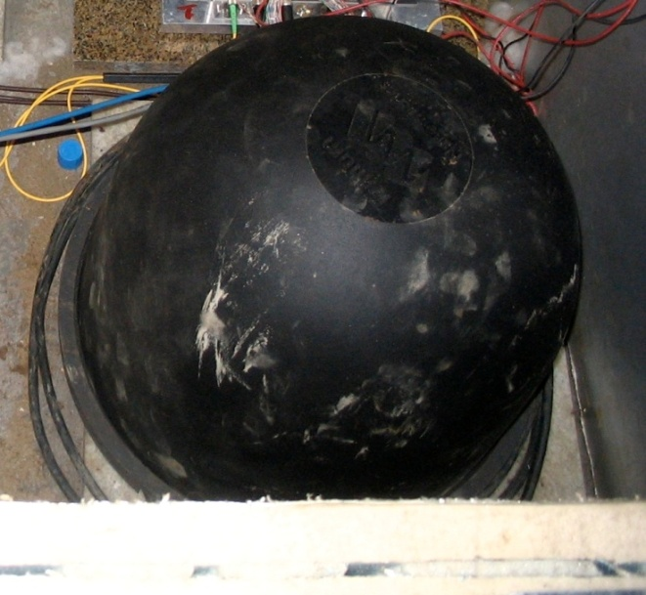
Figure 44,45: Trillium 240 (left) and the same seismometer installed with its protective and insulating rubber cover (right)
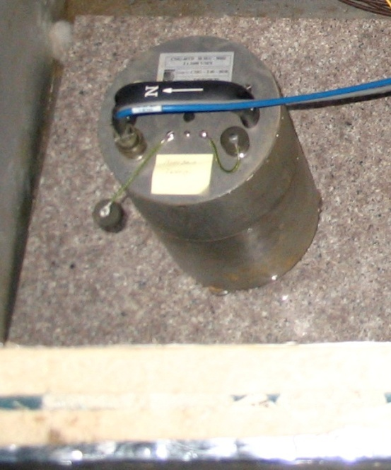
The Güralp CMG-40T seismometer is the less sensitive at low frequencies and uses decoupled sensors but is cheaper than the expensive STS-2 and Trillium 240. For this reason the Güralp is installed at the higher level of the array, in the old 90 m underground level station. As it was the last instrument to be installed this summer 2009 we had not time to complete the instrument three axis calibration due to exit cage time in our last day of work (see section IV).
Figure 46: Güralp CMG-40T seismometer

VI.3. Horizontal seismometer prototypes
Since December 2009 in addition to Trillium 240 seismometer the old 1250 m station hosts two prototypes of seismometers aligned to a common horizontal direction and developed by the group of Fabrizio Barone (University of Salerno - INFN) based on a monolithic tunable folded pendulum (figure 47) ⁽⁴⁾. Pendulum profile is shaped with precision machining and electric discharge machining from one original body of Al-Cu-Be alloy, and the central mass is linked by four elliptic flex joints with a minimum thickness of 100μm. This instrument is very sensitive in the low frequency seismic noise band (from 10⁻³ to 10 Hz): its sensitivity is comparable or better (with interferometric readout) than the STS-2 ⁽⁴⁾. The resonance frequency is tunable (figure 48,49) as well as the integrated optical readout composed by optical lever and interferometer using a NIR laser source (figure 50,51).
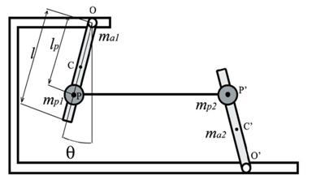
Figure 47: scheme of the folded pendulum system ⁽⁴⁾
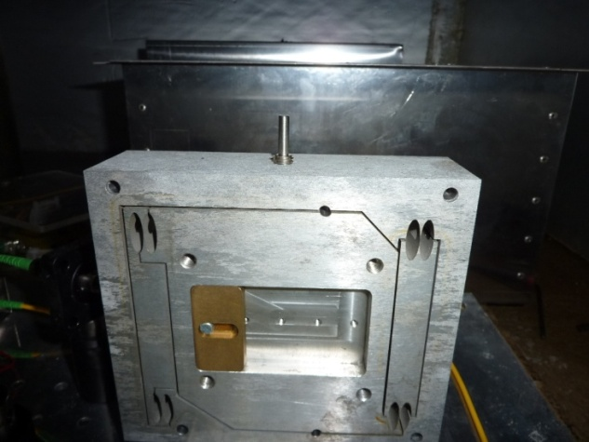
Figure 48,49: horizontal seismometer prototype is shown on the right: a red arrow denotes the tunable center mass; resonance frequencies depending on mass position are shown in figure 49 ⁽⁴⁾
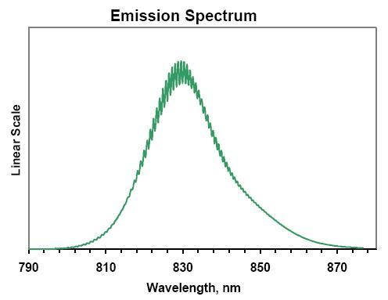
Figure 50,51: the optical lever used in the horizontal seismometer prototype is shown on the left, the dotted red line denotes the optical path from laser transmitter reflecting to the PSD ⁽⁴⁾ . In the right the laser emission spectrum
After the implementation of these two prototypes on December 2008 there were some not understood problems with the remote read-out system that impeded its functioning. Only this summer we could make a check-up of the instruments: the folded pendulum was intact, the laser source that had been turned off due to a black out was reactivated, the optical lever was aligned. However we found a failure of the two electronic boxes connected with the seismometer: we changed these electronic boxes with two new boxes from the University of Salerno, replacing operational circuits, cabling new BNC connectors and looking for possible shorts. We suppose that the electronics damage was due to a connector inverted during a previous access, or voltage surges in the DC power supply: this power supply must be repaired or replaced and a UPS unit installed. During our tests we opened the instrument box of the first prototype and the consequent strain may have affected the instrument calibration; we could not recalibrate the instrument because the electronics still did not work properly with the damaged DC power supply. A new calibration will be needed in future.
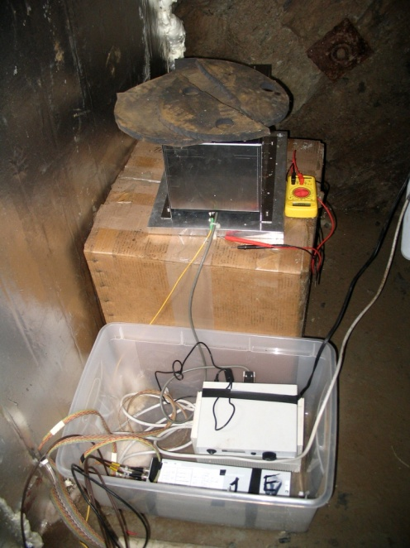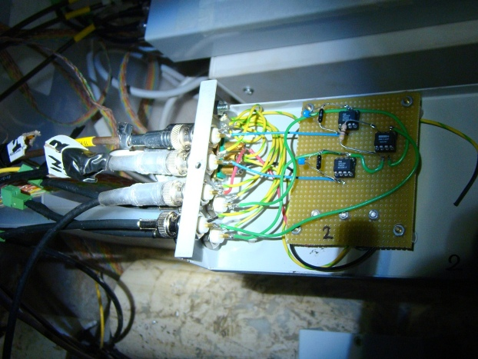
Figure 52,53: on the right the laser source is shown in the metal box, while the laser power supply, DC power supply and electronics boxes are in the plastic box; on the left an electronic box opened during the work

VI.4. Station instruments and data acquisition

Figure 54: Sketch of the remote-access scheme and data acquisition. The system can be controlled remotely via the remote-desktop function. External users have to log into the surface PC. A second remote desktop can then be started on this machine to take control over the underground PCs. Data access is provided by a simple ftp server. A scheduled task copies data every 20min from the underground stations to the ftp folder of the surface PC. A second scheduled task calls Matlab functions to down-sample some of the channels, before a virtual machine with Linux guest system retrieves the data (which is in ASCII format) and converts it into LIGO frames ⁽²⁾.

As discussed above, each station is built with a computer hut containing the acquisition and power instruments: DC power supply, UPS unit, DELL computer with Windows XP or Windows Vista O.S., signal amplifier and DAQ card. The acquisition starts with the PCI 6289 card from National Instruments containing an 18 bit ADC and an internal amplifier, its nominal resolution is 80.1 μV assuming 5% over range and its highest resolution 0.8 μV at maximum gain. ⁽²⁾. The connectors are two 68-pin VHDCI supporting 32 analog inputs. The data acquisition is managed by LabVIEW based programs (figure 55) which also generates analog-output signals to initiate mass-centering procedures of seismometers if necessary. The data is first stored in ASCII files as 128 s records sampled at 128Hz and then is downsampled (except for the seismic channel) and converted into LIGO standard frames.
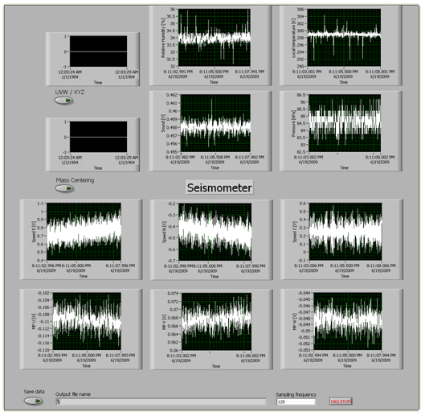
Figure 55: LABview data handling and visualization
The data can be accessed from internet running an FTP server. A DHCP server reserves an address range for static IPs. External requests through an ftp port are forwarded to the IP of the FTP server; a second port is configured to forward remote desktop access to the same PC which is the surface PC. When logged onto this machine it is possible to use LAN-internal remote access to control the underground stations connected to the network: one can start or stop DAQ and copy the data to the FTP server. As already mentioned underground levels are connected to the web via optical cables. Simple NTP demons are installed on all machines; the absolute timing proved to be too poor for long time correlation measurements due to time drifts between DAQs and PCs timing. For short time correlation measurements the temporal coherence can be maximized with a time shift technique (figure 56); a new and more accurate optical distributed timing system will be implemented in the next future. We found the best spectral coherence between two stations A and B at 2000ft in the range from 70 mHz to 400 mHz (figure 57).
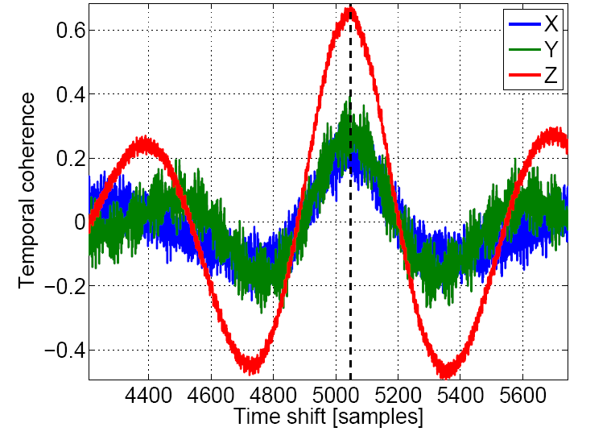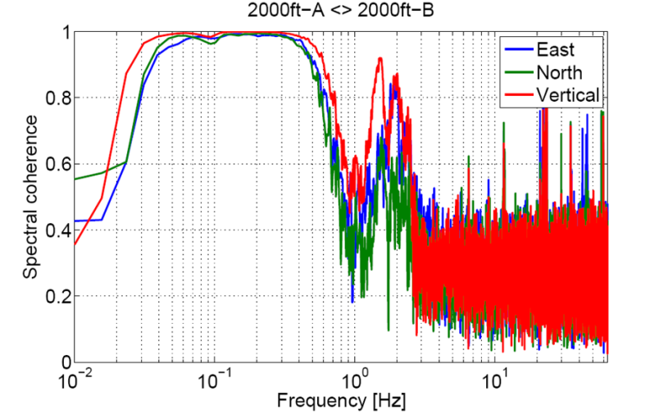
Figure 56,57: time shift to maximize the temporal coherence (right) and spectral coherence between 2000ft-A and 2000ft-B stations

VII. Preliminary results
This section illustrates some preliminary results of measurements from the seismometer array at Homestake in comparison with seismometer stations at Hanford LIGO Observatory. The data was collected during the first days of August 2009 using our acquisition system at Homestake for the 610 m and the 1250 m station (the one connected to the network) and the data viewer at Hanford for End-X station, End-Y station and the vertex station Vault. In figure 58 a spectral time-frequency plot of the 2000ft-B station (610 m) for a whole day is shown. The two low frequency bursts at 0 and 0.2 day are caused by drilling operation at that level, the perturbation over all frequencies at about 0.15 day is caused by the passage of the mine-train next to the station.
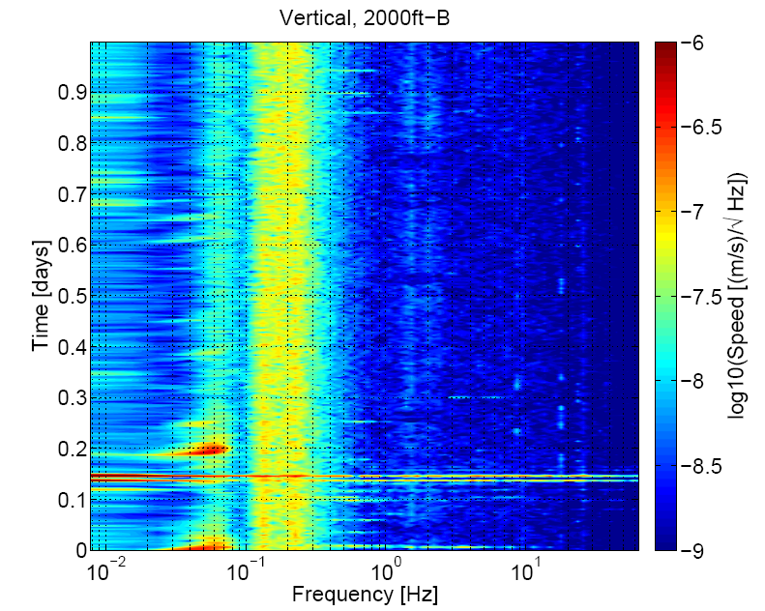
Figure 58: amplitude density spectrum in a whole day time-frequency plot for the 610 m B station. The low frequency bursts around 0 and 0.2 are caused by drilling operation, while the perturbation over all frequency at 0.15 is due to a train passing next to the station. The yellow range of frequencies (0.1-0.2 Hz) over all day represents the microseismic peaks caused by oceanic activity
In figure 59 are shown amplitude density spectra for the 1250 m station at Homestake compared to the average seismic data from LIGO Hanford observatory at End-X, End-Y and Vault stations; the last plot of figure 59 shows a comparison between the quiet and noisy data from 1250m at Homestake and Hanford End-X station: at low frequencies Hanford noisy data get worse of more than two orders of magnitude during noisy times, while at Homestake the average plot shows that even during noisy time the spectrum remains close to the quietest data. Clearly this is a remarkable advantage of this underground location.
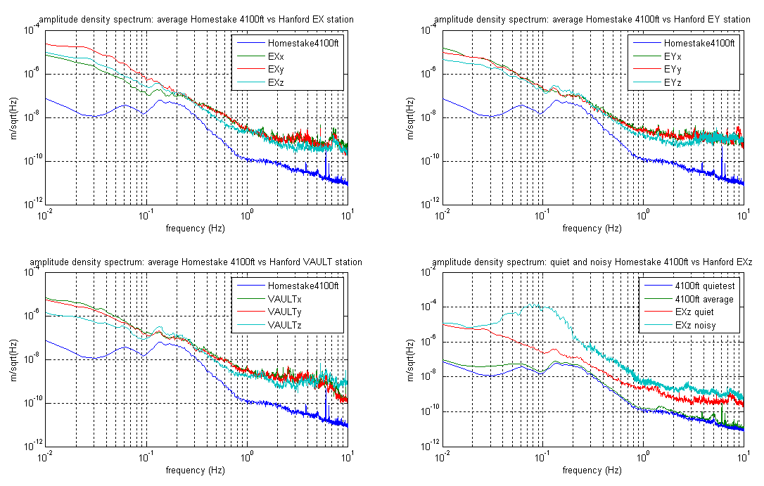
Figure 59: amplitude density spectra for Homestake and LIGO Hanford observatory data. In the first three plots the blue line represent the Homestake average data at 4100 ft in comparison with average data from End-X, End-Y and Vault station at Hanford. The last plot shows a comparison between quiet and noisy data at Hanford and Homestake: this remarkable result shows clearly the advantage of an underground site for future generation GWID operating at low frequency
In figure 60 a comparison between average z-component data from 4100 ft Homestake and Hanford stations is shown: even during noisy time Homestake seismic data is quieter than average Hanford data by about one to two orders of magnitude in 1-10 Hz range. In reality in this region the instrumental noise may actually become worse than the actual seismic motion level, hence the advantage may even be greater. Figure 61 shows the comparison with Hanford data during noisy time: between 1 and 10 Hz Homestake underground data, even when noisy, is quieter by two to three orders of magnitude, and at 0.1 Hz Homestake is quieter then Hanford noisy times by nearly four orders of magnitude. The last figure 62 shows amplitude density spectrum of the 4100 ft station compared with Peterson NLNM (New Low Noise Model) that is the estimated minimum Earth noise: from a collection of seismic data from 75 sites around the world, Peterson found that there is a minimum level of Earth noise, noise levels below this are never, or extremely rarely, observed; between 0.1 and 1 Hz our data is quieter than Peterson noise, and this is another remarkable result. Between 1 and 10 Hz increasing seismic noise causes the divergence from the Peterson NLNM shape.
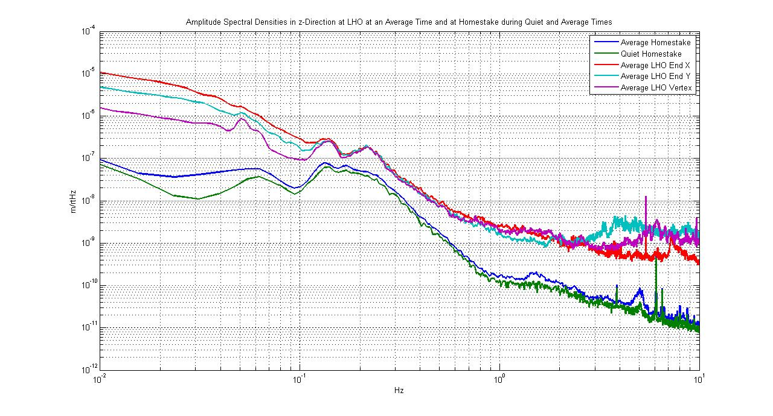
Figure 60: comparison between Homestake 4100ft level quiet and average seismic data with LHO quiet seismic data
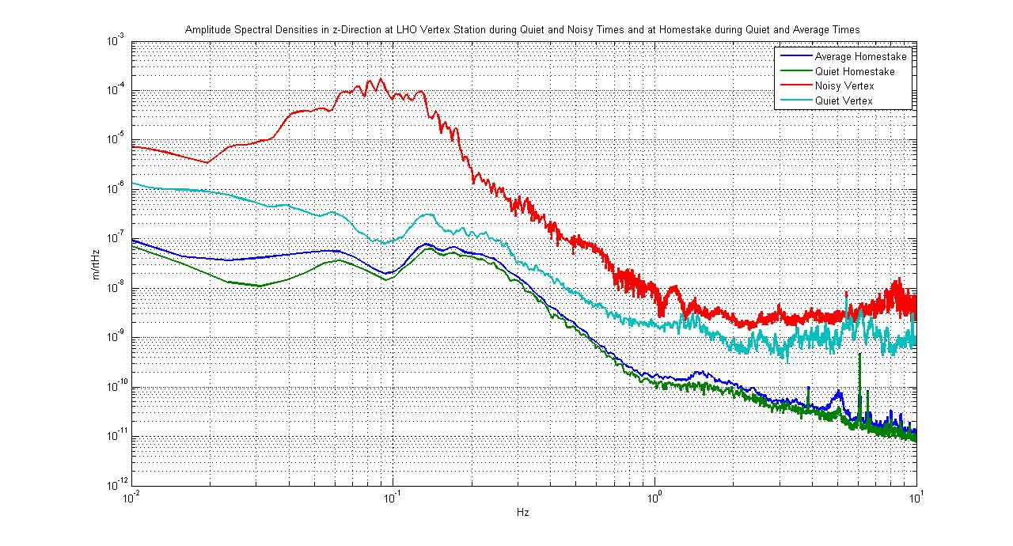
Figure 61: comparison between Homestake 4100ft level and LHO quiet and average seismic data: the seismic data at LHO during noisy and quiet times can differ at some frequencies by as much as three orders of magnitude. Such extreme differences do not exist at the Homestake site.

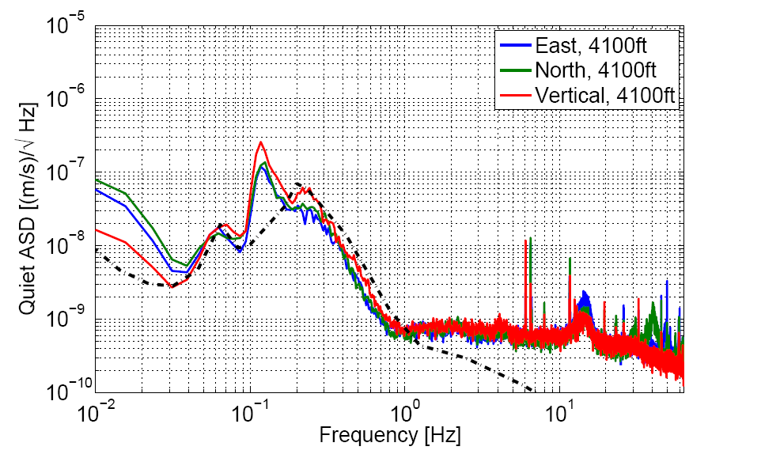
Figure 62: average Homestake seismic data from 4100ft level and Peterson NLNM. Between 0.1 and 1 Hz Homestake data is quieter than the lowest Earth noise recorded by Peterson

VIII. Future plans
The LIGO timing system will take care of our timing problems and allow for more accurate correlation measurements between 610 m and 1250 m level stations. These measurements with a good timing will be helpful to modeling the seismic activity. At 1250 m level two stations will soon be connected to the network and their data will become available. Horizontal seismometer prototypes will be made operative again by repairing or replacing their DC power supply, and new prototypes could join the array. The old station at 610 m level will be offline for some time in autumn, due to consolidation works needed in the cavity which hosts the station. Hopefully new funding from NSF will allow construction of new stations next year at Homestake, possibly also expanding the collaboration with the ET Dutch group, which already provided two seismometers to the array.

VIII. Acknowledgments
First of all I want to thank CalTech and INFN for the opportunity they gave me to work at this project and LIGO and Sanford Underground Laboratory for the support and loan of equipments; especially I want to thank my mentor at Homestake Jan Harms: without his dedication to this work the results here presented would not have been achieved; I’m also grateful to my CalTech mentor Riccardo De Salvo, who has been helping me since I arrived to CalTech this year; I’m thankful to my University mentor Fulvio Ricci, who gave me the opportunity to take part in this student exchange, to Vuk Mandic at University of Minnesota, to Cindy Akutagawa and to Marilyn Wright at CalTech; I also want to thank for their collaboration at Homestake my colleague Thomas O’Keefe and everyone who helped us in our work at Sanford Laboratory: science-liaison director Jaret Heise, geologists Tom Trancynger and Reggie Walters, visitor physicists Jo van den Brand, Mark Beker from Nikhef (Netherlands) and Guido Muller from University of Florida; finally I want to thank Fausto Acernese and Fabrizio Barone for their confidence in me working with their horizontal seismometers.

References:

1. Mitigating noise in future GW observatories in the 1−10 Hz. M. G. Becker et al. 2009.
2. Seismic studies at the Homestake mine in Lead, South Dakota. J. Harms et al. 2009. LIGO-T0900112-v1-H.
3. Synopsis of Homestake Mine Geology. T.J. Campbell
4. Tunable mechanical monolithic horizontal accelerometer for low frequency seismic noise measurement. F. Acernese et al. - Sensors and Smart Structures Technologies for Civil, Mechanical, and Aerospace Systems, 2009. Proc. of SPIE Vol. 7292 72922J-1.

Physics Department and INFN, Universita’ di Roma “Sapienza”, P.le Aldo Moro 2, 00185, Rome, Italy California Institute of Technology – LIGO project, 1200 East California boulevard, Pasadena CA 91125
as the rigidity of a beam goes with the cube of its thickness, a double layer panel is at least 8 times more rigid than a single panel layer. This greatly improves protection against low frequency air currents and pressure waves. The thermal insulation is only doubled of course.
Data acquisition system subsequently described was recently improved, for example connection is now managed by Knology
Network Time Protocol background processes
note the smooth slope above 1.5 Hz, broken only by peaks due to the mine activity. The uniform slope is an indicator of instrument noise limitations

