LIGO Laboratory / LIGO Scientific Collaboration

LIGO-060056-08-M Advanced LIGO 23 May 2007

Advanced LIGO Reference Design

Advanced LIGO Team

This is an internal working note
of the LIGO Laboratory.

California Institute of Technology  LIGO Project – MS 18-34  1200 E. California Blvd.  Pasadena, CA 91125  Phone (626) 395-2129  Fax (626) 304-9834  E-mail: info@ligo.caltech.edu | Massachusetts Institute of Technology  LIGO Project – NW17-161  175 Albany St  Cambridge, MA 02139  Phone (617) 253-4824  Fax (617) 253-7014  E-mail: info@ligo.mit.edu
LIGO Hanford Observatory  P.O. Box 1970  Mail Stop S9-02  Richland WA 99352  Phone 509-372-8106  Fax 509-372-8137 | LIGO Livingston Observatory  P.O. Box 940  Livingston, LA 70754  Phone 225-686-3100  Fax 225-686-7189
http://www.ligo.caltech.edu/

Advanced LIGO Reference Design

1. Overview

This document describes the technical approach for the first major upgrade to LIGO, consistent with the original LIGO design and program plan.

LIGO consists of conventional facilities and the interferometric detectors. The LIGO facilities (sites, buildings and building systems, masonry slabs, beam tubes and vacuum equipment) have been specified, designed and constructed to accommodate future advanced LIGO detectors. The initial LIGO detectors were designed with technologies available at the initiation of the construction project. This was done with the expectation that they would be replaced with improved systems capable of ultimately performing to the limits defined by the facilities.

In parallel with its support of the initial LIGO construction, the National Science Foundation (NSF) initiated support of a program of research and development focused on identifying the technical foundations of future LIGO detectors. At the same time, the LIGO Laboratory worked with the interested scientific community to create the LIGO Scientific Collaboration (LSC) that advocates and executes the scientific program with LIGO.

The LSC, which includes the scientific staff of the LIGO Laboratory, has worked to define the scientific objectives of upgrades to LIGO. It has developed a reference design and carried out an R&D program plan. This development has led to this Reference Design for construction of the Advanced LIGO upgrade following the initial LIGO scientific observing period.

This document gives a summary of the principal subsystem requirements and high-level conceptual design of Advanced LIGO. The document is intended to be dynamic, and will be updated as our technical knowledge improves.

2. Sensitivity and Reference Design Configuration

The Advanced LIGO interferometer design allows tuning and optimization of the sensitivity both to best search for specific astrophysical gravitational-wave signatures and to accommodate instrumental limitations. To define the goal sensitivity of Advanced LIGO, a single measure is given: a equivalent strain noise of 10⁻²² RMS, integrated over a 100 Hz bandwidth centered at the minimum noise region of the strain spectral density, a factor of 10 more sensitive than initial LIGO. This measure allows some margin with respect to our present best estimates of the possible sensitivity.

Figure 1 gives several examples of target sensitivity curves using our present best (2006) prediction of the instrument performance. The tunings are optimized for the following sources:

Neutron-star inspiral: The greatest ‘reach’ is obtained by optimizing the sensitivity in the ~100 Hz region, at the expense of sensitivity at lower and higher frequencies. Averaged over all polarizations and angles, and for a signal-to-noise of 8 or greater, a single Advanced LIGO interferometer can see 1.4-solar-mass binaries as far as 175 Mpc, and the three interferometers if all tuned to this optimization, can see ~300 Mpc.

Black Hole inspiral: Here the best tuning is one which optimizes low-frequency sensitivity. For equal mass binaries, the frequency of the gravitational waves when the merger phase begins is estimated to be ~250 (20M_{s}/M)Hz where M is the total mass of the binary and M_{s} is the mass of our sun. Advanced LIGO can observe a significant part of the inspiral for up to ~50 solar mass binaries. The third interferometer, tuned to be more sensitive at higher frequencies, can study the waves generated during the merger.

Stochastic Background: Random, but correlated signals would be produced by an e.g., cosmological, cosmic string, or confusion-limited source. For a search for cosmological signals, using an interferometer at Livingston and one at Hanford (separated by 10msec time-of-flight for gravitational waves), this sensitivity would allow a detection or upper limit, for a background flat in frequency, at the level of Ω≥ 9x10⁻¹⁰ for a 12 month observation time. Using the collocated interferometers, it is possible to search for an isotropic stochastic background around 37 kHz. This is at the first free-spectral-range (FSR) of the 4km interferometer, where its equivalent strain noise is comparable to the equivalent strain noise at low frequencies.

Unmodeled transient sources: These are sources exhibiting short transients (lasting less than one second) of gravitational radiation of unknown waveform, and thus have a fairly broad (and imprecisely known) frequency spectrum. These include burst signals from supernovae and black hole mergers for which the physics and computational implications are complex enough that make any analytical calculation of the expected waveforms extremely difficult. Advanced LIGO can detect the merger waves from BH binaries with total mass as great as 2000 MO, to cosmological redshifts as large as z=2. Empirical evidence suggests that neutron stars in type II supernovae receive kicks of magnitude as large as ~1000 km/s. These violent recoils imply the supernova’s collapsing-core trigger may be strongly asymmetric, emitting waves that might be detectable out to the Virgo cluster of galaxies (event rate a few/yr).

In the event of a transient gravitational wave detection, the two collocated detectors at the Hanford site will provide a powerful tool. The identical – within their measurement error – signals expected to be recorded in the two collocated instruments will be independent of signal strength, direction, polarization admixture or specific data analysis selection criteria.

Pulsars: A narrow-band tuning, centered e.g., on the region of the ‘pile-up’ of anticipated gravitational-wave signals from pulsars, LMXRBs, or other continuous-wave sources. To obtain this response, mirror transmission in the instrument must be changed from the configurations discussed above. For a single interferometer, an sensitivity of 1.5x10⁻²⁴ in a one Hz bandwidth or a RMS equivalent strain noise, unity SNR, of ~9x10⁻²⁸ for a 3-month observation is possible.

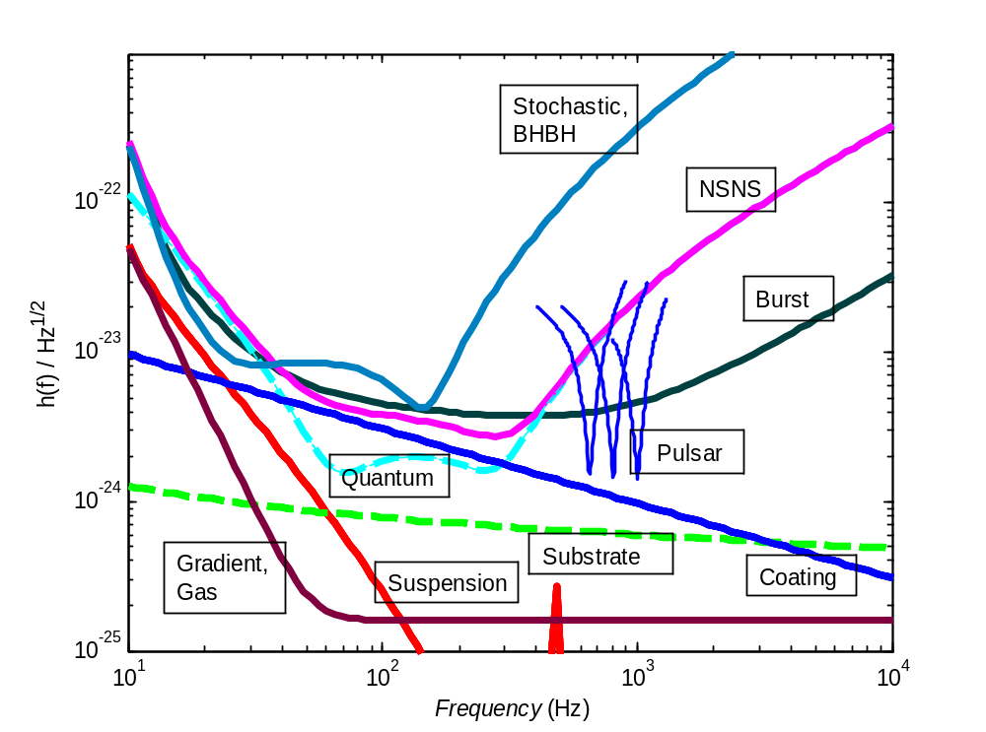
Figure 1: Limiting noise for a variety of Advanced LIGO tunings. The equivalent strain noise, in a one-Hz bandwidth, of Advanced LIGO as limited by the thermal and quantum noise. Noise curves are shown for tunings optimized for a Stochastic background (flat frequency dependence) or 50 Solar Mass BH-BH inspiral, 1.4 Solar Mass NS-NS inspiral, and pulsars at 650, 800, and 1000 Hz. Also shown are expected contributions from Suspension, Substrate, and optical Coating thermal noise. The other significant limit is quantum noise (shown only for the NS-NS curve), which in quadrature sum with the thermal noise leads to the curves shown. Facility limits due to the gravitational gradients, and the fluctuations in optical path due to residual gas for the lowest achievable pressure (10⁻⁹ torr), are shown at the bottom.

The specific starting configuration (narrow-band vs. broad-band) of the three interferometers of Advanced LIGO is best determined closer to the time of implementation. The changes to the optical system are relatively small, involving fixing the transmission of one in-vacuum suspended optic; multiple substrates are planned for this signal-recycling mirror. It is likely that we will have further information from either discoveries by the first generation of gravitational-wave detectors, and/or from a better understanding of the astrophysics, which will help in making a choice.

Advanced LIGO is designed to be a flexible platform, to evolve as technologies become available and as astrophysical insights mature. Narrowband or broadband operation is one specific variation which is in the Advanced LIGO baseline. Other modifications, such as using squeezed light to improve the sensitivity without increasing the optical power, are currently being pursued by the community, and can be considered as modifications or upgrades of Advanced LIGO as appropriate.

To obtain the maximum scientific return, LIGO is also planned to be operated as an element of an international network of gravitational wave detectors involving other long baseline interferometric detectors and acoustic detectors. Long baseline interferometric detectors are expected to be operated by the Virgo Collaboration at Pisa, Italy and by the GEO600 Collaboration at Hannover, Germany. Memoranda of Understanding to cover coordination of the observations during and after the Advanced LIGO Project are currently in discussion and will be established. Plans are also underway to establish long baseline interferometric detectors in Japan and Australia, and we will strive to coordinate with these efforts as well. Simultaneous observations in several systems improve the confidence of a detection. A global network of detectors will also be able to provide full information from the gravitational waves, in particular, the polarization and the source position on the sky.

Configuration

The LIGO Scientific Collaboration, through its Working Groups, has worked with the LIGO Laboratory to identify a reference design for the Advanced LIGO detector upgrade. The reference design is planned to lead to a quantum noise limited interferometer array with considerably increased bandwidth and sensitivity.

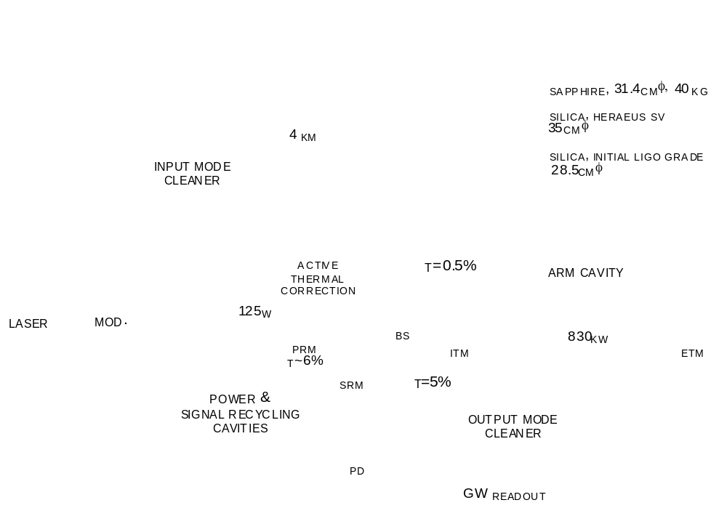
SILICA, 34 CM Φ, 40 KG
SILICA, 37 cm φ
SILICA, 26.5 cm φ

Figure 2: Schematic of an Advanced LIGO interferometer, with representative mirror reflectivities optimized for neutron star binary inspiral detection. Several new features compared to initial LIGO are shown: more massive test masses; 20x higher input laser power; signal recycling; active correction of thermal lensing; an output mode cleaner. (ETM = end test mass; ITM = input test mass; PRM = power recycling mirror; SRM = signal recycling mirror; BS = 50/50 beam splitter; PD = photodetector; MOD = phase modulation). Seismic Isolation system, Optics Suspensions, and the mode-matching and beam-coupling telescopes not shown.

The basic optical configuration is a power-recycled and signal-recycled Michelson interferometer with Fabry-Perot “transducers” in the arms; see Figure 2.. Using the initial LIGO design as a point of departure, Advanced LIGO requires the addition of a signal-recycling mirror at the output “dark” port, and changes in the RF modulation and control systems. This additional mirror allows the gravitational wave induced sidebands to be stored in the arm cavities or extracted (depending upon the state of resonance of the signal recycling cavity), and allows one to tailor the interferometer response according to the character of a source (or specific frequency in the case of a fixed-frequency source). For wideband tuning, quantum noise dominates the instrument noise sensitivity at most frequencies.

The laser power is increased from 10 W to 180 W, adjustable to be optimized for the desired interferometer response, given the quantum limits and limits due to available optical materials. The resulting circulating power in the arms is roughly 800 kW, to be compared with the initial LIGO value of ~10 kW. The Nd:YAG pre-stabilized laser design resembles that of initial LIGO, but with the addition of a more powerful output stage. The conditioning of the laser light also follows initial LIGO closely, with a ring-cavity mode cleaner and reflective mode-matching telescope, although changes to the modulators and isolators must be made to accommodate the increase in power.

Whereas initial LIGO uses 25-cm diameter, 11-kg, test masses, the fused-silica test mass optics for Advanced LIGO are larger in diameter (~32 cm) to reduce thermal noise contributions and more massive (~40 kg) to keep the radiation pressure noise to a level comparable to the suspension thermal noise. Polishing and coating are required to be somewhat better than the best results seen for initial LIGO. In particular, the coating mechanical losses must be managed to limit the thermal noise. Compensation of the thermal lensing in the test mass optics (due to absorption in the substrate and coatings) is added to handle the much-increased circulating power.

The test mass is suspended by fused silica ribbons (or tapered fibers as an alternate) attached with hydroxy-catalysis bonds, in contrast to the steel wire sling suspensions used in initial LIGO. Fused silica has much lower mechanical loss (higher Q) than steel, and the fiber geometry allows more of the energy of the pendulum to be stored in the earth’s gravitational field while maintaining the required strength, thereby reducing suspension thermal noise. The resulting suspension thermal noise is anticipated to be less than the radiation pressure noise and comparable to the Newtonian background (“gravity gradient noise“) at 10 Hz. The complete suspension has four pendulum stages, and is based on the suspension developed for the UK-German GEO-600 detector. The mechanical control system relies on a hierarchy of actuators distributed between the seismic and suspension systems to minimize required control authority on the test masses. The test mass magnetic actuators used in the initial LIGO suspensions can thus be eliminated (to reduce thermal noise and direct magnetic field coupling from the permanent magnet attachments) in favor of electrostatic forces for locking the interferometer. The much smaller forces on the test masses reduce the likelihood of compromises in the thermal noise performance and the risk of non-Gaussian noise. Local sensors and magnets/coils are used on the top suspension stage for damping, orientation, and control.

The isolation system is built on the initial LIGO piers and support tubes but otherwise is a complete replacement, required to bring the seismic cutoff frequency from ~40 Hz (initial LIGO) to ~10 Hz. RMS motions (dominated by frequencies less than 10 Hz) are reduced by active servo techniques, and control inputs complement those in the suspensions in the gravitational-wave band. The attenuation offered by the combination of the suspension and seismic isolation system eliminates the seismic noise limitation to the performance of the instrument, and for the low-frequency operation of the interferometer, the Newtonian background noise dominates.

Reference Design Parameters

Table I Principal parameters of the Advanced LIGO reference design with initial LIGO parameters provided for comparison
Subsystem and Parameters | Advanced LIGO  Reference Design | Initial LIGO Implementation
Comparison With initial LIGO Top Level Parameters
Observatory instrument lengths;  LHO = Hanford, LLO = Livingston | LHO: 4km, 4km;  LLO: 4km | LHO: 4km, 2km;  LLO; 4km
Anticipated Minimum Instrument Strain Noise  [rms, 100 Hz band] | < 4x10⁻²³ | 4x10⁻²²
Displacement sensitivity at 150 Hz | ~1x10⁻²⁰ m/√Hz | ~1x10⁻¹⁹ m/√Hz
Fabry-Perot Arm Length | 4000 m | 4000 m
Vacuum Level in Beam Tube, Vacuum Chambers | <10⁻⁷ torr | <10⁻⁷ torr
Laser Wavelength | 1064 nm | 1064 nm
Optical Power at Laser Output | 180 W | 10 W
Optical Power at Interferometer Input | 125 W | 6 W
Optical power on Test Masses | 800 kW | 15 kW
Input Mirror Transmission | 0.5% | 3%
End Mirror Transmission | 5-10 ppm | 5-10 ppm
Arm Cavity Beam size (1/e^2 intensity radius) | 6 cm | 4 cm
Light Storage Time in Arms | 5.0 ms | 0.84 ms
Test Masses | Fused Silica, 40 kg | Fused Silica, 11 kg
Mirror Diameter | 34 cm | 25 cm
Suspension fibers | Fused Silica ribbons | Steel Wires
Seismic/Suspension Isolation System | 3 stage active,  4 stage passive | Passive, 5 stage
Seismic/Suspension System Horizontal Attenuation | ≥10⁻¹⁰ (10 Hz) | ≥10⁻⁹ (100 Hz)

3. Facility Modifications and Preparation (FMP)

Overview

Advanced LIGO technical requirements will necessitate modifications and upgrades to the LIGO buildings, and vacuum equipment. In addition, the strategy for executing the Advanced LIGO construction will require some facility accommodations.

The principal impact on this WBS element is as follows:

- It is a program goal to minimize the period during which LIGO is not operating interferometers for science. For this reason, major subsystems such as the seismic isolation and suspension subsystems should be fully assembled and staged in locations on the LIGO sites ready for installation into the vacuum system as fully assembled and vacuum compatible units. This will require prepared assembly and staging space, materials handling equipment, and softwall clean rooms.
- Increasing the arm cavity length for the Hanford 2-kilometer interferometer to 4 kilometers will require removing and reinstalling the existing mid-station chambers and replacing them with spool pieces in the original locations.
- The larger optical beams in the input optics section (and possibly the output optics section) will necessitate changing out the input optics vacuum tube for a larger diameter tube.
- Two of the general-purpose (HAM) vacuum chambers in the vertex building will be shifted along the beam line for each interferometer to optimize the position of detection components.

Functional Requirements

Vacuum Equipment

All vacuum equipment functional requirements are the same as those in the initial LIGO design except that the vacuum level is required to be one order of magnitude lower (<10⁻⁷ torr; the present system operates at the Advanced LIGO level). Additional equipment (chambers, spool pieces, softwall clean rooms) is needed to accommodate additional arm cavity length for one interferometer and the desire for parallel assembly and installation in more chambers and staging areas. A larger diameter spool piece for the IO Mode Cleaner beam path (and possibly for a similar output mode cleaner) is required. Several of the auxiliary optics chambers in the central building will be moved several meters along the beam line to accommodate the new optical system. The seismic isolation system requirements call for the Advanced LIGO subsystems to be compatible with the original LIGO vacuum envelope.
Other elements of this subsystem are the installation fixtures and hardware, equipment and materials for in-vacuum component and vacuum equipment cleaning/baking, and the installation planning (schedules, ES&H, logistics, SOP's, etc).

Beam Tube

The original end-pumped beam tube system requires no modifications or additions for Advanced LIGO. There is sufficient margin in the present vacuum performance to permit the operation of the more sensitive Advanced LIGO instrument with no changes.

Conventional Facilities

Preassembly of all large Advanced LIGO seismic isolation units prior to installation in the vacuum tanks requires clean onsite staging and assembly space. At both the Hanford and Livingston Observatories there exist suitable staging buildings with appropriate height and basic configuration; portable clean rooms and benches are required. Transporters for delivering fragile systems from the central buildings to the end stations are required.

Concept/Options

Vacuum Equipment

Approximately 1600 square feet of BSC type cleanroom will be installed in the Hanford and Livingston staging buildings. For each of the interferometers, additional clean rooms will be acquired to support parallel installation in additional chambers to facilitate reducing the duration of Advanced LIGO installation.

Four additional spool pieces will be acquired to replace the Hanford mid-station BSC chambers and to connect these chambers to the end-station BSC chambers once relocated. The chambers will be removed and reinstalled at the end stations.

The Input (and potentially the output) Mode Cleaner requires a larger diameter spool piece, ~15m in length, to accommodate the larger mirrors used.

The requirement of base pressure for Adv LIGO (<10⁻⁷ torr) is already met by the present system (which is operating at <10⁻⁸ torr).

Beam Tube

No action needed. The original installation meets requirements for Advanced LIGO.

Conventional Facilities

The existing staging buildings at both observatories will require additions of flow benches, fume hoods, vacuum bake ovens, and other minor equipment to support clean processing operations. In addition, at LHO some retrofit of the HVAC system will be necessary in the Staging Building to meet the cleanliness requirements. HEPA filters and a more powerful motor are needed.

R&D Status/Development Issues

There are no development issues or R&D associated with this WBS element. A Preliminary Design Review is planned for 3qFY07, followed by Final Design starting in 1qFY08.

4. Seismic Isolation Subsystem (SEI)

Overview

The seismic isolation subsystem serves to attenuate ground motion in the observation band (above 10 Hz) and also to reduce the motion in the “control band” (frequencies less than 10 Hz). It also provides the capability to align and position the load. Significantly improved seismic isolation will be required for Advanced LIGO to realize the benefit from the reduction in thermal noise due to improvements in the suspension system. The isolation system will be completely replaced, and this offers the opportunity to make a coordinated design including both the controls and the isolation aspects of the interferometer.

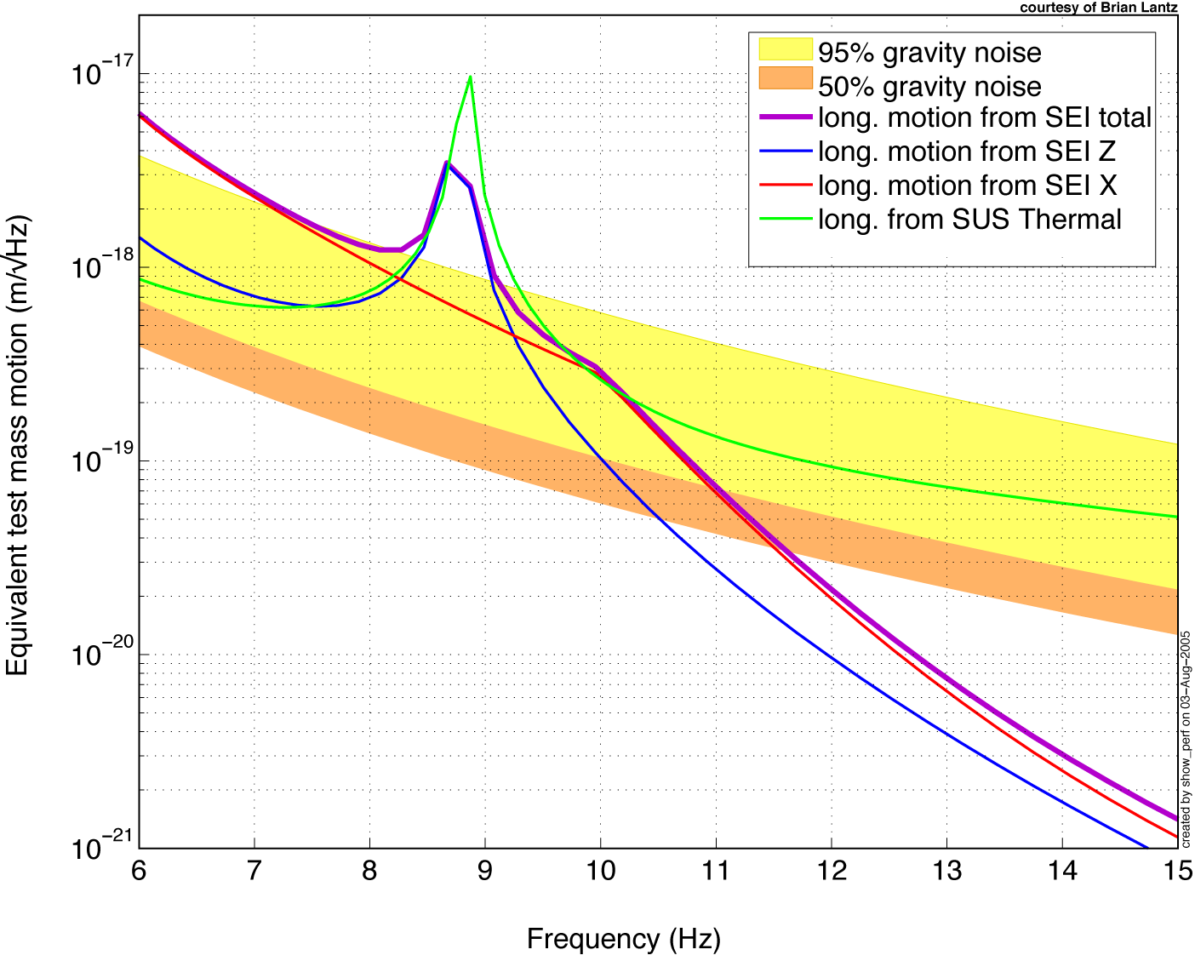
Figure 3 Predicted test mass displacement noise. The orange and yellow shaded regions are the expected longitudinal (beam direction) motion from direct gravity coupling, at 50th and 95th percentile ground motion measured at the LIGO sites; this dominates over the seismic noise above 11 Hz or so. The red, blue and purple lines are, respectively, the contributions to test mass motion from horizontal and vertical seismic isolation system motion and the total seismic contribution at about the 90th percentile level. The green curve is the expected suspension (pendulum) thermal noise; it exceeds the seismic noise above about 10.3 Hz.

Functional Requirements for the BSC (Test Mass Chamber) payloads

The top-level constraints on the design of the isolation system can be summarized:

Seismic attenuation: The amplitude of the seismic noise at the test mass must be equal to or less than the thermal noise of the system for the lowest frequencies where observation is planned, 10 Hz. At about that frequency and below, the competing noise sources (suspension thermal noise, radiation pressure, Newtonian background) conspire to establish a presently irreducible sensitivity level roughly a factor of 30 above the limits imposed by the LIGO facilities. Figure 3 shows current estimates of some of these noise sources, based on 3-D dynamic models of the seismic platform and quadruple pendulum systems, 50th and 95th percentile ground motion statistics, and estimates of direct gravity coupling. At just above 10 Hz, the expected motion from seismic coupling equals that from suspension thermal noise, at about 2–3 x 10⁻¹⁹ m/√Hz, and then falls off rapidly. The visible ‘shoulder’ between 10 and 20 Hz is due to a large BSC vacuum chamber resonance; recent lab results have validated a HEPI feedforward technique to reduce this band even further, should it become a problem.
The RMS differential motion of the test masses while the interferometer is locked must be held to a small value (less than 10⁻¹⁴ m) for many reasons: to limit light fluctuations at the antisymmetric port and to limit cross coupling from laser noise sources, as examples. Similarly, the RMS velocity of the test mass must be small enough and the test mass control robust enough that the interferometer can acquire lock. This establishes the requirement on the design of the seismic isolation system in the frequency band from 1 to 10 Hz of approximately 10⁻¹¹ m/√Hz, and a reduction in the microseism band to several tenths of a µm/√Hz.
The isolation positioning system must have a large enough control range to allow the interferometer to remain locked for extended periods; our working value is 1 week.
The system must interface with the rest of the LIGO system, including LIGO vacuum equipment, the adopted suspension design, and system demands on optical layout and control.

The requirements for the HAM (Auxiliary optics) payloads are less stringent at 1 Hz by a factor of approximately 30 and ~100 at 10 Hz, due to the reduced optic sensitivity for these chambers. Additional information on Advanced LIGO seismic isolation requirements is available.

Concept

The initial LIGO seismic isolation stack will be replaced with an Hydraulic External (to the vacuum) Pre-Isolator (HEPI) stage, and an In-vacuum two-stage active Seismic Isolation (ISI) platform (Figure 4 is a solid model of the currently under-construction prototype). The in-vacuum stages are mechanically connected with stiff springs, yielding typical passive resonances in the 2-8 Hz range. Sensing its motion in 6 degrees of freedom and applying forces in feedback loops to reduce the sensed motion attenuates vibration in each of the two-cascaded stages. Stage 1 derives its feedback signal by blending three real sensors for each degree of freedom: a long-period broadband seismometer, a short-period geophone, and a relative position sensor. The inertial sensors (seismometers and geophones) measure the platform's motion with respect to their internal suspended test masses. The position sensor measures displacement with respect to the adjacent stage. The resulting “super-sensor” has adequate signal-to-noise and a simple, resonance-free response from DC to several hundred hertz. Stage 2 uses the position sensor and high-sensitivity geophone, and some feed-forward from the outer stage 1 seismometer.

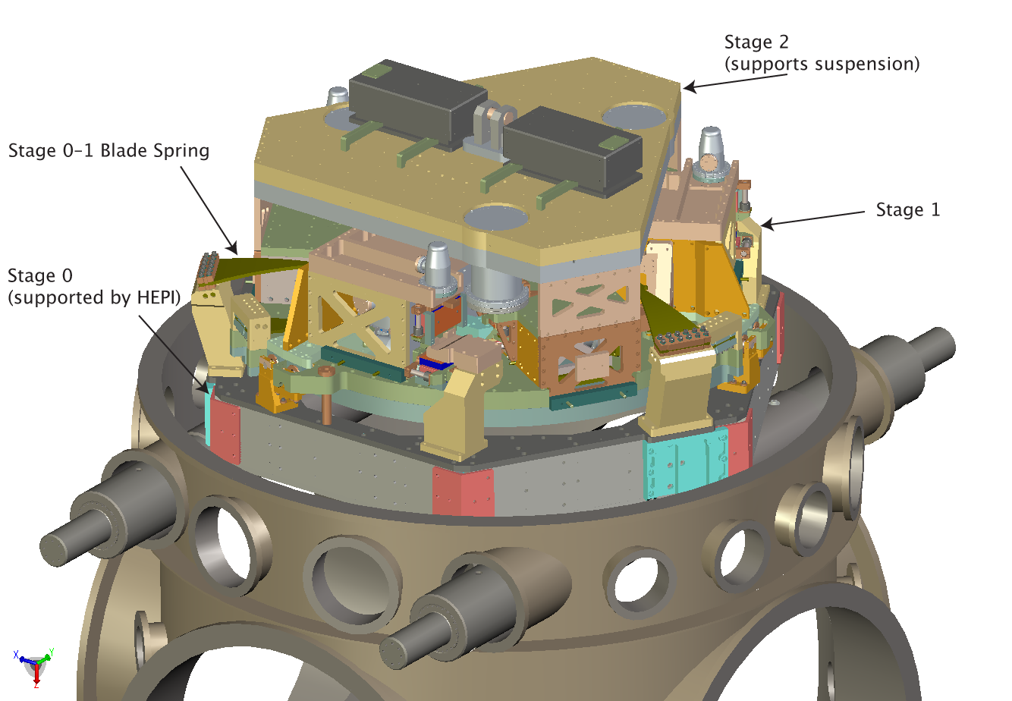
Figure 4 Computer rendering of the prototype two-stage in-vacuum active seismic isolation system (ISI) for the test-mass (BSC) vacuum chambers, which is under construction as of this writing. The outside frame (stage 0) supports the stage 1 from three trapezoidal blade springs and vertical flexure rods. Stage 2, which supports the payload, is likewise suspended from stage 1. The bottom of stage 2 is an optics table under which the test mass suspensions are mounted.

The outer frame of the isolation system is designed to interface to the existing in-vacuum seismic isolation support system, simplifying the effort required to exchange the present system for the new system. The outer stage is hung from the outer frame using trapezoidal leaf springs to obtain the 2-6 Hz resonances. The inner platform stage is built around a 1.5-m diameter optics table (BSC) or a larger polygonal table (HAM). The mechanical structures are carefully studied to bring the first flexible-body modes well above the ~50 Hz unity gain frequencies of the servo systems. For each suspended optic, the suspension and auxiliary optics (baffles, relay mirrors, etc.) are mounted on an optical table with a regular bolt-hole pattern for flexibility.

We will use commercial, off-the-shelf seismometers that are encapsulated in removable pods. This allows the sensors to be used as delivered, without concerns for vacuum contamination, and allows a simple exchange if difficulties arise. The actuators consist of permanent magnets and coils in a configuration that encloses the flux to reduce stray fields. These components must meet the stringent LIGO contamination requirements. The multiple-input multiple-output servo control system is realized using digital techniques; 16-bit accuracy with ~2 kHz digitization is sufficient.

The external pre-isolator is used to position the in-vacuum assembly, with a dynamic range of 1 mm, and with a bandwidth of 2 Hz or greater in all six degrees of freedom. This allows feedforward correction of low-frequency ground noise and sufficient dynamic range for Earth tides and thermal or seasonal drifts. We target approximately a factor of 10 reduction of the ~0.16 Hz microseismic motion from feedforward correction in this stage.

The performance of the ISI system is calculated with a model that includes all solid-body degrees of freedom, and measured or published sensitivity curves (noise and bandwidth) for sensors. It meets the Advanced LIGO requirements for both the test-mass (BSC) and auxiliary (HAM) chambers.

The passive isolation of the suspension system provides the final filtering. A sketch of the system as applied to the test-mass vacuum chambers (BSC) is shown in Figure 5. A similar system is designed for the auxiliary optics chambers (HAM). Further details can be found in the subsystem Design Requirements and Conceptual Design documents.

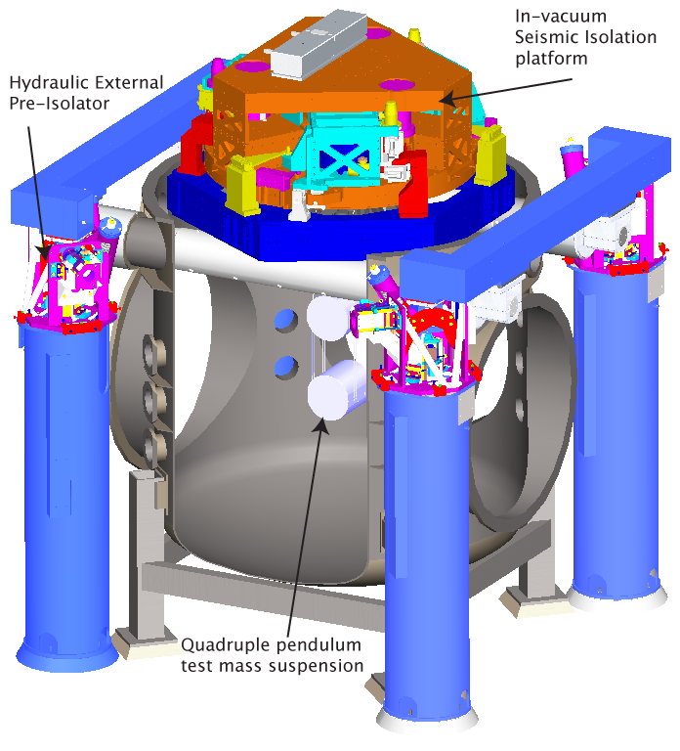
Figure 5 Rendering of the internal isolation system (ISI) installed in the BSC (test mass chambers), with a suspension system attached below. The external pre-isolator (HEPI) provides the interface between the vertical blue piers and the green horizontal support structure.
A similar design has been developed for the auxiliary optics HAM chambers, which uses the hydraulic external pre-isolator, and a single-stage system in the vacuum. The relaxed requirements for this chamber allow this simpler system, reducing cost and commissioning time.

R&D Status/Development Issues

A first-generation prototype of the in-vacuum isolation system has shown performance at low- and high-frequencies comparable to the requirements. The HEPI system was installed in LIGO Livingston before LIGO’s S4 science run, specially configured to reduce transmitted ground noise up to 2–3 Hz, in order to allow daytime operation in the presence of noise from local forestry and other human activity. A second-generation “technology demonstrator” prototype of the in-vacuum isolation (HAM configuration) has been built and tested at the Stanford Engineering Test Facility. It has been used to demonstrate the required noise floor of the critical stage 2 geophones, as well as the 12 degrees-of-freedom active noise reduction. The exercise has validated a servo topology that avoids tilt-horizontal coupling and allows compensation for imperfections in the mechanical plant, and has allowed development of techniques for coping with mechanical resonances in payload structures. It has also provided tests of the instrumentation performance to requirements.

Based on these results, a full-scale prototype of the test-mass BSC chamber in-vacuum isolator has been designed and fabricated. It has been assembled for fit-checks and to determine that the basic spring assembly functions correctly, and is (May 07) in the process of being cleaned for re-assembly and installation in the MIT LASTI test bed. With the completion of characterization of this unit, the Final Design can start in 1qFY08. Development of software to aid in the characterization and tuning of the servocontrols continues in parallel.

A design for the auxiliary optics HAM chamber isolators has also been completed, and is (May 07) out for bid for construction. Two units of this full-size prototype design will be built, to be installed in at the two LIGO Observatories as part of the enhancements to initial LIGO. Similarly, after characterization, Final Design starts in 2qFY08. A third system, to be used for integrations tests with suspensions and coordinated controls, will be built later and installed at the LASTI test bed.

5. Suspension Subsystem (SUS)

Overview

The test-mass suspension subsystem must preserve the low intrinsic mechanical losses (and thus the low thermal noise) in the fused silica suspension fibers and test mass. It must provide actuators for length and angular alignment, and attenuate seismic noise. The Advanced LIGO reference design suspension is an extension of the design of the GEO-600 Error: Reference source not found multiple pendulum suspensions, with requirements to achieve a seismic wall, in conjunction with the seismic isolation (SEI) subsystem, at ~10 Hz. A variety of suspension designs are needed for the main interferometer and input conditioning optics.

Functional Requirements

The suspension forms the interface between the seismic isolation subsystem and the suspended optics. It provides seismic isolation and the means to control the orientation and position of the optic. These functions are served while minimally compromising the thermal noise contribution from the test mass mirrors and minimizing the amount of thermal noise from the suspension elements.

The optic (which in the case of the main arm cavity mirror serves also as the test mass) is attached to the suspension fiber during the suspension assembly process and becomes part of the suspension assembly. Features on the test mass will be required for attachment. The test mass suspension system is mounted (via bolts and/or clamps) to the seismic isolation system by attachment to the SEI optics table.

Local signals are generated and fed to actuators to damp solid body motions of the suspension components and eddy current damping will be used to complement the active damping for some suspensions. In addition, control signals generated by the interferometer sensing/control (ISC) are received and turned into forces on the test mass and other masses in the multiple pendulums as required, to obtain and maintain the operational lengths and angular orientation. Such forces are applied by use of a reaction pendulum to reduce the reintroduction of noise through motion of the actuator. There are two variants of the test mass suspension: one for the End Test Mass (ETM) which carries potentially non-transmissive actuators behind the optic, and one for the Input Test Mass (ITM) which must leave the input beam free to couple into the Fabry-Perot arm cavity. There are also variants for the beamsplitter, folding mirror, and recycling mirrors; and for the mode cleaner, input matching telescope, and suspended steering mirrors.

Multiple simple pendulum stages improve the seismic isolation of the test mass for horizontal excitation of the pendulum support point; this is a valuable feature, but requires augmentation with vertical isolation to be effective. Vertical seismic noise can enter into the noise budget through a variety of cross-coupling mechanisms, most directly due to the curvature of the earth over the baseline of the interferometer. Simple pendulums have high natural frequencies for vertical motion. Thus, another key feature of the suspension is the presence of additional vertical compliance in the upper stages of the suspension to provide lower natural frequencies and consequently better isolation.

Further detail on requirements can be found in the Design Requirements Document.

Key parameters of the test-mass suspension design are listed in Table II; other suspensions have requirements relaxed from these values.

Table II Test-mass suspension parameters: quadruple pendulum
Suspension Parameter | Value
Test mass | 40 kg, silica
Penultimate mass | 40 kg, silica (lower quality)
Top and upper intermediate masses | 22 kg each, stainless steel
Test mass suspension fiber | Fused silica ribbon
Upper mass suspension fibers | Steel
Approximate suspension lengths | 0.6 m test mass, 0.3, 0.3 m intermediate stages, 0.4 m top
Vertical compliance | Trapezoidal cantilever springs
Optic-axis transmission at 10 Hz | ~ 2 x 10⁻⁷
Test mass actuation | Electrostatic (acquisition and operation)
Upper stages of actuation; sensing | Magnets/coils; incoherent occultation sensors

Concept/Options

The test mass mirror is suspended as the lowest mass of a quadruple pendulum as shown in Figure 6 the four stages are in series. Silica is the reference design mirror substrate material. However, the basic suspension design is such that sapphire masses could be incorporated with a modest level of redesign as a “fall-back” should further research favor its use. Both materials are amenable to low-loss bonding of the fiber to the test mass. The mass above the mirror— the penultimate mass— is made of lower-grade silica.

The top, upper intermediate and penultimate masses are each suspended from two cantilever-mounted, approximately trapezoidal, pre-curved, blade springs (inspired by and similar to the VIRGO blade springs), and four steel wires, of which two are attached to each blade. The blade springs are stressed to about half of the elastic limit. The upper suspension wires are not vertical and their lengths and angles gives some control over the mode frequencies and coupling factors.

Fused silica pieces form the break-off points for the silica ribbons at the penultimate and test masses. These pieces or ‘ears’ are attached to the penultimate and test masses using hydroxy catalysis bonding, which is demonstrated to contribute negligible mechanical loss to the system. A CO₂ laser-based machine has been developed for pulling the ribbons and for welding them to the ears.

Tolerable noise levels at the penultimate mass are within the range of experience on prototype interferometers (10⁻¹⁷ m/√Hz at tens of Hz) and many aspects of the technology have been tested in special-purpose setups and in the application of the approach to GEO-600. At the top-mass, the main concern is to avoid acoustic emission or creep (vibration due to slipping or deforming parts).

To meet the subsystem noise performance requirements when damping the solid-body modes of the suspension, sensors with sensitivity ~10⁻¹⁰ m/√Hz at 1 Hz and 0.7 mm peak-peak working range will be used in conjunction with suitable servo control algorithms with fast roll-off in gain, complemented by eddy current damping for some degrees of freedom.

Actuation will be applied to all masses in a hierarchy of lower force and higher frequency as the test mass is approached. Coils and magnets will be used on upper stages, and electrostatic actuation on the test mass itself (see Figure 7) with switchable high- and low-force (and hence noise) modes for acquisition and operation respectively.

Other suspended optics will have noise requirements that are less demanding than those for the test masses, but still stricter than the initial LIGO requirements, especially in the 10-50 Hz range. Their suspensions will employ simpler suspensions than those for the test masses, such as the triple suspension design for the mode cleaner mirrors (see Figure 8).

More design detail can be found in additional subsystem documentation.
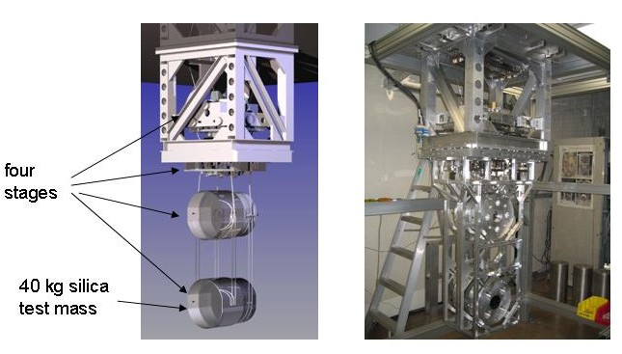
Figure 6 Left: schematic diagram of quadruple suspension showing main chain and parallel reaction chain for interferometer control actuation, with lower support structure removed for clarity. Right: all-metal controls prototype under test at Caltech, presently installed at the MIT LASTI testbed

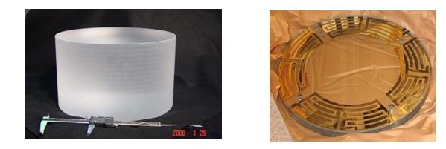
Figure 7 Left: full-size silica test mass (unpolished) procured with UK funding. Right: gold coated glass plate for testing electrostatic actuation in the controls prototype quadruple suspension
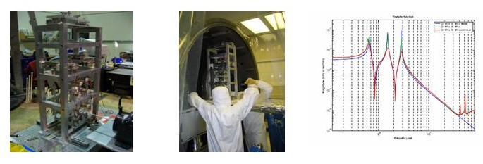
Figure 8 Left and middle: prototype modecleaner mirror triple suspension being bench tested and being installed for further test at the LASTI facility. Right: Longitudinal transfer function top mass drive to top mass position for modecleaner -green (damping off, red (damping on), blue: MATLAB model

R&D Status/Development Issues

The SUS effort within the LSC is spread widely over several institutions including a major contribution from the UK. A consortium of the University of Glasgow and the University of Birmingham was successful in securing UK funding of ~ $12M from the Science and Technology Facilities Council (STFC) to supply the test-mass and beamsplitter suspensions for Advanced LIGO, and funding started in 2003, with delivery of 4 test mass blanks already completed (see Figure 7). The GEO group at the University of Glasgow is the originator of GEO suspension design, and thus the UK team is very well positioned to carry through this effort, working in close collaboration with the US team. Other suspensions are the responsibility of the US members of SUS.

The primary role of the suspension is to realize the potential for low thermal noise, and much of the research into suspension development explores the understanding of the materials and defines processes to realize this mission. In addition, design efforts ensure that the seismic attenuation and the control properties of the suspension are optimized, and prototyping efforts ensure that the real performance is understood.

The GEO-600 suspensions utilizing the basic multiple-pendulum construction, fused-silica fibers, and hydroxy-catalysis attachments, have been in service since 2001. The systems have been reliable and the controls function essentially as modeled. Lessons learnt from the design, construction, installation and operation of the suspensions have been noted for application to the Advanced LIGO designs.

An all-metal prototype quadruple suspension for the test mass has been constructed in Caltech. This prototype is designed to allow investigation of mechanical design, control aspects and installation and alignment procedures. In parallel, design in the UK of a “noise” prototype with silica suspensions and silica mirror is complete, and in fabrication. The design builds on the experience being gained from constructing and testing the controls prototype. The prototype is due to be shipped to LASTI in mid-2007, for integration with the seismic isolation system. The LIGO-UK Suspension team works collaboratively on all of these efforts.

Two all-metal triple pendulum prototypes (Figure 8) for modecleaner mirrors have been constructed and assembled at Caltech for initial tests, and subsequently sent to LASTI where full characterization of its behavior including comparison with computer models has been successfully completed. The two suspensions are being used in an optical cavity to study cavity locking and controls.

The design for the Output Mode Cleaner suspension has been completed, and the first of two copies fabricated for characterization, and subsequent use in the enhancements to Initial LIGO.

Remaining work in the development phase focuses in the UK on the FM/BS configuration, to develop a combined input test mass suspension with the mirror used to enable the second interferometer at Hanford and to suspend the beamsplitter. The design is nearing completion, and the prototyping will commence 4qFY07. In the US, the design for the recycling mirrors will be completed and prototyped (mid FY08). This suspension will be tested in the MIT LASTI testbed in integration with the seismic isolation systems installed there.

6. Pre-Stabilized Laser Subsystem (PSL)

Overview

The Advanced LIGO PSL will be a conceptual extension of the initial LIGO subsystem, operating at the higher power level necessary to meet the required Advanced LIGO shot noise limited sensitivity. It will incorporate a frequency and amplitude stabilized 180 W laser. The Advanced R&D program related to this subsystem has developed rod optical gain stages that are used with an injection-locked power oscillator.

Functional Requirements

The main requirements of the PSL subsystem are output power, and amplitude and frequency stability. lists the reference values of these requirements. Changes in the readout system allow some requirements to be less stringent with respect to initial LIGO; the higher power and extension to lower frequency provides the principal challenge.

Table III PSL Requirements
Requirement | Value
TEM00 Power | 180 W
Non-TEM00 Power | <5 W
Frequency Noise | 10 Hz/Hz^{1/2} (10 Hz)
Amplitude Noise | 2×10-9 /Hz^{1/2} (10 Hz)
Beam Jitter | 2×10-6 rad/Hz^{1/2} (100 Hz)
RF Intensity Noise | 3dB above shot noise of 50mA above 9MHz

TEM₀₀ Power: Assuming an optical throughput of 0.72 for the input optics subsystem, the requirement of 120 W at the interferometer input gives a requirement of 165 W PSL output.
Non-TEM₀₀ Power: Modal contamination of the PSL output light will mimic shot noise at the mode cleaner cavity, producing excess frequency noise. A level of 5 W non-TEM₀₀ power is consistent with the input optics frequency-noise requirements.
Frequency Noise: Frequency noise couples to an arm cavity reflectivity mismatch to produce strain noise at the interferometer signal port. The requirement is obtained based on a model with an additional factor of 10⁵ frequency noise suppression from mode cleaner and interferometer feedback, a 0.5% match in amplitude reflectivity between the arm cavities (a conservative estimate for the initial LIGO optics), and a signal recycling mirror of 10% transmissivity.
Amplitude Noise: Laser amplitude noise will mimic strain noise in two main ways. The first is through coupling to a differential cavity length offset. The second and larger coupling is through unequal radiation pressure noise in the arm cavities. Assuming a beamsplitter of reflectivity 50±1%, the requirement is established.
Beam Jitter Noise: The coupling of beam jitter noise to the strain output is through the interferometer optics misalignment. Based on a model of a jitter attenuation factor of 1000 from the mode cleaner, a nominal optic alignment error of 10⁻⁹ rad rms imposes the requirement on higher order mode amplitude.
RF Intensity Noise: The presence of intensity noise at the RF modulation frequency can couple via auxiliary control loops into strain noise. The noise is limited with the requirement above.

Concept/Options

The conceptual design of the Advanced LIGO PSL is similar to that developed for initial LIGO. It will involve the frequency stabilization of a commercially engineered laser with respect to a reference cavity. It will include actuation paths for coupling to interferometer control signals to further stabilize the beam in frequency and in intensity.

The front end for the Advanced LIGO Laser is based on the proven GEO600 laser. A rod-based amplifier increases the output of a monolithic non-planar ring oscillator, producing ~35 W. The high-power laser is based on a ring-resonator design with four end-pumped laser heads. Each laser head is pumped by ten 30 W fiber-coupled laser diodes. Each laser diode is individually temperature stabilized to minimize the linewidth of each fiber bundle. To improve the laser diode reliability and lifetime, the output power of each laser diode is de-rated by one-third. A fused silica rod homogenizes the transverse pump light distribution due to the spatial mixing of the rays emerging from the different fibers. This minimizes changes to the pump light distribution in the event of a pump diode failure or degradation. Thus failure of a pump diode can be compensated for by increasing the operating current for the remaining pump diodes. Three lenses then image the output of the homogenizer into the laser crystal. The Advanced LIGO laser is illustrated in Figure 9

The optical layout of the PSL has four main components: the 180-W laser, a frequency stabilization path including a rigid reference cavity; an acousto-optic modulator as an actuator for the second frequency stabilization loop; a spatial filter cavity and a diagnostic path that permits investigation of the laser behavior without any disturbance to the output of the PSL. The output of the 180-W laser is spatially filtered by a small triangular ring cavity prior to being mode-matched into the suspended modecleaner.

A sample of the spatially filtered output is mode matched to the rigid reference cavity used for frequency stabilization. The scheme used is identical to that used in initial LIGO.

Two more beam samples, taken before and after the suspended modecleaner are used for the power stabilization. The baseline plan for power stabilization of the PSL is to actuate on the pump diode current to control the intensity of the laser by use of a current shunt.

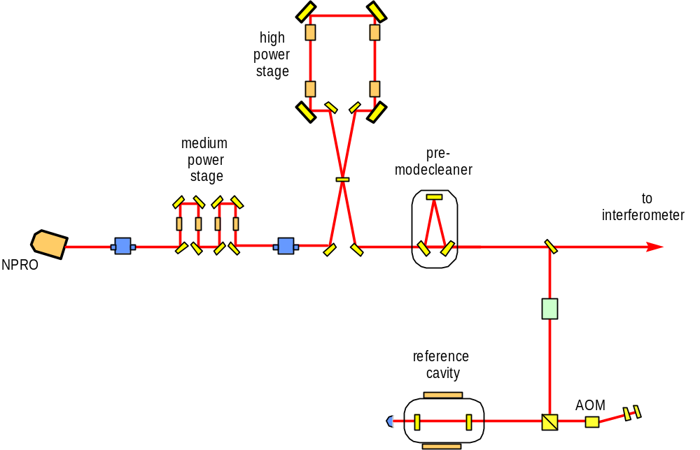
Figure 9 Schematic of the Advanced LIGO PSL.

R&D Status/Development Issues

A successful Conceptual Design Review for the PSL was held at the March 2005 LIGO Scientific Collaboration meeting. The PSL is currently in the preliminary design phase.

At present work is continuing on improving and characterizing the design of the 180-W laser. Some minor problems have been encountered relating to cleanliness issues around the laser optics but these have been resolved. Issues concerning interfacing the 180-W laser with the Advanced LIGO CDS electronics, such as interfaces and sample rates, are being addressed.

An Innolight non-planar ring oscillator (NPRO) laser, similar to that used by Laser Zentrum Hannover, was acquired for testing of the planned digital control electronics. Experience gained with the initial LIGO PSL intensity stabilization suggests that a digital implementation of the servo design is desirable for maximum flexibility. A suitable digital signal processor (DSP) board from Xilinx has been identified and will be used in a technology demonstration testbed.

Progress has been made in further understanding the noise sources that limit the performance of the intensity stabilization at low frequencies. The results achieved at the Albert Einstein Institute to date are RIN=5x10⁻⁹/√Hz@10Hz and 3.5x10⁻⁹/√Hz [60Hz - 8kHz], both out-of-loop measurements, and so are close to meeting the Advanced LIGO requirement of 1/10 of the strain noise at those frequencies.

An effort with an industrial partner, the Laser Zentrum Hannover, similar to our practice in initial LIGO, is underway to engineer a reliable unit that will meet the LIGO availability goal. Tests of a complete full-power PSL will be made in Germany in early FY09. The PSL subsystem design work will proceed in parallel with the laser work, including the intensity stabilization system will be ‘wrapped around’ the entire high power laser in this test. Installation, Standard Operating Procedure, and Safety documentation will be completed, enabling the Final Design Phase in early FY09. The complete subsystem will be ready for installation in early 2011.

The Max Planck Institute for Gravitational Wave Research/Albert Einstein Institute in Hannover, Germany will supply the PSL systems for Advanced LIGO as a German contribution to the partnership in Advanced LIGO. The Max-Planck-Gesellschaft has approved funding for both the development (which is underway) and construction phase. As part of this contribution, the enhancements to initial LIGO, planned to follow the completion of the S5 science run, will include the implementation of the first two stages of the Advanced LIGO laser (increasing the available power from ~10W to ~30W), and will yield considerable experience with the lasers and their interface. The first of these lasers will be delivered to Caltech in summer 2007.

7. Input Optics Subsystem (IO)

Overview

The Advanced LIGO Input Optics (IO) subsystem will be an extension of the initial LIGO Input Optics design, with the higher specified power and the lower noise level required by Advanced LIGO. The IO will consist primarily of beam conditioning optics including Faraday Isolators and phase modulators, a triangular input mode cleaner, and an interferometer mode-matching telescope.

Functional Requirements

The functions of the IO subsystem are to provide the necessary phase modulation of the input light, to filter spatially and temporally the light on transmission through the mode cleaner, to provide optical isolation as well as distribution of interferometer diagnostic signals, and to mode match the light to the interferometer with a beam-expanding telescope. Table IV lists the requirements on the output light of the Advanced LIGO IO subsystem.

Table IV Advanced initial LIGO requirements
Requirement | Value
Optical Throughput | 0.67 (net input to TEM₀₀ out)
Non-TEM₀₀ Power | <5%
Frequency Noise | 3×10⁻³ Hz/ Hz^{1/2} (at 10 Hz)
Beam Jitter (relative to beam radius/divergence angle) | < 4 ×10⁻⁹ / Hz^{1/2} (f > 200 Hz)

The Input Optics has to deliver 120 W of conditioned power to the advanced LIGO interferometer. The optical throughput requirement ensures that the required TEM₀₀ power will be delivered. The cavities of the main interferometer will accept only TEM₀₀ light, so the IO mode cleaner must remove higher-order modes and its beam-expanding telescope must couple 95% of the light into the interferometer.

The IO reduces the frequency, and beam-jitter noise of the laser. The suspended mode cleaner serves as an intermediate frequency reference between the PSL and interferometer. Beam jitter (pointing fluctuation) appears as noise at the interferometer output signal through optical misalignments and imperfections. The nominal optic alignment error of 1×10⁻⁹ rad imposes the requirement in Table 4. Further details can be found in the IO Design Requirements document.

Concept/Options

The schematic layout of the IO is displayed in Figure 10, showing the major functional components. The development of the IO for Advanced LIGO will require a number of incremental improvements and modifications to the initial LIGO design. Among these are the needs for larger mode cleaner optics and suspensions to meet the Advanced LIGO frequency noise requirement, cross-product free modulation spectrum (with no sidebands-on-sidebands), increased power handling capability of the Faraday Isolator and phase modulators, and the ability to adaptively control the laser mode structure into the interferometer.

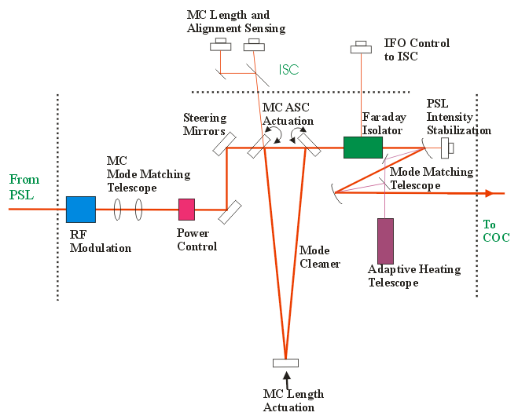
Figure 10 Schematic diagram of the Advanced LIGO Input Optics (IO) subsystem.
Phase modulation for use in the length and angle sensing systems is applied using electro-optic crystals. Faraday isolators are used to prevent parasitic optical interference paths to the laser and to obtain information for the sensing system.

The mode cleaner is an in-vacuum suspended triangular optical cavity. It filters the laser beam by suppressing directional and geometric fluctuations in the light entering the interferometer, and it provides frequency stabilization both passively above its pole frequency and actively through feedback to the PSL. Noise sources considered in design studies include sensor/actuator and electronic noise, thermal, photothermal, and Brownian motion in the mode cleaner mirrors, and radiation pressure noise. The mode cleaner will use 15-cm diameter, 7.5-cm thick fused silica mirrors. The cavity will be 16.7 m in length, with a finesse of 2000, maintaining a stored power of ~100 kW. A triple pendulum (part of the suspensions subsystem) will suspend the mode cleaner mirrors so that seismic and sensor/actuator noise does not compromise the required frequency stability.

Finally, the mode-matching telescope, which brings the beam to the final Gaussian beam parameters necessary for interferometer resonance, will be similar to the initial LIGO design using three spherical mirrors, but will use an auxiliary CO₂ laser to adjustably control the effect radius of curvature of the mirrors for in-situ adjustment of mode matching without the need for vacuum excursions. This design allows for optimization of mode-matched power by having independent adjustment of two degrees of freedom, waist size and position, over a wide range of modal space.

Further documentation of the design can be found in the Input Optics Conceptual Design Document and Preliminary Design Document and references therein.

R&D Status/Development Issues

The IO subsystem completed its Design Requirements and Conceptual Review in May 2002 and the Preliminary Design Review in May 2007. Major development efforts within the IO focus on optical components capable of handling high power (180 W level), including the development of the Faraday Isolators, phase modulators, as well as thermal modeling of the mode cleaner and mode-matching telescope.

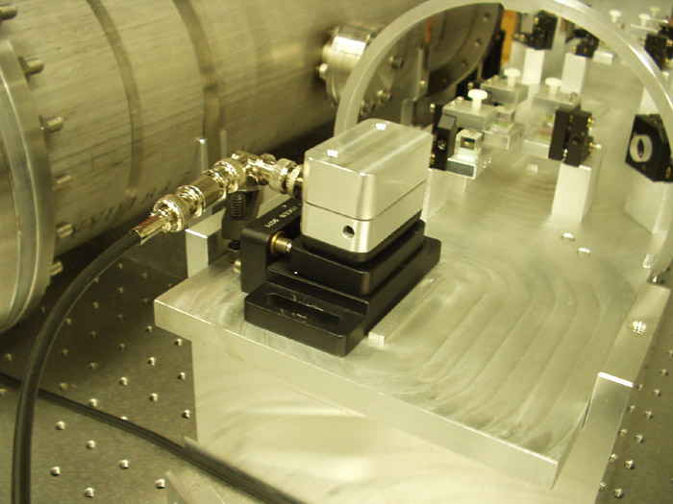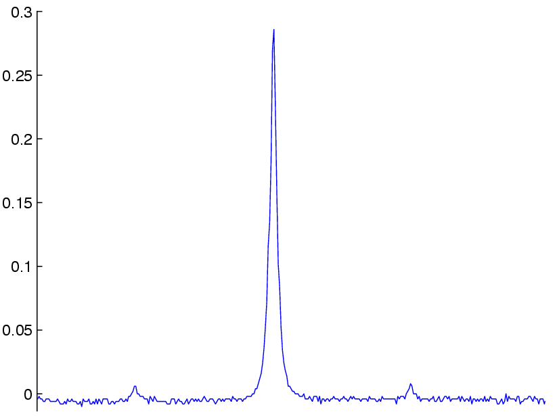
Figure 11 The Advanced LIGO electro-optic modulators with modulated spectrum shown in the inset.
We have developed electro-optic modulators based on rubidium titanyl arsenate (RTA) and rubidium titanyl phosphate (RTP) electro-optically active crystals. We have characterized the thermo-optic and electro-optic performance of our modulators at powers up to 100 W and power densities exceeding Advanced LIGO conditions. Negligible absorption and thermal lensing as well as high electro-optic efficiency were observed, and we have operated these modulators at high powers for over 300 hours with no change in performance. In addition, we are investigating methods for synthesizing pure sideband modulation spectra based on both Mach-Zehnder and amplitude/phase modulation methods. Efforts to date have focused on defining requirements for MZ technical noise limits, fabrication and characterization of a prototype MZ (servo requirements), and developing serial AM/PM methods for synthesizing pure sideband spectra.

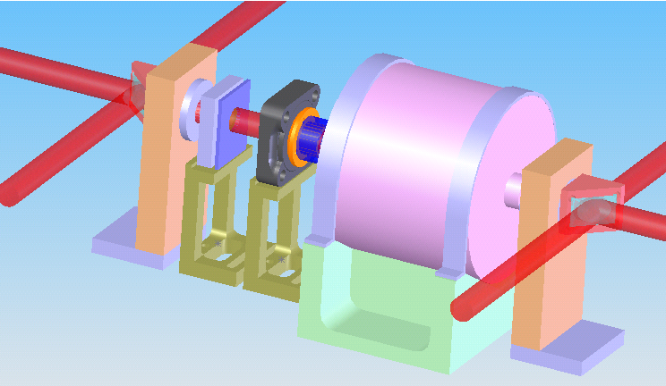
Figure 12 Schematic drawing of the Faraday Isolator, showing from right (beam entrance) to left i) initial polarizer, ii) Faraday rotator, iii) 1/2 waveplate, iv) thermal lens compensator, and v) final polarizer.

For the mode cleaner, we have finished the optical design and analyzed its thermal performance using Melody combined with finite element modeling to better understand the effects of optical absorption on the mode quality of the interferometer. The coating absorption dominates the thermal effect due to high intra-cavity powers. Absorption levels 0.5 ppm or less preserve transmitted mode quality at 165 W input powers. The relatively compact design of the mode cleaner cavity produces small spot sizes on the mirrors with average intensities of approximately 700 kW/cm². This is below the quoted damage threshold for tantala/silica supermirrors (approximately 1 MW/cm²). However, the intensity is sufficiently high that we are investigating the long term effects of high intensity exposure. In addition, we are examining ways to reduce the mode cleaner finesse using active stabilization on the input beam to the mode cleaner

For the Faraday Isolator, we have addressed both wavefront distortion (thermal lensing) and depolarization through a new design capable of providing compensation for polarization distortion and high isolation ratios up to the maximum test power of 160 W as shown in Figure 12. Using a negative dn/dT material (deuterated potassium dihydrogen phosphate) to introduce negative lensing, we achieved significant compensation of the thermal lens in the Faraday isolator, with the system focal length increasing from ~ 7 m to > 40 m at 75 W power levels.

To address control of the mode matching, we have developed and characterized an adaptive mode matching telescope for Advanced LIGO. It relies on controlled optical path deformation in the in-vacuum Faraday Isolator. Four radial heating elements allow both focus and astigmatism to be adjusted, and can be adjust the matching to the Core Optics for a range of input power to the interferometer.

The IO subsystem lead role will remain with the University of Florida group who built the IO for initial LIGO. Fabrication of prototype high power Faraday Isolators and phase modulation methods has been proceeding under the University of Florida Advanced R&D program. Advanced LIGO performance level modulators and isolators will be used for the initial LIGO enhancements to follow the S5 science run. Design of the adaptive telescope is underway, as well as the layout of the entire optical system. Stand-alone tests of modulator phase and amplitude noise, completion of the adaptive mode matching telescope design, and damage studies of optical coatings in mirrors are currently underway. The Faraday Isolator and modulator designs are to be employed in the enhancements to LIGO at the 35 W power level used there, giving excellent feedback on their utility in situ. The Mach-Zehnder modulation system is in test at the Caltech 40m interferometer testbed. The testing of the triple suspension planned for the Mode Cleaner at the MIT LASTI testbed gives confidence in that design and the controls for locking the mode-cleaner cavity.

The remaining development for the Input Optics system is ‘clean up’ from the recencly completed review, and incorporating any lessons learned from the installation, characterization, and use of the components in the enhancements to Initial LIGO. Final Design will commence in 4qFY08.

8. Core Optics Components (COC)

Overview
The Advanced LIGO COC will involve an evolution from the initial LIGO COC to meet the higher power levels and improved shot-noise and thermal-noise limited sensitivity required of the Advanced LIGO interferometer. Many of the fabrication techniques developed for the fused silica initial LIGO COC will be directly applicable to the optics production. However, a larger mass is needed to keep the radiation reaction noise to a level comparable to the suspension thermal noise, and a larger surface reduces the thermal noise. The optical coatings must also undergo development to achieve the combination of low mechanical loss (for thermal noise) while maintaining low optical loss. Reduction of mechanical loss in coatings has a direct impact on the Astrophysical reach of Advanced LIGO.

Functional Requirements
The COC subsystem consists of the following optics: power recycling mirror, signal recycling mirror, beam splitter, folding mirror, compensation plate, input test mass, and end test mass (see Figure 13). The following general requirements are placed on the optics:

- the radius of curvature and surface figure must maintain the TEM₀₀ spatial mode of the input light;
- the optics microroughness must be low enough to limit scatter to acceptable levels;
- the substrate and coating optical absorption must be low enough to limit the effects of thermal distortion on the interferometer performance;
- the optical homogeneity of the transmitting optics must be good enough to preserve the shape of the wavefront incident on the optic;
- the intrinsic mechanical losses, and the optical coating mechanical losses, must be low enough to deliver the required thermal noise performance

Table V lists the COC test mass requirements.

Table V COC test mass requirements
Mass | 40Kg
Dimensions | 340mm x 200mm
Surface figure  (deviation from sphere over central 12 cm) | < 1 nm RMS
Micro-roughness | < 0.1 nm RMS
Optical homogeneity  (in transmission through 15 cm thick substrate,  over central 8 cm) | < 20 nm rms, double pass
Bulk absorption | < 3 ppm/cm
Bulk mechanical loss | < 3 10⁻⁹
Optical coating absorption | 0.5 ppm (required)  0.2 ppm (goal)
Optical coating scatter | 2 ppm (required)  1 ppm (goal)
Optical coating mechanical loss | 2 10⁻⁴ (required)  3×10⁻⁵ (goal)

Requirements Documents

LIGO-T000127-01 COC Design Requirements Document
LIGO-T000128-02 COC Development Plan
LIGO-T000098-02 Conceptual Design Document
LIGO-C030187-01 Coating Development Plan
LIGO-T030233 Coating Test Plan

Concept

Advanced LIGO will draw on initial LIGO core optics design. Low optical absorption fused silica is the material chosen for the input and end test mass material. The initial LIGO optics far exceeded many of the specifications for Advanced LIGO; it is assumed that we will be able to acheive similar results as for LIGO1, but over a larger area and volume. A polishing demonstration program is underway with several vendors to scale the LIGO1 approach to 40 kg sizes. Some work is required to ensure acceptable mechanical losses of fused silica in large substrates, although very low losses have been seen in smaller samples and scaling laws with volume and surface are understood. The required material properties of fused silica do imply reliance on the thermal compensation system (see 9. Auxiliary Optics Subsystem (AOS)).

The beam splitter requirements are met by the best presently available low absorption fused silica. Due to the large aspect ratio of the beamsplitter there is a coating demonstration program to ensure the stress of the coating can be compensated in order to preserve the flatness of the beamsplitter.

The very long lead time for production of substrates, for polishing, and for coating requires early acquisition in the Advanced LIGO schedule.

R&D Status/Development Issues

Four 40kg input test mass blanks have been received from the UK as part of their PPARC-funded contribution to Advanced LIGO. The blanks are Heraeus 311 material, a low absorption, ultra homogeneous fused silica. These blanks are being used in the development phase for the polishing pathfinder demonstration, and then subsequently processed as Advanced LIGO test masses in the Project phase.

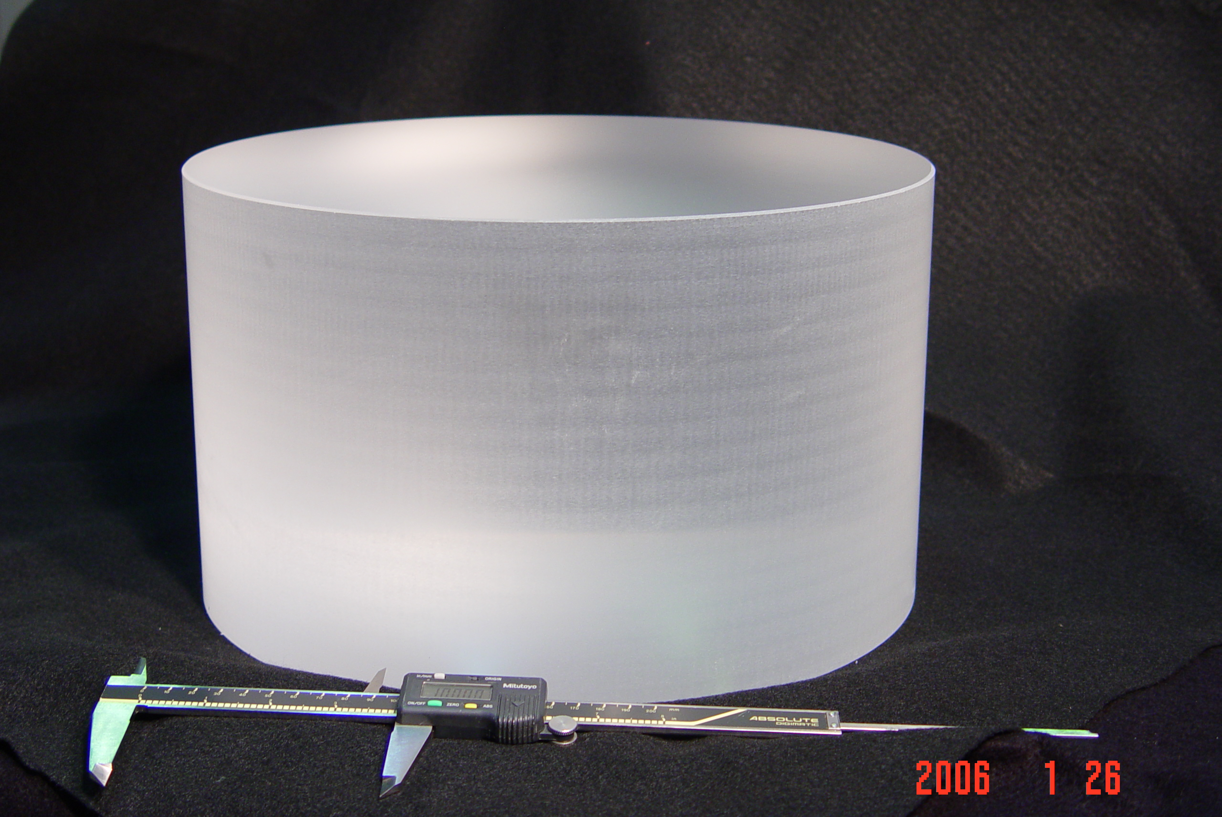
Figure 13 40kg Input test mass blank, supplied by University of Glasgow.
A very active program involving several commercial vendors to characterize and reduce the mechanical loss in the coatings has made progress. The principal source of loss in conventional optical coatings has been determined by our research to be associated with the tantalum pentoxide, likely due to material. Doping of the tantala with titania is the most promising coating developed, with significantly lower thermal noise and optical properties near requirements. Silica doped titania is also a promising high index material. Further development of both of these materials along with research into new materials and processes is planned with multiple vendors. We had a goal of an approximate factor of ten reduction in the mechanical loss found in standard low-optical-loss coatings, as a coating mechanical loss at this level would lead to a coating thermal noise which does not play a significant role in the net sensitivity of the instrument. We have seen reductions of 2.5 in selected samples of exploratory coatings. The current level of mechanical loss would be acceptable, but as improvements translate directly into improved astrophysical reach, we will continue to pursue this avenue.

An early test of the ability to coat full-size pieces is underway, with a prototype test mass to be used in the integration tests of the optics, suspensions, and seismic isolation. While the polish of this mass is not to the final requirements, it gives an opportunity to test handling, cleaning, and metrology processes at one vendor.

Studies of charging of the test mass and means to mitigate it are proceeding. Several university groups are pursuing the measurement of charge and its relaxation time on clean silica surfaces to set the scale of the problem, and others are investigating means to remove the charge through exposure to UV light or a very slightly conductive coating on the test mass.

Scattering from the surfaces of the initial LIGO optics has received attention, as the round-trip losses of those cavities are greater than anticipated. Two sources of greater loss have been identified: point scatterers, perhaps due to insufficient cleaning in preparation for coating; and (through improved numerical modeling) greater impact from microroughness. These findings will be folded into the specifications for the optics and their remediation will be investigated in the pathfinder.

The polishing pathfinder process is underway, with two vendors currently polishing and a search for a third starting. Polishing of high precision optics is currently limited by metrology. The polishing pathfinder will provide the opportunity for three vendors to polish a full size LIGO test mass. Performance on this task will be weighed alongside vendor proposals to determine qualified polishers for Advanced LIGO. This is planned to wrap up in 1qFY08.

The purpose of the beamsplitter/fold mirror pathfinder is different from the polishing pathfinder. Optics of high aspect ratio are known to warp under the compressive stress of ion beam coatings. This change must be compensated in order to provide sufficiently flat optical surfaces. The compensation will be accomplished either by coating the back side of the optic with an equally stressful coating, by annealing, or by pre-figuring the optic slightly concave so that the resulting optic is flat. This pathfinder is planned to finish in 3qFY08.

The compensation plate, used in the thermal compensation system (see AOS), also is being prototyped; it is currently in fabrication (May 07), and will be delivered to LASTI for integration with the suspension system in 4qFY07.

The time scale for developing a satisfactory coating, with appropriate optical and mechanical losses, is associated with the commencement of coatings on the production optics about one year into the Project, or 1qFY09. Development of a titania doped tantala coating with satisfactory optical properties is a priority. Further development of silica doped titania and explorations of new materials will also be pursued.

9. Auxiliary Optics Subsystem (AOS)

Overview

The AOS for Advanced LIGO is an extension of this subsystem for initial LIGO, modified to accommodate the planned higher laser power and additional signal-recycling mirror. The AOS is responsible for transport of interferometer output beams and for stray light control. It includes suspended pick-off mirrors, beam reducing telescopes, and beam dumps and baffles. AOS also has responsibility for providing optical lever beams for all the suspended optics, and for establishing the initial alignment of the interferometer. An additional element of this subsystem is active optics thermal compensation, where compensatory heating of an optic is used to cancel thermal distortion induced by absorbed laser power. It also includes the photon calibrator, which uses light pressure to apply precise calibration forces to the end test masses of the interferometer.

Functional Requirements

The conventional subsystem requirements relate to control of interferometer ghost beams and scattered light, delivery of interferometer pickoff beams to the ISC subsystem, and maintenance of the surface figure of the core optics through active thermal compensation. While the requirements on these elements are somewhat more stringent than for the initial LIGO design, no significant research and development program is required to meet those requirements.

An additional important element is that of active thermal distortion compensation. The requirements for this component are numerically determined as part of the systems flowdown. The axisymmetric thermal lens must be corrected sufficiently to allow the interferometer to perform a “cold start”; the compensation may also be required to correct for small (cm-) scale spatial variations in the substrate absorption.

Concept/Options

The AOS conventional elements consist of low-aberration reflective telescopes that are placed in the vacuum system to reduce and relay the output interferometer beams out to the detectors, and baffles of absorptive black glass placed to catch stray and “ghost” (products of reflections from the residual reflectivity of anti-reflection coatings) beams in the vacuum system. The elements must be contamination-free and not introduce problematic mechanical resonances. Because of the increased interferometer stored power, the AOS for Advanced LIGO will involve careful attention to control of scattered light, and will require greater baffling and more beam dumps than for initial LIGO.

The thermal compensation approach involves adding heat, which is complementary to that deposited by the laser beam, using two complementary techniques: a ring heater that deals with circularly symmetric distortions, and a directed laser that allows uneven absorption to be corrected. For the input test masses, a compensation plate receives the complementary heating pattern.

R&D Status/Development Issues

Development of active optic thermal compensation is proceeding under the LIGO advanced R&D program. Models of the thermal response of the interferometer in a modal basis and via numerical propagation using Huygen’s principle are used extensively to make predictions for the deformations and of the possible compensation. A prototype has successfully demonstrated thermal compensation, in excellent agreement with the model, using both the ring heater and directed laser techniques. In a transfer of technology from Advanced LIGO R&D to initial LIGO, the instruments are currently using CO₂ laser projectors on the input test masses of all three interferometers for thermal compensation both of the interferometers’ self-heating and of their static mirror curvature errors. This experience is teaching us a great deal about servo control methods for thermal compensation and allowed us to measure compensator noise injection mechanisms (see Figure 15 and Figure 15).
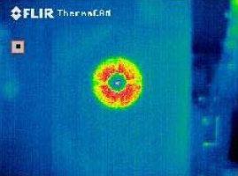
Figure 14 An initial LIGO thermal compensation pattern.
The photon calibrator will be redesigned to employ Nd:YAG lasers, which are more reliable than the Nd:YLF lasers currently in use. This will require the photon calibrator laser to be offset-locked from the main carrier laser to prevent scattered light coherence, but this is not difficult to implement.

The thermal compensation development program needs to complete the Conceptual Design phase, at which point a prototype of the thermal compensation system will be fabricated, installed in the LASTI Testbed, and exercised using a CO₂ beam to emulate the thermal loading from the main Nd:YAG beam. Designs for the ‘conventional’ elements of the subsystem are moving forward; the Preliminary Design will be reviewed in 1qFY08. Final design starts a year later in 1qFY09.

.
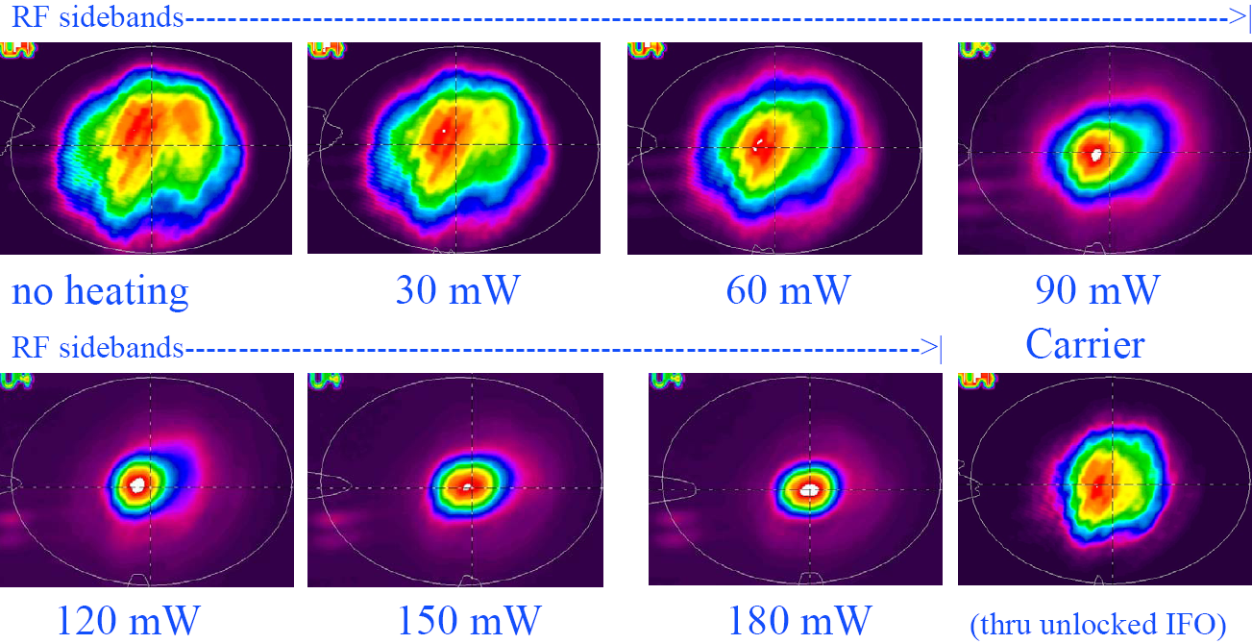
Figure 15 RF sideband mode shape control using thermal compensation.
Note the optimum overlap between RF sideband and carrier mode at 90 mW heating power.

Work on the active optics thermal compensation is proceeding under the advanced R&D program. A testbed thermal compensation system is under test in the ACIGA Gingin facility in 2005; while their compensator design is not adaptable to Advanced LIGO, they use a Hartmann sensor developed at our LSC collaborator Adelaide University to detect thermal aberrations, which is being adopted as a component for Advanced LIGO, and they are gaining valuable experience in thermal sensing and compensation of high-power suspended cavities.

As a further exercise of the designs for Advanced LIGO, plans are being implemented for thermal compensation for the increased power levels to be used in enhancements to initial LIGO after the S5 science run. A prototype test of the Advanced LIGO thermal aberration sensors will be implemented at the MIT LASTI testbed, where an optic (as part of the optics-suspension-isolation integration exercise) will be thermally loaded with a CO₂ beam and the wavefront characterized with the Hartmann sensor.

Photon calibrators have been used on the LIGO interferometers for several years, and adaptation to Advanced LIGO is not expected to pose any difficulty.

A reduction in the angle-sensing jitter of the present optical lever system, due to displacement/tilt cross-coupling of sensed mirror surfaces, was demonstrated with a prototype optical lever receiver telescope which was developed for Advanced LIGO. The design process for the beam dumps, baffles, reducing telescopes will resemble that for enhancements to the initial LIGO design, allowing in-situ tests of the approaches planned.

10. Interferometer Sensing and Controls Subsystem (ISC)

Overview

This subsystem comprises the length sensing and control, the alignment sensing and control, and the overall controls infrastructure modifications for the Advanced LIGO interferometer design. The infrastructure elements will be modified to accommodate the additional control loops in the reference design. The most significant differences in the Advanced LIGO subsystem are the addition of the signal recycling mirror and the resulting requirements on its controls, the addition of an output mode cleaner in the output port, and the implementation of homodyne, or DC, readout of the gravitational wave channel.

Functional Requirements

Table VI lists significant reference design parameters for the interferometer length controls.

Table VI Significant Controls Parameters
Configuration | Signal and power recycled Fabry-Perot Michelson interferometer
Controlled lengths | differential arm length (GW signal)  near-mirror Michelson differential length  common-mode arm length (frequency control)  power recycling cavity resonance  signal recycling mirror control
Controlled angles | 2 per core optic, 14 in total
Main differential control requirement | 10⁻¹⁴ m rms
Shot noise limited displacement sensitivity | 4×10⁻²¹ m/√Hz
Angular alignment requirement | 10⁻⁹ rad rms

The requirements for the readout system are in general more stringent than those for initial LIGO. The differential control requirement is a factor of 10 smaller, as is the angle requirement, and the additional degrees of freedom add complexity. Integration with the thermal compensation system and the gradual transition from a “cold” to a “hot” system will be needed.

In spite of the increased performance requirements for Advanced LIGO, significant simplification in the controls system is foreseen because of the large reduction in optic residual motion afforded by the active seismic isolation and suspension systems. Reduced core optic seismic motion can be leveraged in two ways. First, the control servo loop gain and bandwidth required to maintain a given RMS residual error can be much smaller. Second, the reduced control bandwidths permit aggressive filtering to block leakage of noisy control signals from imperfect sensor channels into the measurement band above 10 Hz. While control modeling is just getting started, this latter benefit is expected to significantly relieve the signal-to-noise constraints on sensing of auxiliary length and alignment degrees of freedom.

The length sensing system requires that non-TEM₀₀ and RF sideband light power at the antisymmetric output port be reduced substantially to allow a small local-oscillator level to be optimal and thus to maintain the efficiency of the overall shot-noise-limited sensing. This is the function of the output mode cleaner.

Concept/Options

The signal-recycled configuration is chosen to allow tunability in the response of the interferometer. This is useful for the broadband tuning to control the balance of excitation of the mirrors by the photon pressure, and the improvement in the readout resolution at 100-200 Hz. A narrow-band instrument (to search for a narrow-band source, or to complement a broad-band instrument) can also be created via a change in the signal recycling mirror transmission. An example of possible response curves for a single signal recycling mirror transmission is shown in Figure 16.

Another important advantage of the signal recycled configuration is that the power at the beamsplitter for a given peak sensitivity can be much lower; this helps to manage the thermal distortion of the beam in the beamsplitter, which is more difficult to compensate due to the elliptical form of the beam and the significant angles in the substrate.

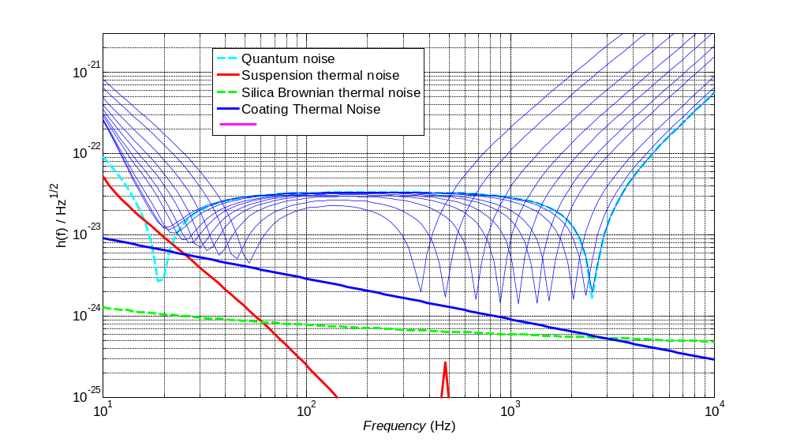
Figure 16 Equivalent strain noise curves for a narrowband interferometer. By changing from a signal recycling mirror optimized for broadband operation to one chosen to give optimum performance around 800 Hz, good performance at a selected frequency between ~400–2000 Hz can be achieved by tuning the signal recycling mirror position microscopically; the set of curves shown span a signal recycling mirror motion of less than a micron. At the lower end of the range, coating thermal noise limits the performance; at higher frequencies, above ~500 Hz, the quantum noise limits the best performance (modeled using Bench)

Most length sensing degrees-of-freedom will be sensed using RF sidebands in a manner similar to that in initial LIGO. However, for the gravitational-wave output, a baseband (‘DC’) rather than synchronous modulation/demodulation (‘RF’) approach will be used. The output of the interferometer is shifted slightly away from the dark fringe and deviations from the setpoint become the measure of the strain. This approach considerably relaxes the requirements on the laser frequency; the requirement on baseband intensity fluctuations is not different from the case of RF detection. A complete quantum-mechanical analysis of the two readout schemes has been undertaken to determine which delivers the best sensitivity, and the requirements imposed on the laser and modulation sources due to coupling of technical noise have been followed through, both indicating the preference for this DC readout scheme.

Given the DC readout scheme, the output mode cleaner will be a short, rigid cavity, mounted in one of the output HAM chambers. Both the VIRGO Project and GEO-600 use output mode cleaners in their initial design. We plan to start with a study of their approach and the experience with those systems. The cavity must be aligned with the nominal TEM00 axis of the interferometer, but the bulk (by several orders of magnitude) of the output power will be in higher-order modes; determining the correct alignment is thus non-trivial. The length control, in particular the lock acquisition sequence, also adds complexity.

The frequency-dependent transmission and filtering properties required of the output mode cleaner will be determined with respect to the readout scheme. Australian National University (ANU) , with their expertise in sensing systems, are aiding in the design of the output mode cleaner

In Advanced LIGO, all of the detection will be performed in vacuum with photodetectors and auxiliary optics mounted on seismic isolation systems. This will avoid the influence of air currents and dust on the beam, and minimize the motion of the beam with respect to the photodiode.

Alignment sensing and control will be accomplished by wavefront sensing techniques similar to those employed in initial LIGO. They will play an important role in managing the potential instability in angle brought about by photon pressure if exerted away from the center of mass of the optic.

The greater demands placed by optical powers and sensitivity are complemented by the improved seismic isolation in Advanced LIGO, leading to similar demands on the control loop gains. In general, the active isolation system and the multiple actuation points for the suspension provide an opportunity to optimize actuator authority in a way not possible with initial LIGO.

For more detail on the subsystem, please see “Length Sensing and Control for AdLIGO”

R&D Status/Development Issues

The signal-recycled optical configuration chosen for Advanced LIGO challenges us to design a sensing and control system that includes the additional positional and angular degrees of freedom introduced by the signal-recycling mirror. Several straightforward extensions of the sensing system for initial LIGO have been considered. Mason, Delker and Shaddock have demonstrated locking of signal-recycled tabletop interferometers using variants of the initial LIGO asymmetry method, adapted in more or less radical ways to accommodate the additional signal recycling cavity degrees of freedom.

These tabletop experiments and their associated simulations have shown that it is not difficult to arrive at non-singular sensing schemes by adding an additional RF modulation which, through selection of resonant internal lengths, preferentially probes the new cavity coordinates. However there is a great deal of subtlety in choosing parameters to decouple the coordinate readouts adequately to establish a simple, robust control design while realizing the high strain signal-to-noise required. A detailed prototype test of the control system was undertaken in GEO (Glasgow), with results leading to a baseline readout scheme. An engineering control demonstration is well underway in the LIGO 40 Meter Interferometer (Caltech); it has made a complete emulation of the control system using the target control hardware and software. Locking and operation of the system have been studied for one readout scheme. A second is now being pursued, and a demonstration of the DC readout scheme is being prepared. The output mode cleaner will be studied using the modeling tools developed for the Mode Cleaner cavity as well as overall interferometer controls models. We also have built a prototype output mode cleaner, to be tested on the Caltech 40-meter prototype interferometer (see Figure 17).

The plan for enhancements to initial LIGO, to follow the S5 science run, call for an implementation of in-vacuum detection components, the inclusion of an output mode cleaner, and the use of the DC readout approach. This will give considerable in situ experience with these elements of Advanced LIGO.

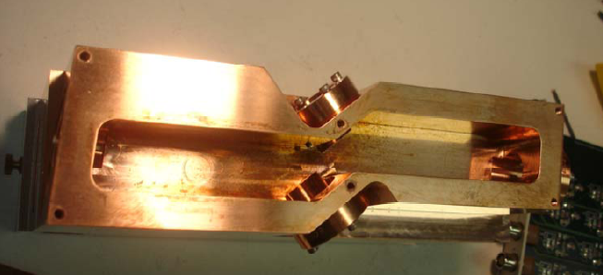
Figure 17: The 4-mirror output mode cleaner prototype at the Caltech 40-meter prototype interferometer.

We are studying the advantages and difficulties associated with making stable the optical modes of the signal and power recycling cavities. In initial LIGO, the effective recycling optical cavity is nearly flat-flat, leading to mode degeneracy and a high sensitivity to mirror defects. By including focusing elements in the cavity, it can be made stable, and there are strong advantages for both the power and signal recycling cavities in this. There are some layout challenges, as it puts more interferometrically sensed optics into the HAM chambers. Some more modeling of the impact on the optical modes is also being pursued.

A possible auxiliary sensing of the seismic optical tables is being pursued in a systems-level study which is closely linked to the sensing and control system and the locking of the interferometer. ANU is leading this study. The objective is to allow the relative velocity of the test masses to be reduced before the interferometer is locked, to aid in (and to accelerate) the locking process. The system may also be used in the operational mode. Several implementations are being considered, with a low-finesse interferometer formed between mirrors rigidly mounted to the seismic tables as one straightforward possibility.

To accommodate the needs for wideband multi-frequency auxiliary length readouts, the DC strain readout, and high-frequency wavefront sensing, characterization of photodiodes will be undertaken. As for initial LIGO detectors, the first steps will be surveys of commercial devices and those developed by colleagues in other projects. This phase will likely be followed in one or more cases by development work to customize or to improve performance and to optimize the electronic amplifiers that mate to these detectors.

Though not required, lower noise analog-to-digital and digital-to-analog converters would be of benefit in the design of the sensing and control signal chain and could ease other requirements. We are prototyping board circuitry and software to integrate these converters into our digital control environment. We also will experiment with new topologies and circuits for the critical analog signal conditioning filters that match the dynamic range of the converters to that of the physical signals they deal with.

The ISC subsystem will have its Conceptual Design Review in June 2008. Data from a number of the testbeds will contribute to the design effort, as well as the ‘ripening’ simulation and modeling. The Preliminary Design Review is planned for 2qFY08, informed by the results of the precision testing of the DC readout and Ouput Mode Cleaner used in the enhancements to Initial LIGO. Final Design commences in 2qFY09.

11. Data Acquisition, Diagnostics, Network & Supervisory Control (DAQ)

Overview

The differences between the initial LIGO and Advanced LIGO Data Acquisition, Network & Supervisory Control (DAQ) requirements derive from the increased number of channels in the Advanced LIGO interferometers, due to the greater number of active control systems.

Functional Requirements

The principal Advanced LIGO reference design parameters that will drive the data acquisition subsystem requirements are summarized in Table VII.

Table VII Principal impacts of the Advanced LIGO Reference Design on Data Acquisition and Data Analysis Systems. The number of Degrees of Freedom (DOF) is indicated for the main interferometer to give a sense of the scaling.
Parameterization | Advanced LIGO  Reference Design | Initial LIGO Implementation | Comment
Acquisition System Maximum Sample Rate, s/s | 16384 | 16384 | Effective shot noise frequency cutoff is well below f_{Nyquistt}  (8192 Hz)
Active cavity mirrors, per interferometer | 7 | 6 | Signal Recycling Mirror will be added.
Active seismic isolation system servos | 11 chambers per interferometer; 18 DOF per chamber; total, 198 DOF | 2 end chambers per interferometer, total, 12 DOF | Iinitial LIGO uses passive isolation with an external 6 DOF pre-isolator on end test masses;  Advanced LIGO uses active multistage 6 DOF stabilization of each seismic isolation platform.
Axial and angular alignment & control, per interferometer | SUS DOF : 42  DOF: 5  (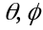) DOF:12 | SUS DOF: 36  DOF: 4  () DOF: 10 | Advanced LIGO has one additional cavity. Each actively controlled mirror requires 6 DOF control of suspension point plus (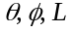) control of the bottom mirror.
Total Controlled DOFs | 257 | 62 | Relative comparison of servo loop number for maintaining resonance in the main cavities  (PSL and IO not included)

Advanced LIGO will require monitoring and control of many more degrees of freedom (DOF) than exist in the initial LIGO design. The additional DOFs arise primarily from the active seismic isolation, with a smaller contribution from the move to multiple pendulum suspensions and the additional suspended mirror. Both the suspension and the seismic isolation systems will be realized digitally (except for the sensors and actuators) and the DAQ will need to capture a suitable number of the internal test points for diagnostics and state control (as is presently done for the initial LIGO digital suspension controllers).

Referring to Table VII, the number of loops per interferometer that are required for Advanced LIGO is seen to be ~ 250. This is to be compared to ~ 60 for initial LIGO. The number of channels that the DAQ will accommodate from the interferometer channels for Advanced LIGO will reflect this 4X increase in channel number.

Table VIII presents approximate channel counts classified by sample bandwidth for Advanced LIGO and compares these to initial LIGO values. These represent the total volume of data that is generated by the data acquisition (DAQS) and the global diagnostics system (GDS); a significant fraction of these data are not permanently acquired. Nonetheless, the ability to acquire all available channels must be provided.

Table VIII DAQ Acquisition Data Channel Count and Rates
System | Advanced LIGO Reference Design | Initial LIGO | Comments
Channels, LHO + LLO  Total  (Total: 3 x IFO + 2 x PEM) | 5464 + 3092  8556 | 1224 + 714  1938 | Adv. LIGO will have ~4.5X greater number of channels.
Acquisition Rates, MB/s  LHO + LLO  Total | 29.7 + 16.3  46 | 11.3 + 6.1  17.4 | DAQS has ~3X total data acquisition.
Recorded Framed Data Rates, MB/s  LHO + LLO  Total | 12.9 + 7.7  20.6 | 6.3 + 3.5  9.8 | DAQS has ~2X total framed data recording rate.

Concept/Options

The driving features of the Advanced LIGO hardware design are the increase in channel count and the resulting increase in data rate, in terms of both the rate that must be available on-line, and the rate that is permanently archived..

The additional data channels required for the newer seismic isolation and compound suspension systems will require additional analog-to-digital converters distributed throughout the experimental hall Control and Data Systems (CDS) racks. Additional racks will be required and can be placed alongside the present CDS racks within the experimental halls. In those cases where there is interference with existing hardware, racks will need to be located further away, at places previously set aside for LIGO expansion. Additional cable harnesses for new channels will be accommodated within the existing cable trays.

The initial LIGO data acquisition processors do not have excess capacity sufficient to accommodate the increase in acquisition rate and will need to be upgraded. The upgrade will be a combination of updating the hardware technology and using a greater number of processors. The DAQ framebuilder and on-line mass storage systems will be upgraded to accommodate the greater data and frame size. The Global Diagnostic System (GDS) will be upgraded to handle ~3X as much real time data as the initial LIGO GDS.

Further details can be found in the Subsystem Documentation.

R&D Status/Development Issues

There are two technology changes from initial LIGO that are currently being pursued: A change from VME to PCIx, and a distributed network change from Reflective Memory to Myrinet, the latter having higher capacity and being more flexible (star-configuration versus ring). We have moved from VxWorks to real-time Linux as the software basis. Infiniband will be prototyped as an open-source alternative to Myrinet.

Acquisition systems have been designed and prototyped to determine performance of candidate hardware solutions. These systems are currently being used at the 40 Meter Interferometer at Caltech, and the LASTI testbed at MIT, for both acquisition and control, and feedback going to the acquisition design team.

The Global Diagnostics System (GDS) hardware will need to be scaled for the greater processing and throughput requirements. Parallelization techniques that are being used in the initial LIGO design (e.g., passing messages across Beowulf clusters) can be introduced to solve compute-bound data processing problems.

The Conceptual Design review took place in May 2007, enabling the start of Preliminary Design. Design and prototyping of the various elements of the subsystem (with tests at the various testbeds) will continue to 1qFY09, when Final Design commences.

It is plausible that hardware technology trends will continue over the coming years. Thus, it is likely that the solutions required to support the ~3X increased acquisition rates and data volumes would become commercially available by the time they are needed. We have taken as the point of departure that “Moore’s law” will be a reasonable predictor of the growth in available performance.

12. LIGO Data and Computing Subsystem (LDCS)

Overview

The computational load is increased over that for initial LIGO due to the broader frequency range of detector sensitivity. The enhanced frequency band in Advanced LIGO means that sources whose characteristic frequency of emission varies with time will be observable in the detection band for longer periods. Most of the search algorithms are based on frequency-domain matched filtering and thus the pipelines are compute-bound using the Fast Fourier Transform. Since the computational cost of the FFT grows as ~N logN with the number of data samples, longer duration waveforms require computational power that grows non-linearly with the length of the dataset. Data volume is also increased over that for initial LIGO because the interferometers are more complex and have a greater number of data acquisition channels that must be accommodated.

The impact on data analysis strategies of exploiting the increased instrumental sensitivity depends on the source type being considered and will be discussed below for those classes of search that drive the computational needs. Most presently envisioned search and analysis strategies involve spectral-domain analysis and optimal filtering using template filter banks calculated either from physics principles or parametric representations of phenomenological models. The interferometer strain output is the primary channel of interest for astrophysics. The other thousands of channels in Advanced LIGO are used to validate instrumental behavior. It is expected that relatively few channels (< 50) will also prove useful in producing improved estimates of GW strain. This would be done by removing instrumental cross-channel couplings, etc. either with linear regression techniques in the time domain (Kalman filtering) or in the spectral domain (cross-spectrum correlation). Based on Initial LIGO experience, signal conditioning is not expected to be a driver for LIGO Data and Computing System (LDCS) upgrades.

The Advanced LIGO Data and Computing Subsystem is a scaled up version of current systems with an important point of departure. By the time LDCS will be needed for Advanced LIGO science observations, disk-based mass storage technology is expected to have outpaced tape storage. Therefore, the current plan is to convert to a disk-based archival system that can grow and is sustainable throughout the period of Advanced LIGO science operations.

Functional Requirements

LIGO Laboratory and the LSC are active participants in a number of NSF-sponsored initiatives, and have already implemented a large-scale production data analysis grid, termed the LIGO Data Grid (LDG). The LDG scope includes not only LIGO Laboratory resources, but also LIGO Scientific Collaboration. Its goal has been to adopt and make widely available grid computing methods for the analysis of LIGO data. A significant portion of LIGO Laboratory’s operations activities in software development has been dedicated to grid-enabling legacy software and pipelines primarily designed to run on targeted cluster resources.

The construction of Advanced LIGO offers an opportunity to start by integrating the latest grid middleware technology available at the time Advanced LIGO science operations begin. This proposal addresses the LIGO Laboratory Tier 1 components of LIGO data analysis and computing. It is assumed that these resources will be complemented by computing facilities elsewhere in the LSC (US/abroad). At appropriate times in the future, the Laboratory and the LSC will respond to opportunities for funding that will be needed in order to also enhance the Tier 2 facilities at the collaboration universities. Such enhancements will include an increase in the number of Tier 2 university centers serving the LIGO data analysis community.

LIGO Laboratory Computational Resources for Advanced LIGO

For the classes of sources considered (transient “bursts”, compact object inspirals, stochastic backgrounds, and continuous-wave sources), the continuous-wave and binary inspirals place the greatest demands on the computational requirements. Optimal searches for periodic sources with unknown EM counterparts (the so-called blind all-sky search) represent computational challenges that require O[10¹⁵ or more FLOPS] and will likely remain beyond the capacity of the collaboration to analyze using LIGO Tier 1 and Tier 2 resources. Alternative techniques have been developed that lend themselves to a distributed grid-based deployment. Research in this area has been ongoing during initial LIGO and will continue. For example, during the 2005 Einstein World Year of Physics, the LIGO Scientific Collaboration, the University of California’s BOINC Project, and the American Physical Society (APS) developed a project called Einstein@home to develop a screensaver based on SETI@home technology to analyze LIGO data to look for continuous gravitational waves. By 1Q2006 Einstein@home had been downloaded onto over 200,000 home computers of all types. A recent posting by the BOINC Project indicated that Einstein@home had been used by over 150,000 users during a 24 hour period, contributing an astounding 80 TFLOPS of computational effort to the search for continuous gravitational waves.

The Tier 1 center installation for Advanced LIGO will not be specifically targeted to this class of search, since it is one that will need to be addressed on a much larger scale within the national Grid infrastructure.

Thus, the driver for establishing the computing requirements becomes the search for compact binary inspiral events. Advanced LIGO will search for compact object binary inspiral events using the same general technique that is employed in initial LIGO: a massive filter bank processing in parallel the same data stream using optimal filtering techniques in the frequency domain. The extension to lower frequencies of observation allowed by Advanced LIGO means that the duration of observation of the inspiral is significantly longer, leading to a concomitant increase in the computing power required. Counterbalancing this trend, however, are emergent theoretical improvements in techniques applying hierarchical divide-and-conquer methods to the search algorithms. Improvements in search efficiency as high as 100X should be possible by optimal implementation of these techniques. While not yet demonstrated with actual data, it is reasonable to expect that algorithmic improvements will become available by the time of Advanced LIGO turn-on.

The number of distinct templates required in a search depends on many factors, but is dominated by the low-frequency cutoff of the instrument sensitivity (since compact binaries spend more orbital cycles at low frequencies) and the low-mass cutoff of the desired astrophysical search space (since low-mass systems inspiral more slowly, and hence spend more cycles in the LIGO band). Approximate scaling laws can be used, but in practice the precise number of templates depends on the specifics of the LIGO noise curve and the template-placement algorithm.

Table 9 provides a comparison between relative computational costs for inspiral searches down to 1M_{O/}1M_{O}binary systems between initial LIGO and Advanced LIGO. The length of the chirp sets the scale of fast-Fourier transforms (FFTs) that are required for optimal filtering. FFT computational cost scales as ~N log₂N. On the other hand, the greater duration of the chirp provides more time to perform the longer calculation. Considered together, a ~7X increase in signal duration corresponds to a ~2X increase in computational cost. In addition, the lower frequency sensitivity of Advanced LIGO requires an additional ~2X greater number of templates. A detailed model of the computational cost indicates that ~10X greater capacity will be required to keep up with the data stream for LHO with two interferometers. If one were to go to lower mass systems, the computational costs will scale as (M_{min})^{-8/3}. However, current stellar evolution models predict that the minimum mass of a neutron star remnant is around 1M_{O}. Extending the template bank below this limit may be of interest in order to cover all plausible sources, with a margin to allow for discoveries not predicted by current theories.

There is much room to improve computational methods to increase signal-to-noise for fixed computational cost. An 80% fitting factor would be enough for the first stage of a hierarchical search, which would go on to apply a restricted set of more accurate templates to candidate events in order to achieve a near-optimal signal-to-noise ratio. As a rough estimate, we assess a computational cost based on a flat search of a template bank twice as large as is required for the spinless case, or ~ 200,000 templates.

Table 9 Initial LIGO and Advanced LIGO Analysis System Requirements for compact object binary inspiral detection using Wiener filtering techniques. M=1M_{O}provides a reference to indicate how quantities change with M_{min}. Quantities were calculated using a spreadsheet model of the data flow for the inspiral detection analysis pipeline, and assume a 20 Hz start frequency for observation.
Parameter | Advanced LIGO (LHO, 2 IFOs)  1M_{O/}1M_{O} | Initial LIGO (LHO, 2 IFOs)  1M_{O/}1M
Maximum template length, seconds | 280 s | 44 s
Maximum template length, Bytes | 128 MB | 16 MB
Number of templates | 2.5 x 10⁵ | 1.3 x 10⁵
Calculation of templates, FLOPS | ~ 4 GFLOPS | ~ 2 GFLOPS
Wiener filtering analysis, FLOPS  (flat search) | ~ 5 TFLOPS | ~ 0.4 TFLOPS

The total requirements for the Advanced LIGO Computing are given in Table 10. The demands are dominated by the BH-NS search type, leading to 760k templates. We assume Moore’s law, a doubling of computing power for every 18 months, holds over the interval from the present (May 2007) to the time of purchase of the computing equipment (the last procurement of the Project, planned to be in FY2014).

In establishing these requirements, it is important to note that we have assumed that the LIGO Laboratory via the Advanced LIGO Project will supply one-half of the computing power needed to exploit the data stream from Advanced LIGO. It is assumed that the remaining computing resources will be supplied from the community in the US (with NSF support) and elsewhere (with other support).

Table 10: Projected LIGO Laboratory Computational Facilities for an early Advanced LIGO Science Run. 1AN is equal to 35LN assuming 18Month doubling.1LN is equal to 8.8GHz of Opteron-core performance.
 | Ligo Node (LN) |  | Advligo Node (AN)
Inspiral | 29550 | 845
Periodic | 300 |  | 300
Burst | 1000 |  | 29
Stochastic | 379 |  | 11
TOTAL | 31,229  (274THz CPU-core) |  | 1185

Data Archival/Storage Upgrades

Advanced LIGO data rates are ~3X the initial LIGO rates. These are summarized in Table 11. Based on already demonstrated data compressibility, the volume of data that will be generated is ~600 TB per year. Allowing for 300% copies, Adv. LIGO archives will grow at the rate of 1.8 PB per year.

Table 11: Data volumes generated by the Advanced LIGO Reference Design
Data rate, per interferometer | 10 MB/s | Annual Data Volume
Uncompressed rate for 3 interferometers | 30 MB/s | 947 TB
Rate for 3 interferometers, with 1.6X lossless compression | 19 MB/s | 592 TB (single copy)
300% archive | 57 MB/s | 1.8 PB (3 copies)

Experience to date with LIGO I has shown that any data that are acquired are required to be archived indefinitely. We will use this same data model as a conservative estimate for Advanced LIGO requirements. In this model, all data are acquired and stored for several weeks on-line in a disk cache at the observatories that is shared with the CDS LAN to permit real-time data access from the control rooms. The data are also ingested into the RAID cluster data array capable of storing ~ 2.5 PB on the cluster disk array. This is sufficient to accommodate more than 1 year of on-site data at each observatory (for all interferometers). Data will be streamed over the WAN to the main archive at Caltech, where multiple copies will be made for backup. Reduced Data Sets (RDSs) in this tapeless model can be produced wherever it is convenient (for initial LIGO the full raw data are initially only accessible at the sites, where all RDSs are created). The experience in initial LIGO is that several stages of RDSs are desirable, each reducing the volume of data via channel selection and data downsampling by a factor ~10X. As shown in the table, accounting for a 300% backup of archived frame data, Advanced LIGO will require a ~ 1.8 PB/yr archive capacity.

Handling Greater DAQ Data Rates – Frame Data Archive Growth

The greater data rate is accommodated in the model described above.

Software Upgrades

Unified Authentication and Access

The importance of computer security and access control to computer resources is an evolving technology, continuing to provide greater protection to valuable computer resources as risk assessment dictates. Having the GLOBUS GSI infrastructure in common to all these tools assures that as the GLOBUS developers make security related changes such as bug fixes, and enhancements, they will become available to all of LIGO’s data analysis environments in lock-step. The LDACS group will continue to track the evolution of access and authentication technologies, making the necessary changes and upgrades to the infrastructure to assure secure and reliable utilization of the computational resources available to the LIGO Laboratory and the LIGO Scientific Collaboration (LSC).

Reduced Data Sets (RDS) Frames

Archival RDS Frames

With Advanced LIGO, the preliminary estimates are that the number of channels will increase by more that a factor of four and that the recorded frame data rates will be ~3X relative to Initial LIGO. This implies that larger frame files will be needed if the time interval chunk size for each file is remain the same. The longer waveforms in Advanced LIGO suggests that there will be a benefit to moving to longer time intervals for the RDS frames used for analysis. To efficiently manage these larger data volumes, the underlying software used to generate the RDS frames will need to be improved upon in two areas to be able to keep up with data rates during science runs; larger processor address space in memory; better throughput from I/O through better processor speed and software efficiencies. It is also likely that the data sets associated with the raw frames and RDS will see the same gradual increase in size over time as the new Advanced LIGO interferometers are being tuned through improved understanding of their properties.

Larger, more complex frame files for Advanced LIGO will increase the importance of having thorough tools available for validating both raw and RDS frames as they are generated at the observatories and after being transferred over the internet or copied from tapes.

Custom User Frames

As user signal processing needs evolve, these and other more advanced algorithms may become important enhancements. In addition, the larger data sets typical of Advanced LIGO will require extending the address space of the processes associated with producing these custom user frames to support 64 bits to be able to work with larger files and datasets.

Data Location

Ongoing development of the data discovery, data location and data replication tools has identified these areas as candidates for integration into a more cohesive environment. To achieve this unification the extremely efficient algorithms for data discovery found in the LDAS diskCacheAPI have been made available as shared object libraries either for inclusion into existing scripts or as a basis for a new service. Grid Security Infrastructure is critical to this environment so the GLOBUS Toolkit will be an important component. With the newly wrapped GLOBUS for TCL/TK applications the option to provide this new service using TCL/TK has been proposed as a possible integration path for Advanced LIGO.

Concept/Options

The implementation of Advanced LIGO computational facilities (LDCS) is an expansion of initial LIGO LDAS. Large multi-core processor PC clusters will replace existing clusters. LAN network infrastructure in place for initial LIGO will be capable of expansion to accommodate 10 gigabit. The latest generation of Initial LIGO cluster technology supports very large volumes of hot-swappable RAID-configured disk arrays resident within the compute clusters, thereby providing data where they are needed – on the nodes. This has been shown to work successfully and we plan to capitalize on this paradigm, expanding it to accommodate a tapeless archive system for Advanced LIGO. The disk systems will support growth of both meta-databases and framed databases. Data servers will be upgraded to the enterprise class servers available at the time. Multiple servers may be clustered to provide greater throughput where this is required.

Existing tape libraries will be kept for large-scale backups, but will not be needed for providing deep look back production level science data access.

WAN access to LIGO data will be provided from each observatory and Caltech at 10 gigabit-over-Ethernet or greater bandwidth.

R&D Status/Development Issues

Most of the improvements in hardware performance that are discussed and identified above should become naturally available through the advance in technology that comes from market forces. LIGO will continue to meet its needs using commercial or commodity components.

Software evolution towards a grid-based paradigm will occur through continued participation by the Laboratory and the LSC in NSF-funded grid computing initiatives and in concert with the LSC Data Analysis Software Working Group.

Procurement of hardware for Advanced LIGO Data and Computing Systems will follow the model successfully implemented during the initial LIGO commissioning and science runs. Namely, procurement will be deferred until Advanced LIGO integration and test has sufficiently progressed to the point that Advanced LIGO science operations will be expected within 18 months of the start of the procurement process.

Up to this point, LIGO Laboratory will rely on its initial LIGO computing resources to support early Advanced LIGO engineering runs, integration, and test. Unlike the experience with initial LIGO, when four green-field computing facilities had to be implemented, for the Advanced LIGO construction phase, the Laboratory will be able to continue to provide to the collaboration the existing resources that will continue to be maintained and upgraded as needed as part of LIGO Laboratory operations.

An initial procurement plan will be developed by LIGO Laboratory in coordination with the LIGO Scientific Collaboration’s Data Analysis Working Group (DASWG) and the LSC Computing Committee which is comprised of representatives from all the Tier 1 and Tier 2 LSC computing facilities. The plan will be provided to NSF for comment and approval, typically as part of the regular Advanced LIGO Construction review cycle. Once LIGO has received approval for the plan, the procurement will proceed in a coordinated, phased manner to ensure that each LIGO Laboratory site is prepared to receive the hardware. This was executed several times during initial LIGO successfully.

The software development model has undergone a major change since the beginning of initial LIGO science operations. The creation of the collaboration-wide Data Analysis Software Working Group (DASWG) has consolidated most major software projects across the collaboration. The coordination of these activities takes place in the forum of DASWG weekly meetings. The tasks outlined above relating to upgrades to existing infrastructure in preparation for Advanced LIGO science operations will be formulated and presented for review within this working group. The activities will be organized, including as appropriate software experts from the broader collaboration. These activities will be carried out as part of the ongoing LIGO Laboratory operations program throughout the construction of Advanced LIGO.

The development of this system will conclude in early FY09, and the design finalized just in time to allow the most advantage of the ongoing commercial technology development.

LIGO Project Management Plan, LIGO M950001-C-M (http://www.ligo.caltech.edu/LIGO_web/ligolab/m950001-c.pdf); LIGO Lab documents can be accessed through the LIGO Document Control Center (http://admdbsrv.ligo.caltech.edu/dcc/)
LIGO Laboratory Charter, LIGO http://www.ligo.caltech.edu/docs/M/M010213-01/ (http://www.ligo.caltech.edu/LIGO_web/ligolab/charter.html)
http://www.ligo.org/charter.pdf
Status of the GEO600 Detector H Lück et al (GEO600 collaboration) Class. Quantum Grav. 23, S71-S78, 2006; Damping and tuning of the fibre violin modes in monolithic silica suspensions S Gossler, G Cagnoli, D R M Crooks, H Lück, S Rowan, J R smith, K A Strin, J Hough and K Danzmann Class. Quant. Grav, 21, S923 - S933 , 2004
Advanced LIGO Seismic Isolation Design Requirements Document, LIGO-E990303-03-D
Classical and Quantum Gravity 21(9): 2255-2273.
Phys. Rev. D 58, 122002
Advanced LIGO Seismic Isolation Design Requirements Document, LIGO-E990303-03-D; HAM Seismic Isolation Requirements (update), http://www.ligo.caltech.edu/docs/T/T060075-00.pdf
Advanced LIGO Seismic Isolation System Conceptual Design, E010016-00; ﻿Status Report for the Single Stage HAM ISI for Enhanced LIGO and Advanced LIGO, LIGO-T070088
R. Abbott, R. Adhikari, G. Allen, S. Cowley, E. Daw, D. DeBra, J. Giaime, G. Hammond, M. Hammond, C. Hardham, J. How, W. Hua, W. Johnson, B. Lantz, K. Mason, R. Mittleman, J. Nichol, S. Richman, J. Rollins, D. Shoemaker, G. Stapfer, and R. Stebbins. Seismic isolation for advanced LIGO. Classical and Quantum Gravity 19(7):1591, 2002. P010027-01-R
Test Mass Suspension Subsystem Design Requirements Document, T010007
Advanced LIGO Suspension System Conceptual Design, T010103; Quadruple Suspension Design for Advanced LIGO, N A Robertson et al Class. Quantum Grav. Vol. 19 (2002) 4043-4058; P020001-A-R; Quad Noise prototype PDR-3 overview, T060142; Monolithic stage conceptual design for Advanced LIGO ETM/ITM C. A. Cantley et al T050215; Discussion Document for Advanced LIGO suspension (ITM, ETM, BS, FM) ECD Requirements K A Strain T050093; Advanced LIGO ITM/ETM suspension violin modes, operation and control K A Strain and G Cagnoli, T050267; Conceptual Design of a Double Pendulum for the Output Modecleaner, T060257
Pre-Stabilized Laser Design Requirements, T000035
Advanced LIGO PSL Front End: Amplifiers vs Oscillator, LIGO-T060235
High-Power Fundamental Mode Single-Frequency Laser, LIGO-P040053-00-R
LIGO-P060015-00-Z, Laser power stabilization for second generation gravitational wave detectors, Optics Letters
A High-Power Pre-Stabilized Laser System for the Advanced LIGO Gravitational Wave Detectors, K. Danzmann, LIGO M060061-00-M
Advanced LIGO Input Optics Design Requirements Document, T020020
Advanced LIGO Input Optics Subsystem Conceptual Design Document, T020027
Input Optics Subsystem Preliminary Design Document, LIGO-T060269
“Upgrading the Input Optics for High Power Operation”, LIGO-E060003
R. G. Beausoleil, E. K. Gustafson, M. M. Fejer, E. D'Ambrosio, W. Kells, and J. Camp, "Model of thermal wave-front distortion in interferometric gravitational-wave detectors. I. Thermal focusing”, J. Opt. Soc. B 20 1247-1268 (2003).
E. Khazanov, N. Andreev, A. Babin, A. Kiselev, O. Palashov, and D. H. Reitze, “Suppression of Self-Induced Depolarization of High-Power Laser Radiation in Glass-Based Faraday Isolators”, J. Opt. Soc. Am B. 17, 99-102 (2000); E. Khazanov, N. Andreev, A. Mal’shakov, O. Palashov, A. Poteomkin, A. M. Sergeev, A. Shaykin, V. Zelenogorsky, Igor Ivanov, Rupal Amin, Guido Mueller, D. B. Tanner, and D. H. Reitze, “Compensation of thermally induced modal distortions in Faraday isolators”, IEEE J. Quant. Electron. 40, 1500-1510 (2004).
AOS: Optical Lever System & Viewports Conceptual Design Requirements, T060232; AOS: PO Mirror Assembly & Telescope, and OMMT Conceptual Design Requirements, LIGO-T060360; AOS: Stray Light Control (SLC) Conceptual Design Requirements, LIGO-T060263
Auxiliary Optics Support System Conceptual Design Document, Vol. 1 Thermal Compensation System, T060083
R.G.Beausoleil, E. D'Ambrosio, W. Kells, J. Camp, E K.Gustafson, M.M.Fejer: Model of Thermal Wavefront Distortion in Interferometric Gravitational-Wave Detectors I: Thermal Focusing, JOSA B 20 (2003)
B. Bochner, Y. Hefetz, A Grid-Based Simulation Program for Gravitational Wave Interferometers with Realistically Imperfect Optics; Phys. Rev. D 68, 082001 (2003) , LIGO P030048-00.pdf
Adaptive thermal compensation of test masses in Advanced LIGO, R. Lawrence, M. Zucker, P. Fritschel, P. Marfuta, D. Shoemaker, Class. Quant. Gravity 19 (2002)
http://www.ligo.mit.edu/bench/bench.html
LIGO–T060272 (http://www.ligo.caltech.edu/docs/T/T060272-00.pdf)
J. Mason, “Length Sensing and Noise Issues for a Advanced LIGO RSE Interferometer,” PAC Meeting, 1 May 2000 (http://www.ligo.caltech.edu/docs/G/G000119-00.pdf)
T. Delker, G. Mueller, D. Tanner, and D. Reitze, “Status of Prototype Dual Recycled-Cavity Enhanced Michelson Interferometer,” LSC Meeting, 15 Aug 2000 (http://www.ligo.caltech.edu/docs/G/G000275-00.pdf)
M. Gray, D. Shaddock, C. Mow-Lowry, and D. McClelland, “Tunable Power-Recycled RSE Michelson Interferometer for Advanced LIGO.” LSC Meeting, 15 Aug 2000 (http://www.ligo.caltech.edu/docs/G/G000227-00.pdf)
These rates include are derived from LIGO I rates with scaling as indicated in the table. Data rates quoted include a number of diagnostics channels and this rate is greater than the framed data rate which eventually is recorded for long term storage.
LIGO I channel counts differ by site and interferometer; representative values are indicated.
Advanced LIGO Control and Data System Infrastructure Requirements, LIGO T070056; AdvLigo Control and Data System Conceptual Design, T070059
c.f., Brady et al., PRD 57 (1998) 2101-2116 and PRD 61 (2000) 082001
http://www.einsteinathome.org/
http://www.boincstats.com/
Dhurandhar et al., gr-qc/030101025, PRD 64 (2001) 042004
Phys.Rev. D67 (2003) 082004 Class.Quant.Grav. 19 (2002) 1507-1512
This factor represents actually achieved compressions for initial LIGO data.

