1 | Safety | 2
2 | Objective & Scope | 2
3 | Contamination Control | 3
4 | Hardware & Fasteners | 4
5 | Documents | 6
6 | Documenting the Assembly Process | 6
7 | Preparing the Structural Weldment | 8
8 | Assembling the Top Blade Guards | 10
9 | Assembling the Preamplifier Bracket | 11
10 | Assembling the Coil Holder Brackets | 11
11 | Assembling the Earthquake Stops | 12
12 | Assembling the Rotational Adjusters | 13
13 | Assembling the Upper Wires | 15
14 | Assembling the Lower Wires | 17
15 | Assembling the Upper Mass | 19
16 | Assembling the Magnets | 25
17 | Assembling the Metal Bench | 25
18 | Installing the Top Blade Guard Assemblies | 27
19 | Installing the Blade Platforms & Rotational Adjusters | 27
20 | Installing the Earthquake Stop Assembly | 29
21 | Installing the Metal Bench | 30
22 | Installing the Upper Mass & Coil Holder Assembly | 30
23 | Attach the Wires to the Blades | 32
24 | Suspending the Masses | 34
25 | Balancing the Suspended Masses | 35
26 | Removing Components for Creak/Creep Baking | 40
27 | Reinstalling the Components | 43
28 | Preparing the OMCS for Electronics Testing | 44
29 | Metal Build Testing | 47
30 | Final Assembly, Transportation, & Storage | 47
31 | Replacing the Metal Bench with the Glass Optics Bench | 49
32 | Appendix | 50

OMCS (Metal Bench) | OMCS (Glass Bench)

Safety
Read and understand the OMCS Assembly and Installation Hazard Analysis (E0900042). For specific safety information on wire handling, see the Appendix.

Objective & Scope
The objective of this document is to outline and describe the steps necessary for the assembly of the OMCS. The following tasks are within the scope of this document:
- Assembly of subassemblies (Masses, Wires, Earthquake Stops, etc.), including the use of jigs and fixtures shown in D0900293 (OMCS Overall Assembly with Fixtures)
- Installation of subassemblies into the suspension structure
- Balancing of the suspension
- Installation and alignment of OSEMs
- Creep baking of the maraging steel blades
- Installation of the optic into the suspension
- Transportation of the suspension using a storage container

The following tasks are outside the scope of this document:
- Testing and commissioning of the suspension – see Ideal Order/Contents of aLIGO Triple Suspension Testing/Commissioning (G1200070)
- Assembly of the Output Mode Cleaner Breadboard
- Installation of the suspension into the chamber

Assembly Sequence
The steps required for the assembly of the OMCS are listed below. Some of the steps can be done in parallel with one another, while other steps can be rearranged to accommodate whatever tools, parts, or hardware are available.
- Prepare Structural Weldment (D0900308)
- Assemble subassemblies, in any order:
- Top Blade Guard Assemblies (2 D070145)
- Pre-Amplifier Bracket Assembly (1 D1201502)
  - Coil Holder Bracket Assembly (1 D1201213)
  - Earthquake Stop Assemblies (2 D1201441)
  - Rotational Adjusters (2 D030451)
  - Upper Mass Assembly (1 D060502)
  - Metal Bench Assembly (1 D070035)
- Attach Top Blade Guard Assemblies to Structural Weldment
- Attach Blade Platforms (D070028) to Structural Weldment
- Attach Rotational Adjusters to Blade Platforms and flatten Upper Blades
- Assemble Upper Wire Assemblies (2 D060536 and D070139) and attach to Upper Mass Assembly
- Assemble Lower Wire Assemblies (4 D060537 and D070249) and attach to Upper Mass Assembly
- Place Coil Holder/Tablecloth (D060530) over Upper Mass Assembly and lock the two together
- Attach Upper Mass Assembly and Coil Holder Assembly to Structural Weldment
- Connect Upper Wire Assemblies to Upper Blades
- Install Metal Bench Assembly suspended from Lower Wire Assemblies.
- Attach Earthquake Stop Assemblies (2 D1201441)
- Attach Pre-Amplifier Assembly (1 D1201502)
- Attach Corner Brackets (8 D0900309)
- Suspend all Masses
- Initial balancing
- Remove all Masses and Rotational Adjusters
- Creep baking of Upper Blades (in Rotational Adjusters) and Lower Blades (in Upper Mass Assembly)
- Reinstall Rotational Adjusters, Wires and Masses.
- Rebalancing.
- Install BOSEMs on Coil Holder/Tablecloth.
- Metal-Build Testing (Phase 1) (not covered in this document – see G1200070)
- Transport OMCS to chamber side using a Quad storage container (D1002222)
- Metal-Build Testing, Continued (Phase 2a) (not covered in this document – see G1200070)
- Replace Metal Bench Assembly with Glass Bench
- Rebalancing
- Glass-Build Testing (Phase 2b) (not covered in this document – see G1200070)
- Install OMCS into chamber (not covered in this document – see E070271)
- AdvLIGO SUS HAM6-H1 XYZ Local CS… (not covered in this document – see D1300240)
- AdvLIGO SUS HAM6-L1 XYZ Local CS… (not covered in this document – see D1300077)
- In-Chamber Testing (Phase 3) (not covered in this document – see G1200070)

Contamination Control

Related Documents
E0900047 LIGO Contamination Control Plan
E960022 LIGO Clean and Bake Methods and Procedures

General Practices
All assembly procedures must be performed in a Class 100 clean room environment while wearing:
- Hood
- Face Mask
- Coverall
- Overshoe Boots
- LIGO-approved UHV Gloves
- Safety Glasses (when working around wires, blades under load, and/or chemicals)
- Glove Liners (when pulling Wire Assemblies)
All work surfaces used for Class A or B components should be wiped down at the beginning of each work day, first with Acetone, then with Isopropanol. All HSTS parts are Class A hardware and, once cleaned and baked, should not come into contact with anything but Class A or B hardware. Review the LIGO Contamination Control Plan (E0900047) for details.

Clean & Bake of Components
All parts and hardware must be cleaned and baked to Class A or B as described in E960022. Any part that comes into contact with anything other than an equivalent to a Class A or B part must be recleaned and rebaked.

Hardware & Fasteners

Applications of Screw Types
The table below lists the most common types of screws used in the assembly of the OMCS, along with their applications. These types and applications apply to socket head cap screws (SHCS), flat head cap screws (FHCS), and set screws.
Table 1: Common Types of Screws
Screw Type | Description | Applications
Stainless Steel (SSTL) | Most common type of screw | - Threaded holes in aluminum parts  - Helicoils, in any material
Stainless Steel, Vented | Stainless steel screw with a hole drilled through the shank of the screw | - Threaded holes in aluminum parts where the trapped volume in the hole must be vented  - Helicoils, in any material, where the trapped volume in the hole must be vented
Silver-Plated (Ag) Stainless Steel | Stainless steel screw plated with a thin layer of silver | - Threaded holes ONLY in stainless steel parts
Silver-Plated (Ag) Stainless Steel, Vented | Stainless steel screw plated with a thin layer of silver with a hole drilled through the shank of the screw | - Threaded holes ONLY in stainless steel parts where the trapped volume in the hole must be vented

Silver-Plated Stainless Steel Screws
As listed in the table above, all Silver-Plated screws are made of stainless steel (SSTL).

Torque Values
All Socket Head Cap Screws (SHCS) are required to be tightened to the proper torque value using a torque wrench. The proper torque values (unless otherwise specified in this document) come from T1100066 on the DCC and are listed in the table below. In future sections, the given torque values will be rounded to the nearest in-lb.
Torque values for Flat Head Cap Screws (FHCS) will be given in sections where the screws are used. In general, set screws are tightened by hand, not with a torque wrench.
Table 2: Torque Values for SHCS
Supplier | Generic | Holo-Krome | UC Components
Type | Unplated | Unplated | Unplated, Vented | Ag-Plated | Ag-Plated, Vented
SHCS Size | Torque (in-lb)
#2-56 | 2.5 | 4 | 2.9 | 4 | 2.9
#4-40 | 5.2 | 6 | 6.7 | 6 | 6.7
#8-32 | 19.8 | 30 | 25.2 | 30 | 25.2
¼-20 | 75.2 | 100 | 85.8 | 100 | 85.8

In this table, all values are for coarse-threaded (UNC) SHCS, as shown by the listed thread pitch. Torque values for fine-threaded (UNF) or specially-threaded (UNS) SHCS will be given in sections where they are used. The Supplier of a SHCS can be determined in this manner: all Ag SHCS and vented SHCS are supplied by UC Components; Holo-Krome SHCS are indicated by an “H-K” marking on the head; all other SHCS should be considered to be generic, unless UC Components is positively known to be the supplier.

Tightening Screw Patterns
To ensure proper alignment of components and even clamping pressure, it is important to tighten the final few threads of screws in a pattern evenly. That is, after all screws have been tightened initially by hand, each screw should be turned no more than ¼ turn (either by hand or with a wrench) before continuing to the next screw. Continue to tighten each screw ¼ turn or less in a cross pattern sequence until all screws are properly torqued.

Helicoils
Helicoils (also known as threaded inserts) are used in threaded holes in aluminum or SSTL parts for a number of reasons:
- Additional strength
- Additional durability (for example, where a screw is frequently tightened and loosened for adjustment or repeated assembly/disassembly)
- To avoid the use of Ag hardware in a SSTL part

All helicoils used in this assembly are to be made of Nitronic 60. As with any other type of hardware, helicoils are cleaned and baked to Class A and installed using clean tools in a Class 100 clean room. After installation but before removing the tang, all helicoils should be checked by inserting a SHCS of sufficient length.

Washers
The majority of washers used in assembly are flat washers made from stainless steel. In specific locations where parts slide against one another, Nitronic 60 flat washers (D1100785, various types) may be used; these locations will be called out in the assembly procedure.
In the OMCS, some of the washers are vented for an additional measure of vacuum compatibility. Vented flat washers must be installed with the vented side facing away from the head of the SHCS. For SHCS in slots, the vent in the washer should be perpendicular to the direction of the slot, if possible.

Documents
E0900042 OMCS Assembly and Installation Hazard Analysis
E070271 OMCS Installation Procedure
G1200070 Ideal Order/Contents of aLIGO Triple SUS Testing/Commissioning
T0900559 HLTS/HSTS/OMCS Blade Groupings
E1000169 Blade Characterization Spreadsheet
E960022 LIGO Vacuum Compatibility, Cleaning Methods and Qualifications Procedures
T000053 aLIGO, Universal Suspension Subsystem Design Requirements

Documenting the Assembly Process

Related Documents
T1100003 Building Suspensions Subassemblies in ICS
T0900559 HLTS/HSTS/OMCS Blade Groupings
F1300022 OMC Build Sheet Template
E1200343 OSEM Chart

Inventory Control System (ICS)
For Advanced LIGO, all information on parts and assemblies will be recorded in the Inventory Control System (ICS). Information may also be stored in other documents, but it must be included in ICS as well.
As assembly progresses, each (sub)assembly should have an assembly record created in ICS and each part included in that assembly should be added to the corresponding assembly record. In general, this means that parts will be identified by serial number and assemblies will be identified by the serial number of a central part (as outlined in T1100003). Some parts are too small or too numerous to have serial numbers; these parts have been added to ICS in bulk. If the bulk quantities of a particular part have been divided into groups that match the number of parts in an assembly, then that part should be added to the assembly record.
In addition to part and serial numbers, there is important data that should be included in certain assembly records. This data should be included as a comment, but can be supported by images or other attachments. Data that should be recorded is listed in the table below.

Table 3: Data to be Recorded in Assembly Records
Assembly Record | Data to be Recorded
OMCS Overall Assembly (D0900295) | - Overall weight information (including a list of parts that were included when the suspension was weighed)
Rotational Adjusters (D030451) | - Rotational Adjuster position in Overall Assembly  - Blade serial number  - Blade clamp angle and orientation (blade tip up or down)  - Shim height
Upper Mass Assembly (D060502) | - Blade serial numbers  - Blade positions  - Blade clamp angles and orientations (blade tip up or down)  - Pre-creep bake mass value and additional mass configuration  - Metal-build mass value and additional mass configuration  - Final mass value and additional mass configuration
Metal Bench Assembly (D070035) | - Pre-creep bake mass value and additional mass configuration  - Metal-build mass value and additional mass configuration
Coil Holder Assembly (D1201213) | - BOSEM serial numbers and positions
OMC Breadboard Assembly (D1201439) | - Total mass values (including all parts and optics) and additional mass configuration

Process Travelers
Build Sheet traveler for the OMC suspensions (F1300022) is used to record information about part, serial numbers, weights, measurements, and other relevant data during assembly. Any final information recorded in a process traveler must be transferred to the corresponding assembly record in ICS. The completed process traveler should also be attached to the ICS assembly record.

aLogs
The Advanced LIGO logbooks (or aLOGs) are used at the Livingston and Hanford Observatories to keep a daily record of activity on the site. Progress reports during assembly should be posted regularly, along with information important to the assembly process and any other relevant data. Any final data must be transferred to the corresponding assembly record in ICS.

Other Documents
A number of other documents on the DCC and elsewhere are used to record data for certain important suspension parts. These documents are listed below:
- HLTS/HSTS/OMCS Blade Groupings (T0900559) – This document lists suggested groupings of Upper and Lower Blades, along with blade clamp angles and orientations.
- OSEM Chart (E1200343) – This document lists information on BOSEMs and AOSEMs, including open-light counts and other data; the BOSEMs and AOSEMs are arranged by suspension and then position within the suspension. Final information on OSEM positions and other data should be added to this document.

Preparing the Structural Weldment

Related Documents
D0900295 OMCS Overall Assembly
D0900655 OMCS Structural Weldment Assembly

Materials
Qty | Unit | Part Number | Description
1 | Each | D0900308 | Structural Weldment, OMCS
4 | Each | D980184 | LOS (or equivalent) Dog Clamp
56 | Each | 1185-2EN328 | 8-32 X 0.328” (2D), Nitronic 60 Helicoil
4 | Each | N/A | 1/4-20 X 1.5” Ag SHCS
4 | Each | N/A | 1/4” Flat Washer,
1 | Each | N/A | 8-32 Helicoil Go/No Go Gage
1 | Each | N/A | 8-32 Helicoil Tap
1 | Each | N/A | 8-32 Helicoil Insertion Tool
1 | Each | N/A | Helicoil Tang Removal Tool
1 | Each | N/A | 8-32 +0.005” Oversize Tap
1 | Each | N/A | 1/4-20 +0.005” Oversize Tap
1 | Bag | PNHS-99 | Polynit Heatseal Wipes
1  1 | Bottle  Bottle | N/A  N/A | Methanol  Isopropanol

Frame of Reference
For the OMCS Structural Weldment (D0900308) and, in turn, the OMCS Overall Assembly (D0900295), the frame of reference is established as follows. The origin is at the center of the Structural Weldment at table level. From the origin, the +x-axis points toward the three groups of three evenly-spaced holes in the base plate; the -x-axis points toward the three groups of three unevenly-spaced holes in the base plate. The +z-axis points up from the origin. The +y-axis and -y-axis follow from the +x-axis and +z-axis using the Right-Hand Rule.  Location of holes groupings on +X side of the Weldment | +y  -y  +x  -x  +z  Frame of Reference Relative to Structural Weldment

Procedure:
Verify usability of every tapped hole in the Structural Weldment, including holes for Helicoils.  Use a properly-sized Ag SHCS of sufficient length to check every tapped hole. If the silver plating is stripped from the SHCS, replace it before continuing to other holes.  Use a properly-sized Helicoil Go/No Go Gage to check every Helicoil hole (56 8-32 Helicoil). Wipe the Gage down using Methanol after checking each hole.  If any holes need to be retapped, use a clean tap of the proper size and type (tapped hole or Helicoil hole). After tapping, clean the hole and the tap thoroughly using Methanol and recheck the hole.  Install 56 8-32 X 0.328” (2D) Helicoils into the Structural Weldment in the following locations: 12 in the outside of each long side of the top plate, 6 in the inside of each long side of the top plate, 6 in the top of each short side, and 4 in the outside of each short side of the top plate.  Secure the Structural Weldment to an Optical Table using 2 to 4 LOS (or equivalent) Dog Clamps (D980184), 4 1/4-20 X 1.5” Ag SHCS and 4 1/4” Flat Washers. Orient the Structural Weldment so that there is easy access to the back (-x) side, which is the side with the three groups of three unevenly-spaced holes in the base plate.  Create an assembly record in ICS for the OMCS Overall Assembly, using the serial number of the Structural Weldment as the serial number for the assembly. Add the Structural Weldment to the assembly record. | OMCS Structural Weldment with Helicoil Location

Assembling the Top Blade Guards

Related Document
D070145 OMCS Top Blade Guard Assembly

Materials
Qty | Unit | Part Number | Description
2 | Each | D070146 | Blade Guard Crosspiece
8 | Each | 1185-2EN328 | 8-32 X 0.328” (2D) N-60 Helicoil
1 | Each | N/A | 8-32 Helicoil Insertion Tool
1 | Each | N/A | Helicoil Tang Removal Tool
4 | Each | D070147 | Blade Guard Riser
8 | Each | N/A | 8-32 X 0.625” SHCS
2 | Each | N/A | 8-32, Ag Hex Nut
2 | Each | N/A | 8-32 X 1.5” Fully Thread spherical tip SHCS

Procedure:
Install 2 8-32 X 0.328” (2D) Helicoils, into each Blade Guard Riser (D070147). After removing the tangs, thread a SHCS into each Helicoil to be sure that the SHCS runs freely in the Helicoil. If the SHCS does not run freely chase the Helicoil with an 8-32 tap.  Attach 2 Blade Guard Risers (D070147) to the Blade Guard Crosspiece (D070146) using 4 8-32 X 0.625” SHCS. Do not tighten the SHCS, as they will be removed when installing the Rotational Adjuster Assembly.  Thread an 8-32 Ag Hex Nut onto an 8-32 X 1.5” spherical tip SHCS. Thread the SHCS into the Blade Guard Crosspiece as shown in the figure at right.  Repeat Steps 1 through 4 for the second Top Blade Guard Assembly. | Top Blade Guard Assembly

Assembling the Preamplifier Bracket

Related Document
D1201502 OMCS Preamplifier Bracket Assembly

Materials
Qty | Unit | Part Number | Description
1 | Each | D1201501 | Bracket, Preamplifier
2 | Each | D1201502 | OMC Preamplifier Assembly
2  2 | Each  Each | D1301013  D1301012 | Kapton Sleeve  Modified Peek Washers
2 | Each | D1301012 | Modified Peel
2 | Each | D1101529 | Peek Washers
2 | Each | HK 78058 | 1/4-20 x 0.75” SHCS
8 | Each | MFA-310-NA | M3 x .5 x 10 Ag FHCS

Procedure:
Attach the Preamps to the mounting bracket (D1201501) using the M3 x .5 Ag FHCS. | 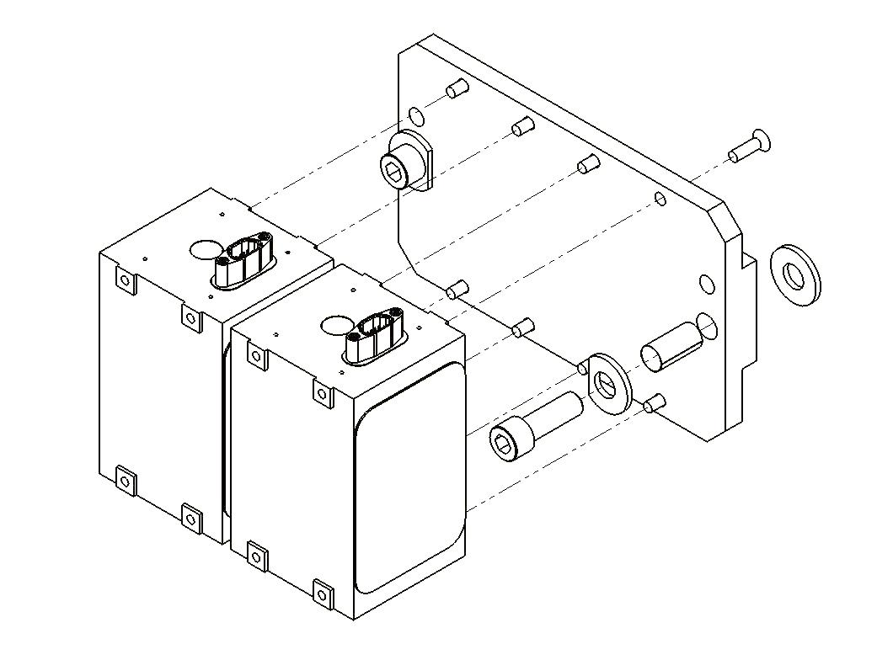  Peek Washers  Kapton Sleeve

Put the modified peek washer on the 1/4-20 x 0.75” SHCS. Wrap the Kapton sleeve around the SHCS and insert the SHCS into the hole in the mounting bracket. Rotate the peek washer so the cut side faces the side of the Preamp.

Put the unmodified peek washer on the 1/4-20 x 0.75” SHCS so that it will be between the mounting bracket and the weldment.

Attach the Preamp assembly to the weldment using the 1/4-20 x 0.75” SHCS

Assembling the Coil Holder Brackets

Related Documents
D060533 Coil Holder Mounting Bracket
D1201213 OMCS Coil Holder Assembly

Materials
Qty | Unit | Part Number | Description
2 | Each | D060533-1 | Coil Holder Mounting Bracket
2 | Each | D060533-2 | Coil Holder Mounting Bracket
4 | Each | D060533-3 | Tablecloth Bracket Wing
12 | Each | N/A | 4-40 X 0.375” SHCS
28 | Each | 1185-2EN246 | 8-32 X 0.246” 1.5D N-60 Helicoil
1 | Each | N/A | 8-32 Helicoil Insertion Tool
1 | Each | N/A | Helicoil Tang Removal Tool
8 | Each | MS1655-640 | Dowel Pin, 3/16” Diameter X 0.625”
1 | Each | N/A | Soft faced Hammer or Mallet

Procedure:

Install 7 8-32 x 0.246 1.5D Helicoils into each of the 4 Coil Holder Mounting Brackets.

Using a soft faced hammer, tap 2 of the 3/16” dowel pin into the center holes in the top of each of the 4 Coil Holder Mounting Brackets. The pin should be flush with the inside (cut away side) face of the Coil Holder Mounting Bracket.

Secure the Tablecloth Bracket Wing to the bottom of the Coil Holder Mounting Bracket with 3 4-40 x 0.375” SHCS.

Assembling the Earthquake Stops

Related Document
D1201441 OMCS Earthquake Stop Assembly

Materials
Qty | Unit | Part Number | Description
2 | Each | D1201471 | Main Bar, Earthquake Stop Assembly
4 | Each | D1201478 | Horizontal Adjust, Earthquake Stop Assembly
2 | Each | D1201472 | Left Support, Earthquake Stop Assembly
2 | Each | D1201473 | Right Support, Earthquake Stop Assembly
4 | Each | D1201476 | Side Bracket, Earthquake Stop Assembly
2 | Each | D1201475 | Top Bracket, Earthquake Stop Assembly
14 | Each | D1201440 | Threaded Bumper, Earthquake Stop Assembly
28 | Each | 1185-4EN250 | 1/4-20 X 0.25” 1D N-60 Helicoil
1 | Each | N/A | 1/4-20 Helicoil Insertion Tool
1 | Each | N/A | Helicoil Tang Removal Tool
16 | Each | 93615A415 | 1/4-20 X 0.75” Low SHCS
36 | Each | WFV-25 | 1/4 Flat Washer, Vented
8 | Each | HK-78062 | 1/4-20 X 1” SHCS
4 | Each | HK-78060 | 1/4-20 X 0.875” SHCS
14 | Each | 91830A581 | Knurled Head Thumb Screw, 1/4-20 X 0.5”
14 | Each | 91318A410 | Set Screw, 1/4-20 X 0.125” Hollow-Lock,

Procedure:

Insert the following number of 1/4-20 X 0.25” (1D) Helicoils into each part listed below.

D1201471 – 6 Helicoils

D1201478 – 2 Helicoils

D1201472 – 2 Helicoils

D1201473 – 2 Helicoils

Thread 4 Threaded Bumpers (D1201440) into the Main Bar (D1201471) so that the unthreaded end of the Bumpers face inward, as shown. Thread 1 Threaded Bumper into each Side Bracket (D1201476) with the unthreaded end facing inward. Thread a Threaded Bumper into the Top Bracket (D1201475) with the unthreaded end facing inward.

Insert a Set Screw, 1/4-20 X 0.125” Hollow-Lock, into the unthreaded end of every Threaded Bumper. Adjust the Set Screw so that it is recessed inside the Bumper.

Thread Knurled Head Thumb Screw 1/4-20 X 0.5” into every Threaded Bumper in the side opposite the Set Screw. Tighten the Knurled Head Thumb Screw until it reaches the Set Screw; then tighten the two together to lock both in place. Be sure that the Set Screw is recessed inside the Bumper.

Assemble 1 Horizontal Adjust (D1201478) to 1 Left Support (D1201472) using 2 SHCS, 1/4-20 X 0.75” Low SHCS, and 2 1/4" Vented Flat Washer. Do not torque the SHCS at this time. The beveled edge of the Left Support faces the inside of the L-shape of the Horizontal Adjust.

Repeat Step 5, replacing the Left Support with 1 Right Support (D1201473).

Assemble 2 Side Brackets (D1201476) to the Main Bar (D1201471) using 4 1/4-20 X 1” SHCS and 4 1/4” Vented Flat Washer. When assembled, the Bumpers in the Side Brackets should face inward.

Assemble 1 Top Bracket (D1201475) to the Main Bar using 2 1/4-20 X 0.875” SHCS and 2 1/4” Vented Flat Washer. Do not torque the SHCS at this time. When assembled, the Bumper in the Top Bracket will face downward.

Attach the Side Brackets with the Left and Right Supports to the Main Bar using 2 1/4-20 X 0.75” Low SHCS, and 2 1/4” Vented Flat Washer for each Side Bracket. Do not torque the SHCS at this time. When assembled, the beveled edges of the Left and Right Supports will face inward.

Repeat Steps 1 through 10 for the second Earthquake Stop Assembly.

Assembling the Rotational Adjusters

Related Documents
D030451 OMCS Rotational Adjuster Assembly
E1000169 HAM Suspension Blade Characterization Spreadsheet
T0900559 Suggested HAM Suspension Blade Pairing
D020677 HSTS/OMCS Library of Clamps

Materials
Qty | Unit | Part Number | Description
1 | Each | D020677 | Library of Clamps
2 | Each | D030451 | Rotational Adjuster Assembly
1 | Each | D030448 | Base Plate
1 | Each | D030447 | Rotating Plate
1 | Each | D080018 | OMCS Upper Blades
1 | Each | D020677 | Upper Blade Clamp, Upper Side, 0-3.5°
1 | Each | D020677 | Upper Blade Clamp, Lower Side, 0-3.5°
1 | Each | D020679 | Upper Blade Clamp, Lower Shim 1mm
1 | Each | D020680 | Upper Blade Clamp, Lower Shim 2mm
1 | Each | D030449 | Push Plate
1 | Each | D030450 | Pull Plate
2 | Each | NA | 1/4" Flat Washer
3 | Each | NA | 1/4-20 x .375”, SHCS
2 | Each | NA | 8-32 x 1”, SHCS
2 | Each | NA | 8-32 x 0.75”, Ag SHCS
1 | Each | NA | 8-32 x 1”, Ag SHCS
1 | Each | NA | 8-32 x 1” Spherical Tip Ag SHCS
3 | Each | D1100785-472 | 1/4” x .472 OD, N-60 Flat Washer
2 | Each | NA | 1/4-20 x 1.25”, Ag SHCS

Procedure:

Select pairs of D080018 Blades and Blade Clamps D020677 per the T0900559 Blade Pairings Spreadsheet. Use the Blade Paring Spreadsheet to select launch angle and direction of the clamp.
Assemble the blade and blade clamp  Sandwich the Blade between the Upper and Lower Clamps using 2 1/4-20 x 1.25” Ag SHCS and 2 1/4” flat washer to hold the parts together.  Place a 1mm or 2mm Lower Side Shim under the Blade/Clamp assembly. Shim height may change based on height of Optical Bench.  Secure the Blade/Clamp/Shim assembly to the Rotating Plate D030447 using the 1/4-20 x 1.25 Ag SHCS. Tighten the SHCS but do not torque.  Secure the Pull Plate D030450 to the Rotating Plate using 2 8-32 x 0.75” SHCS. | 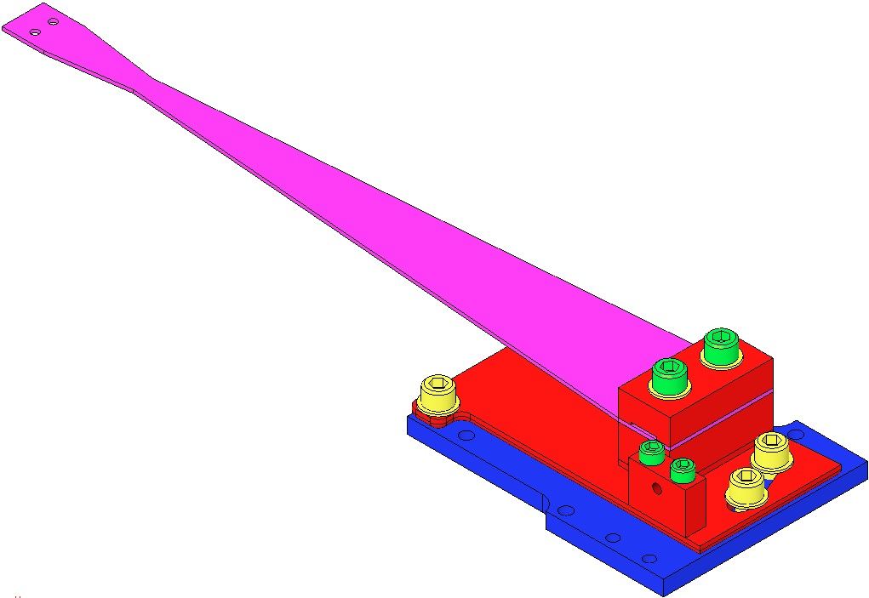  1/4-20 x 1.25” Ag SHCS & 1/4" Flat Washer  Rotating Plate  Pull Plate  8-32 x 0.75  ¼-20 x 0.375”  1/4" Flat Washer  Base Plate
Attach the Blade/Clamp/Shim assembly to the Base Plate:  - Secure the Blade/Clamp/Shim assembly to the Base Plate using 3 1/4-20 x 0.375” SHCS and 3 1/4" Flat Washers. Tighten the 1/4-20 SHCS but do not torque.  - Secure the Push Plate D030449 to the Base Plate using 2 8-32 x 1” SHCS.  - Thread 1 8-32 x 1” Ag and 1 D1100785-359 N-60 Flat Washer through the Push Plate into the Pull Plate.  - Thread 1 8-32 x 1” Spherical Tip Ag SHCS into the Push Plate | 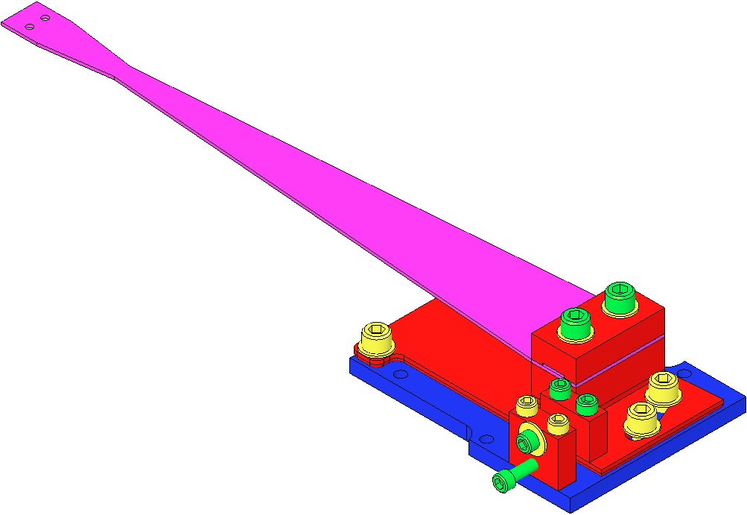  8-32 x 1” Ag Spherical Tip  8-32 x 1” SHCS  8-32 x 1” Ag SHCS  Adding Push Plate

Assembling the Upper Wires

Related Documents
E0900042 OMCS Assembly and Installation Hazard Analysis
D060536 OMCS Upper Wire Assembly
E960022 Vacuum Compatibility, Cleaning Methods and Qualification Procedures

Materials
Qty | Unit | Part Number | Description
1 | Each | D070139 | OMCS Upper Wire Jig Assembly
2 | Each | D070022 | Top Blade Wire Clamp
2 | Each | D030042 | Upper Blade Wire Clamp Plate
2 | Each | D070030 | Upper Mass C Clamp
2 | Each | D020309 | Upper Mass Wire Clamp Plate with Groove
2 | Each | D020139 | Upper Mass Wire Clamp Plate
1 | Spool | N/A | 0.014” Diameter Steel Music Wire
4 | Each | N/A | 4-40 x 0.3125” Ag SHCS
4 | Each | N/A | 4-40 x 0.5” Ag SHCS
8 | Each | N/A | #4 Flat Washers
1 | Each | N/A | 1kg Weight Hanger
3 | Each | N/A | Interlocking Test Weight (1kg)
1 | Set | N/A | Test Weights (1g – 500g)
1 | Bag | PNHS-99 | Polynit Heatseal Wipes
1 | Bottle | N/A | Methanol
1 | Bottle | N/A | Acetone
1 | Bottle | N/A | Isopropanol

Procedure:
Table Edge

Jig

Clevis
Wear safety glasses and glove liners per E0900332.

Assemble the Upper Wire Jig as per D070139.

Attach the jig to an Optical Table using to 2 to 4 dog clamps, so that the unclamped end of the jig extends approximately 3” past the end of the Optical Table.

Assemble the Top Blade Wire Clamps. Do not tighten the SHCS at this time.  Each Top Blade Wire Clamp includes:  1 D070022 Top Blade Wire Clamp  1 D030042 Upper Blade Wire Clamp Plate  2 4-40 X 0.3125”, Ag SHCS  2 #4 Flat Washers  Assemble the Upper Mass C-Clamp:  Each Upper Mass Wire C-Clamp includes:  - 1 D070030 Upper Mass C Clamp  - 1 D020309 Upper Mass Wire Clamp Plate Grooved  - 1 D020139 Upper Mass Wire Clamp Plate  - 2 4-40 X 0.5”, Ag SHCS  - 2 #4 Flat Washers |  | 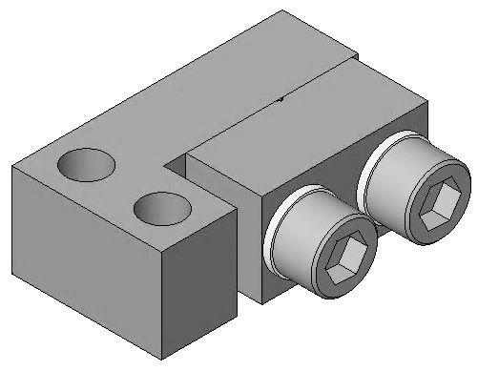  D070022  D030042  D070030  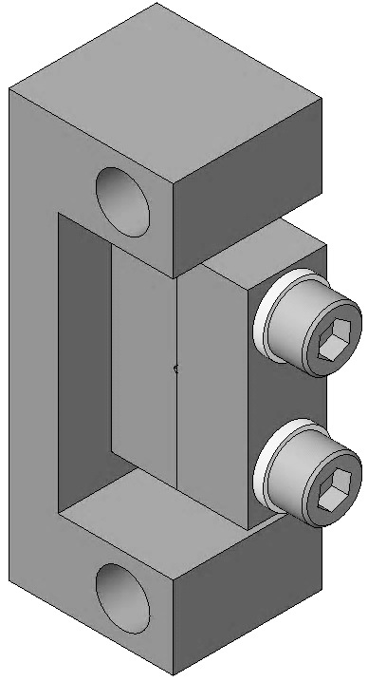  D020139  D020309

Install the Upper Mass C-Clamp assembly on the Bar Jig Step Plate (D070038) per detail A on D070139 and attach the Bar Jig Step Plate to the Upper Wire Jig with 2 8-32 x 0.625” SHCS.

Attach the Top Blade Wire Clamp to the Upper Blade Wire Clamp Attachment (D070023) with 2 4-40 x 0.75” SHCS.

Unspool enough 0.014” diameter Steel Music Wire to extend approximately 12” past the end of the Upper Wire Jig. Cut the Steel Music Wire from the spool. Note: The wire is dirty and will contaminate the wire cutters.

Clean the Steel Music Wire as described in the Appendix.

Feed the Steel Music Wire through the Wire Jig and Clamps in the order shown:

Through the Wire Start Clamp

Through the Upper Mass C-Clamp

Through the Upper Mass Wire Clamp

In the groove in the Upper Wire Height Balance

Over the end of the Upper Wire Jig

With an approximately 0.5” tail of the Steel Music Wire, tighten the SHCS on the Wire Start Clamp.
Tie the end of the Steel Music Wire, hanging over the end of the Upper Wire Jig, around the hook on the Weight Hanger.  Add 3kg of interlocking test weights to the 1kg Weight Hanger and 83g of small test weights, to make up a total hanging weight of 4.83kg.  The Steel Music Wire should now be taut, due to the hanging weight. Make sure the wire lays in the grooves in all the clamps.  Allow the weight to hang from the Steel Music Wire for at least 5 minutes.  Note: The Weight Hanger and test weights are not clean. They should be handled by a “dirty” person so as not to contaminate the wire assembly. |  |  |  | Hanging Weight

Tighten the SHCS on the Upper Mass C-Clamp, ensuring the surfaces of the two halves of the clamp are completely parallel. Torque the SHCS to 6 in-lb.

Tighten the SHCS on the Upper Mass Wire Clamp, ensuring the surfaces of the two halves of the clamp are completely parallel. Torque the SHCS to 6 in-lb.

Remove the hanging weight and Weight Hanger from the wire hanger.

Using clean wire cutters, cut the Steel Music Wire close to the outboard sides of the clamps.
Loosen the SHCS holding the clamps to the Wire Jig (NOT the ones holding the clamps together), and carefully remove the assembled wire from the Jig. Put the wire in a safe location until ready to install it into the suspension.  Record the clamp serial numbers in the OMC Build Sheet and the OMC ICS assembly record. | Assembled Upper Wire

Assembling the Lower Wires

Related Documents
E0900042 OMCS Assembly and Installation Hazard Analysis
D060537 OMC Lower Wire Assembly
T1300081 OMC Lower Wire Clamp Development, Crimp and Testing Procedures
E960022 Vacuum Compatibility, Cleaning Methods and Qualification Procedures

Materials
Qty | Unit | Part Number | Description
1 | Each | D070249 | OMC Lower Wire Jig Assembly
1 | Each | D1300083 | OMC Lower Wire Crimper Tool
4 | Each | D020132 | Lower Blade Wire Clamp
4 | Each | D020133 | Lower Blade Wire Clamp Plate
4 | Each | D1200971 | Beryllium Copper Lower Wire Clamp
8 | Each | N/A | 2-56 x 0.25”, Ag SHCS
8 | Each | N/A | #2 Flat Washer
1 | Spool | N/A | Steel Music Wire, 0.0079” Diameter
1 | Each | N/A | 1kg Weight Hanger
1 | Set | N/A | Test Weights (1g – 500g)
1 | Bag | PNHS-99 | Polynit Heatseal Wipes
1 | Bottle | N/A | Methanol
1 | Bottle | N/A | Acetone
1 | Bottle | N/A | Isopropanol

Procedure
Wear safety glasses and glove liners per E0900332.

Assemble the Lower Wire Jig as per D070249.

Attach the Jig to an Optics Table using 2 to 4 Dog Clamps, so that the end with the Wire Jig Pin Support extends beyond the Optics Table.
Assemble the Lower Blade Wire Clamp. Do not tighten the SHCS.  Each Lower Blade Wire Clamp includes:  - 1 D020132 Lower Blade Wire Clamp  - 1 D020133 Lower Blade Wire Clamp Plate  - 2 2-56 x 0.25” Ag SHCS  - 2 2 Flat Washers  - Attach the Lower Blade Wire Clamp to the Lower Blade Clamp Spacer assembly (D020159) with 2 2-56 x 0.375” Ag SHCS. | D020132  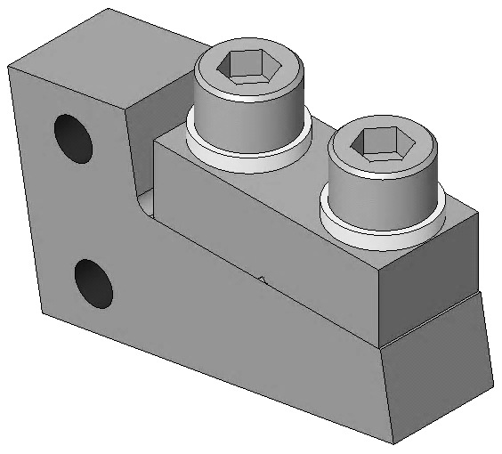  D020133
Unspool enough 0.0079” diameter Steel Music Wire to extend approximately 12” past the end of the Lower Wire Jig. Cut the Steel Music Wire from the spool. Note: The wire is dirty and will contaminate the wire cutters.  Clean the Steel Music Wire as described in Appendix.  Place the Beryllium Copper Lower Wire Clamp in the modified jaw of Crimping tool (D1300083) and lightly close the Crimping tool to hold the Lower Wire Clamp in place.  Thread one end of the Steel Music Wire through the Lower Wire Clamp until 0.25” of the wire extends past the bottom end of the Lower Wire Clamp. Crush the Lower Wire Clamp above and below the cone shaped flare.  Verify, with a caliper, the outer crimped ends measure between 0.057”-0.062”; recrimp the Lower Wire Clamp if necessary. | 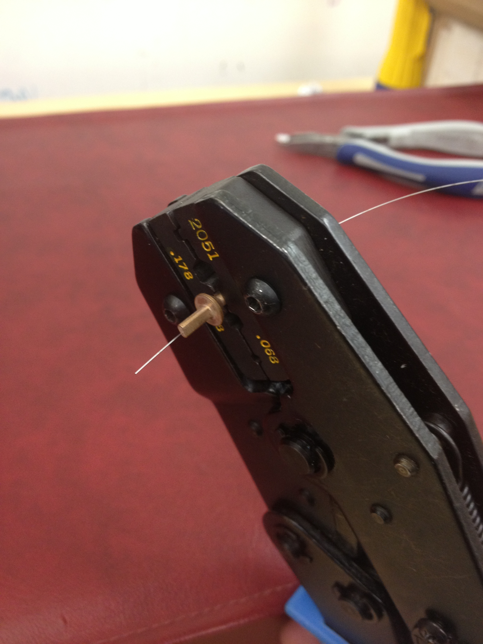  Lower Wire Crimp
Feed the Steel Music Wire through the Wire Jig and Clamps in the order shown:  Through the Lower Blade Wire Clamp  Through the Wire Start Clamp  Over the Clevis Pin  Place the Lower Wire Clamp into the slot in the Metal Mounting Bracket (D1201334).  Carefully pull the wire over the Clevis Pin until it is straight and the Lower Wire Clamp in seated in the Metal Mounting Bracket. |  | Lower Wire Crimped End
Tie the end of the Steel Music Wire hanging over the Clevis Pin around the hook on the Weight Hanger.  Place an additional 75g of small test weight on the 1kg Weight Hanger for a total hanging weight of 1.75kg.  The Steel Music Wire should now be taut, due to the hanging weight. Make sure the wire lays in the grooves in all the clamps.  Allow the hanging weight to hang from the Steel Music Wire for at least 5 minutes.  Note: The Weight Hanger and the small test weights are not clean. They should be handled by a “dirty” person so as not to contaminate the wire assembly. |  |  |  |  | Hanging Weight

Tighten the SHCS on the Lower Blade Wire Clamp, ensuring the surfaces of the two halves of the clamp are completely parallel. Torque the SHCS to 4 in-lb.

Remove the Weight Hanger from the wire.

Using clean wire cutters, cut the Steel Music Wire close to the outboard side of the Lower Blade Wire Clamp.

Remove the SHCS holding the Lower Blade Wire Clamp to the Wire Jig Spacer (NOT the SHCS holding the clamps together).

Carefully remove the assembled wire from the Jig. Put the wire in a safe location until ready to install it into the suspension.

Record the clamp serial numbers in the OMC Build Sheet and the OMC ICS assembly record.

Assembling the Upper Mass

Related Documents
D060502 OMCS Upper Mass Assembly
E1000169 HAM Suspension Blade Characterization Spreadsheet
T0900559 Suggested HAM Suspension Blade Pairing
D020677 HSTS/OMCS Library of Clamps

Materials
Qty | Unit | Part Number | Description
1 | Each | D060530 | Coil Holder (Tablecloth)
1 | Each | D060491 | Main Section, Upper Mass
1 | Each | D070032 | T-Section, Upper Mass
1 | Each | D060503 | Pitch Insert, T-Section
2 | Each | D070045 | Lower Blade Cover
4 | Each | D020482 | Screwdrive System
9 | Each | D070020 | Magnet Holder
9 | Each | D1001695 | Magnet and Flag Assembly
4 | Each | D080019 | OMCS Lower Blade
4 | Each | D020677 | Lower Blade Clamp, Upper Side, 0-3.5°
4 | Each | D020677 | Lower Blade Clamp, Lower Side, 0-3.5°
1 | Each | D040259 | Tablecloth and Upper Mass Jig
1 | Each | N/A | 1/2-20 UNF X 2” Ag Set Screw
2 | Each | N/A | 1/4-20 x 1.125” Ag SHCS
2 | Each | N/A | 1/4-20 x 0.5” Ag SHCS
2 | Each | N/A | 1/4-20 Jam Nut
16 | Each | N/A | #8 Flat Washer
4 | Each | 1185-2EN246 | 8-23 x 1.5D N-60 Helicoil
2 | Each | N/A | 8-32 X 0.375” Ag Set Screw
8 | Each | N/A | 8-32 x 0.75” SHCS
8 | Each | N/A | 8-32 x 1” Ag SHCS
22 | Each | N/A | #4 Flat Washer
22 | Each | N/A | 4-40 x 0.5” Ag SHCS
4 | Each | N/A | 4-40 x 0.375” Spherical Tip SHCS
4 | Each | N/A | 4-40 x 0.625” SHCS
2 | Each | N/A | 4-40 x 0.5” Vented SHCS

Procedure: Main Section, Blade/Clamp Assembly, & T Section
Secure the Tablecloth and Upper Mass Jig (D040259) to the corner of an Optical Table using a 1/4-20 x 1” Ag SHCS. (NOTE: The Tablecloth and Upper Mass Jig will not be shown in the following steps, but it is necessary for assembly of the Upper Mass.)  Place the Upper Mass Main Section (D060491) on the Optics Table with the bottom side facing up.  Attach the Lower Blade Cover (D070045) to the Main Section (D060491) using 4-40 x 0.5” Ag SHCS and #4 washer. | Per the data in T0900559 Blade Pairings, retrieve:  A matched set of 4 D080019 Lower Blades  4 sets of Blade Clamps from the D020677 Library of Clamps, each with an angle corresponding to a specific Blade  Identify the Blades for installation in the Upper Mass as follows:  - Blade with highest tip in +X, +Y corner  - Blade with next to highest tip in –X, +Y corner  - Blade with next to lowest tip in +X, -Y corner  - Blade with lowest tip in –X, -Y corner
Install the 4-40 x 0.375” spherical tip SHCS into the Lower Blade Cover from the top side of the Lower Blade Cover so the spherical tip of the SHCS is flush with the bottom side of the Lower Blade Cover  Assemble the Blade/Clamp Assemblies with:  - 2 8-32 x 1” Ag SHCS  - 2 #8 Flat Washers  - 1 D080019 Lower Blade  - 1 D020677 Lower Blade Clamp  - 1 D020677 Upper Blade Clamp | 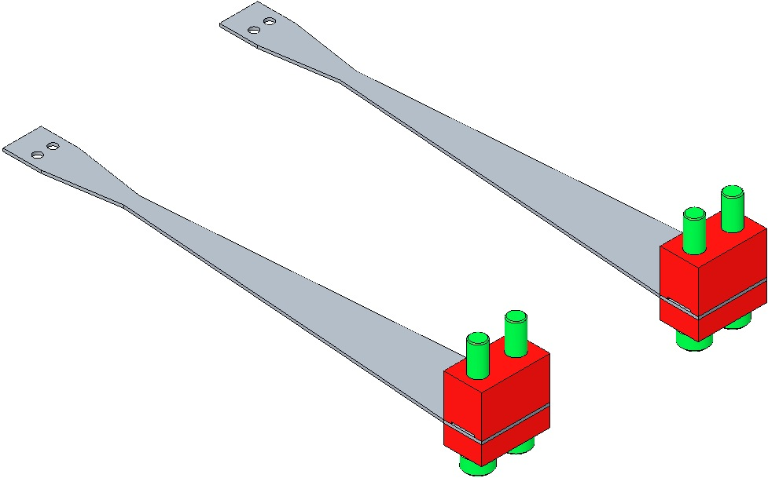  Lower Blade Clamp  Upper Blade Clamp Side
Attach the Blade/Clamp assemblies to the Upper Mass Main Section by putting the blade tip end of the Blade on the Lower Blade Cover and aligning the 8-32 x 1” Ag SHCS with the edge of the mounting holes in the Upper Mass Main Section. Push down on the center of the blade to flatten it until the 8-32 x 1” Ag SHCS can be threaded into their mounting holes.  Align the end of the blades WRT the end of the Lower Blade Cover such that all four blades are parallel. Use a Machinists’ Square to align the Blade/Clamp assembly and torque the 8-32 x 1” Ag SHCS to 30 in-lbs. | When using Blade Clamp pairs other than 0° ensure the orientation of Upper Clamp to Lower Clamp is such that the bolt holes are concentric (visibly, the Clamp sidewalls must be parallel).  Concentric Non-Concentric

Assemble to the T-Section D070032:
- Pitch Insert D060503
- 1/2-20 x 2” UNF Ag Set Screw
- 2 - 8-32 x 0.375” Ag Set Screw

Thread the T-Section onto the 1/4-20 stud at the top of the Jig (D040259).

The Jig is necessary to secure the Upper Mass during the assembly process.

Attach the D060491 Upper Mass Main Section to the T-Section using:

2 – 1/4-20 x 0.5” Ag SHCS

Procedure: Screw Drives

Assemble 4 Screw Drives (D020482).

Install an 8-32 x 1.5D Helicoil into each of 4 the Screw Drives (D020482).

Install an 8-32 x 0.625” SHCS into each of the Screw Drives so the SHCS tip is facing the cutout side of the Screw Drive. Do not run the SCHS in all the way, at this time.

Attach the Screw Drive assemblies to the bottom side of the Upper Mass Main Section using:

8 - 8-32 x 0.75” SHCS

8 - #8 Flat Washers

Use a Machinist’s Square to ensure Screw Drive assemblies are square with the Upper Mass Main Section.

Procedure: Magnet Holders
The Magnet/Flags and Wires are vulnerable to damage and should be handled very carefully during assembly and installation. They can be removed to facilitate the installation process. The Magnet/Flag Assemblies are left off until the Upper Mass/Coil Holder assembly has been installed in the Weldment.

With the Upper Mass Main Section mounted on the Upper Mass Jig.

Assemble 9 (D1001697) Magnet Retainers by pressing a (D1001534) Magnet Plug into the Magnet Retainer, using a small arbor press or a tapping the Magnet Plug into the Magnet Retainer with a Class-B punch.

Attach the 9 (D070020) Magnet Holders to the Upper Mass Main Section using:

2 4-40 X 0.5” Ag Vented SHCS

For the T1 Position only

16 4-40 x 0.5” Ag SHCS

18 #4 Flat Washers

Use a Machinist’s Square to keep the Magnet Holders square to the Main Section.

Screw the 9 Magnet Retainers into the Magnet Holders using a 7/16” wrench to tighten the Magnet Retainers.
Weigh the following items and add mass to the top of the Upper Mass Main Section, as needed to arrive at the Upper Mass total weight of 2900g.  - The completed Upper Mass assembly  - 9 Magnet/Flag Assemblies (D1001695)  - 2 Lower Clamps (with mounting bolts) from the Upper Wire Assembly (D060536):  - 2 D070030 Upper Mass C-Clamp  - 2 D020309 Upper Mass Wire Clamp, Inside  - 2 D020139 Upper Mass Wire Clamp, Outside  - 4 4-40 x 0.5” Ag SHCS  - 4 #4 Flat Washers  - 4 8-32 x 1” Ag SHCS  - 4 #8, D1100785-281 N-60 Flat Washers  - 4 Upper Clamps (with mounting bolts) from the Lower Wire Assembly:  - 4 D020132 Lower Blade Wire Clamp  - 4 D020133 Lower Blade Wire Clamp Plate  - 8 2-56 x .375” Ag SHCS  - 8 #2 Flat Washers  - 8 2-56 x 0.25” Ag SHCS  - Upper Add-on Mass as needed  - (D1200035) 100g mass  - (D1200040) 50g mass  - (D1200043) 20g mass | 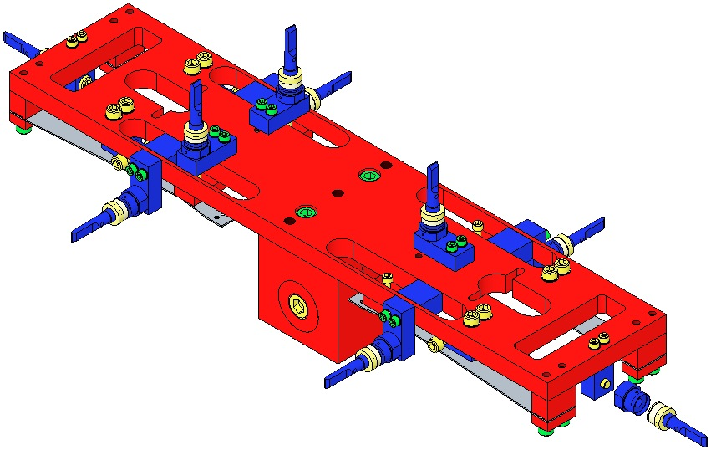  Magnet/Flag Assemblies

Procedure: Upper & Lower Wires Attachment
Mount the Upper Mass on the Upper Mass Jig.  Grasp the C-Clamp end of each D060536 Upper Wire Assembly and feed the assemblies downwards through the oval cutouts in the Upper Mass. Rotate the C-Clamp until the mounting holes in the C-Clamp align with the slots in Upper Mass Main Section.  If the wire becomes kinked during assembly, replace with another Wire Assembly. |  | 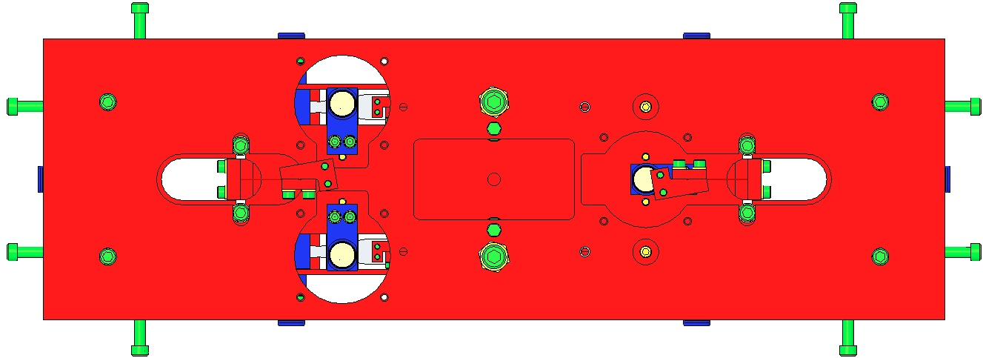  Wire Attachments  Upper Wires Attachment to Upper Mass

Secure the C-Clamps of the Upper Wire Assemblies to the bottom of the Upper Mass Main Section, using:
- 4 8-32 x 1” Ag SHCS
- 4 #8, D1100785-281 N-60 Flat Washers

- Use the 4 Screws from the Screw Drive Systems to center the C-Clamps on the oval openings. Tighten the 8-32 x 1” Ag SHCS enough to hold the C-Clamp in place.

Attach the upper ends of the 4 D060537 Lower Wire Assemblies to the tips of the 4 Lower Blades, using:  - 8 #2-56 x 0.25 Ag SHCS  - 8 #2 Flat Washers  - Torque the screws to 4 in-lbs  Note: the Clamp mounts above the Blade and the Screw assembles from beneath the Blade.  If the wire becomes kinked during assembly, replace with another Wire Assembly. | Lower Wire Clamp Attachment

Procedure: Install the Coil Holder (a.k.a. Tablecloth)
Remove one of the Magnet Holders from the side of the Upper Mass Main Section, to allow the assembly to clear the Coil Holder (D060530).  Holding the Coil Holder on its side close to the Upper Mass Main Section, have an assistant carefully thread the upper clamp assembly of the Upper Wire through the oval slots cut into the top of the Coil Holder, taking care not to kink the wires.  Maneuver the Coil Holder so that the two Magnet Holders on the long side and the one Magnet Holder on the short side are in the BOSEM cutouts in the Coil Holders.  Rotate the Coli Holder until it is resting on top of the Upper Mass Main Section, with all 9 of the Magnet Holders centered in the BOSEM cutouts in the Coil Holder.  Secure the Coil Holder to the Upper Mass Main Section using:  - 2 1/4-20 x 1.125” Ag SHCS  - 2 1/4-20 nuts | Upper Mass/Coil Holder with Upper Wires Installed
Using the 2 1/4-20 Screws, draw the Upper Mass fully upwards into the Coil Holder, to optimize later assembly steps.  Re-attach the side Magnet Holder, removed before installing the Coil Holders.  Install the Earthquake Stops into the Coil Holder using:  - 12 8-32 x 1” Spherical Tip Ag SHCS  - 12 8-32 Hex Nuts  Adjust the Earthquake Stops SHCS to securely hold the Upper Mass Main Sections in the Coil Holder. | Magnet  Holder  re-attached

Assembling the Magnets

Materials
Qty | U | ID | Description
9 | Each | D1100573 | BOSEM Flat Magnet Flag
9 | Each | D1100574 | BOSEM Flat Magnet Flag Disk
9 | Each | FA-403-N | 4-40 x 0.1875” FHCS
9 | Each | D394394N35UHP | Sintered NdFeB, Ni Plated, 10mm x 10mm Magnet
18 | Each | D1001534 | BOSEM Magnetic Plug

Procedure:
Assemble 9 D1001695 BOSEM Magnet/Flag Assemblies, each with:  D1100573 BOSEM Flat Magnet Flag  D1100574 BOSEM Flat Magnet Flag Disk  FA-403-N 4-40 x 0.1875” FHCS  D394394N35UHP Sintered NdFeB Ni-Plated10 x 10 mm magnet  D1001534 BOSEM Magnetic Plug  See Plug Insertion 16.3, below | 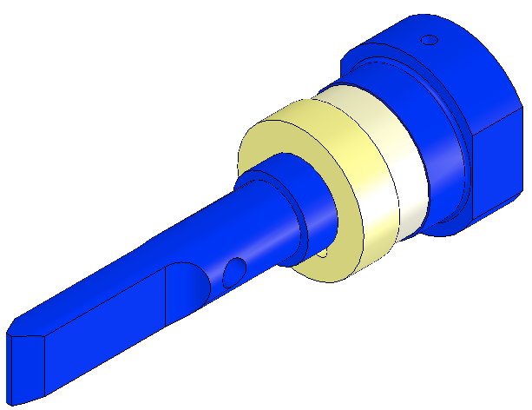  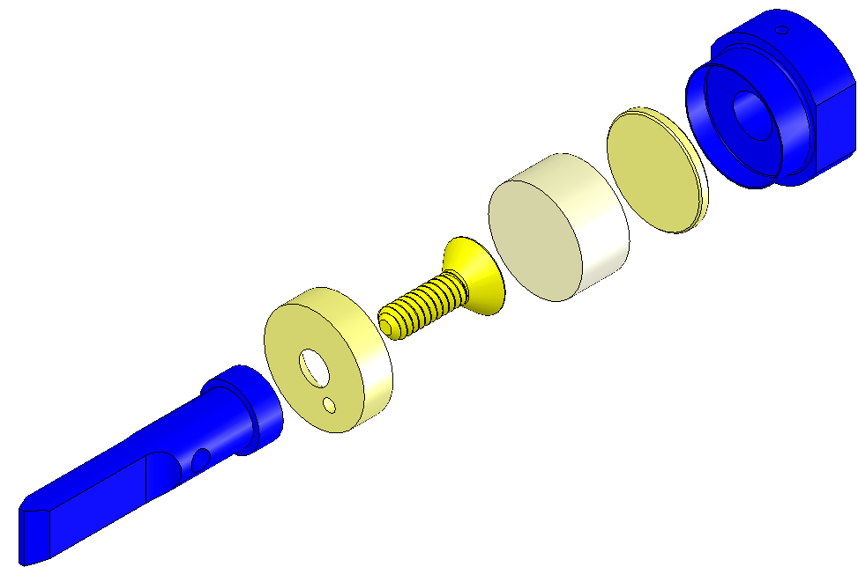  Plug  Magnet  Screw  Disk  Flag  Magnet Holder  Magnet Assembly

Procedure: Plug Insertion

Assemble the (D1001697) Magnet Retainers by pressing a (D1001534) Magnet Plug into the Magnet Retainer, using a small arbor press or by tapping the Magnet Plug into the Magnet Retainer with a Class-B punch.

Assembling the Metal Bench

Related Documents
D070035 OMCS Metal Bench Assembly

Materials
Qty | Unit | Part Number | Description
1 | Each | D070027 | Dummy Metal Optical Bench
2 | Each | D1201469 | OMC Metal Breadboard Shim
4 | Each | D1201335 | OMC Metal Breadboard Adapter
4 | Each | D1201334 | OMC Metal Breadboard Mounting Bracket
8 | Each | N/A | 1/4” Flat Washer
8 | Each | N/A | 1/4-20 x 0.625” SHCS
6 | Each | N/A | 1/4-20 x 0.75” SHCS
12 | Each | N/A | 4-40 x 0.0.375” FHCS
A/R | Each | D020350 | Add-On Mass 100g
A/R | Each | D020351 | Add-On Mass 50g
A/R | Each | D030078 | Add-On Mass 20g
A/R | Each | D1100855 | Add-On Mass 10g
A/R | Each | D1100863 | Add-On Mass 5g
A/R | Each | D1100894 | Add-On Mass 2g

Procedure:
Attach the 2 Metal breadboard Shims (D1201469) to the upper ends of the Metal Bench using:  2 1/4-20 x 0.625” SHCS  2 1/4” Flat Washers  Attach the 4 Adapters (D1201335) to the Mounting Brackets (D1201334) using:  3 4-40 x 0.375” FHCS  Note: Ensure the head of the FHCS is at the least flush WRT the bottom of the Mounting Bracket. If not, the adapter will not sit flat on the Metal Bench, affecting the balance of the Metal Bench.  Attach the 4 Adaptor/Mounting Bracket assemblies to the top of the Metal Bench using a 1/4-20 x 0.625” SHCS and 1/4" Flat Washer. Face the slot in the Mounting Bracket outward WRT the long side of the Metal Bench | 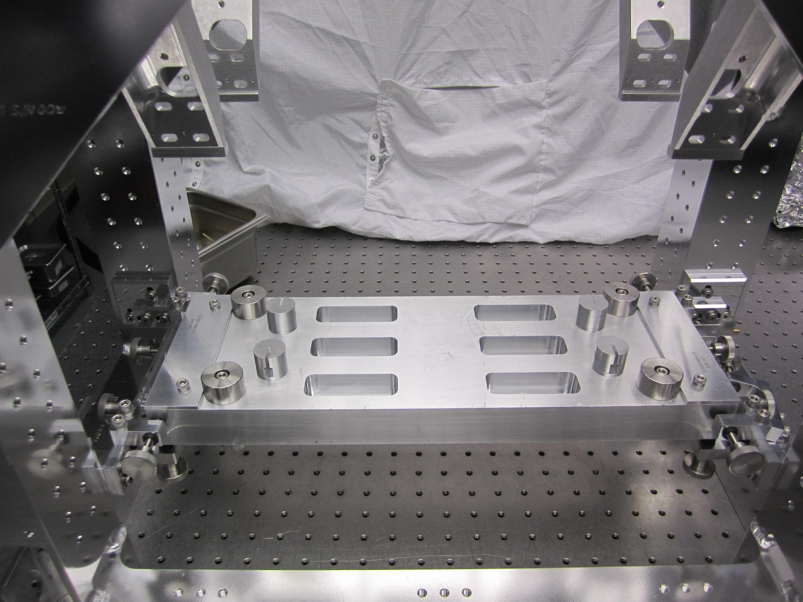  Assembled Metal Bench

Add 4 100g Add-On Masses (D020350) to the upper corners of the Metal Bench using 1/4-20 x 0.75” SHCSs.

Add 2 50g Add-On Masses (D020351) to bottom diagonal corners of the Metal Bench using 1/4-20 x 0.75” SHCSs

Weigh the Metal Bench Assembly. Using the Add-On Masses, from 100g to 2g, adjust the weight of the Metal Bench to the 7200g target weight ± 10g. Distribute any added masses uniformly between the 8 mounting positions (4 on the top and 4 on the bottom) to maintain the CG of the Metal Bench Assembly. When stacking Add-On Masses, it may be necessary to vary the length of the 1/4-20 fasteners. Be sure to account for the change in weight of the fasteners when changing their length.

Note: These masses may need to be shifted to balance the Metal Bench once it has been suspended.

Record the final weight and positional placement of the masses of the Metal Bench in the ICS assembly record, and the Build Sheets traveler (F1300022) used during assembly.

Installing the Top Blade Guard Assemblies

Related Document
D0900295 OMCS Overall Assembly

Materials
Qty | Unit | Part Number | Description
1 | Each | D0900308 | OMCS Structural Weldment
2 | Each | D070145 | OMCS Top Blade Guard Assembly
16 | Each | N/A | 8-32 X 0.5” SHCS
16 | Each | N/A | #8 Flat Washer

Procedure:
Attach the 2 Top Blade Guard Assemblies (D070145), assembled in section #8, to the top of the OMCS Weldment (D0900308) using 4 8-32 X 0.5” SHCS.  Remove 3 of the 4 8-32 x 0.625” SHCS securing the Blade Guard Crosspiece (D070146) to the Blade Guard Risers (D070147).  Rotate the Blade Guard Crosspiece 180° so it is out of the way during the Rotational Adjuster Assembly installation. | Top Blade Guard Assembly

Installing the Blade Platforms & Rotational Adjusters

Related Document
D0900295 OMCS Overall Assembly

Materials
Qty | Unit | Part Number | Description
1 | Each | D0900308 | OMCS Structural Weldment
2 | Each | D070028 | OMCS Blade Platform
2 | Each | D030451 | Rotational Adjuster Assembly
8 | Each | 1185-2EN246 | 8-32 X 0.246” (1.5D) N-60 Helicoil
1 | Each | N/A | 8-32 Helicoil Insertion Tool
1 | Each | N/A | Helicoil Tang Removal Tool
20 | Each | N/A | 8-32 X 0.5” SHCS
8 | Each | N/A | 8-32 x 0.375” SHCS
20 | Each | N/A | #8 Flat Washer

Procedure:
Position the Weldment near the end of a clean and level Optics Table with the –x (a.k.a. back, see Section #7.3) side facing the end of the Optics Table.  Secure the Weldment to the Optics Table with 2 to 4 Dog Clamps, using appropriate length 1/4-20 Ag SHCS and 1/4” Flat Washer. Position the Dog Clamps around the Weldment and tighten the SHCS so the Weldment is held flat on the Optics Table and cannot move.  Install 4 8-32 x 1.5D Helicoils into each of the Blade Platform (D070028). Remove the tangs and chase the Helicoils as necessary to ensure free running threads.  Install the Blade Platforms on the Weldment, with the long overhang facing toward the center of the structure, using:  10 8-32 x 0.5 SHCS  10 #8 Flat Washers | 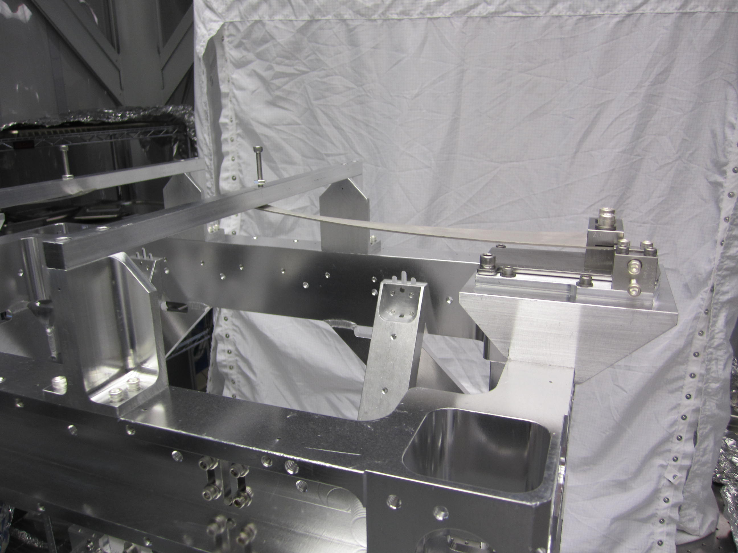  Upper Blade Rotational Assembly
Attach the 2 Rotational Adjuster Assemblies (D030451) to the Blade Platform using:  4 8-32 x 0.375” SHCS  With the Blade Clamps, Shim, and Blade assembly square WRT each other, torque the 1/4-20 Blade Clamp bolts to 100 in-lbs.  Loosen the Push/Pull adjuster screws and the 3 1/4-20 Rotating Plate screws. Position the Rotation Plate so the Blade tip is approximately centered in the Weldment. Retighten the 1/4-20 screws. | Pay attention to the specific side location of the Rotational Adjuster Assembly as defined in Assembly Procedure Section 12.3.
- Have an assistant reach into the Weldment from below the top Weldment cross bar and take hold of the tip of the blade. With one of the 8-32 x 0.625” SHCS (removed in Procedure #16.3.2) in hand, have the assistant pull down on the tip of the blade until the Blade Guard Crosspiece (D070146) can rotate into place. Quickly, rotate the Blade Guard Crosspiece into position and install the 8-32 x 0.625” SHCS. Tighten both SHCS so the Blade Guard Crosspiece is securly fastened to the Blade Guard Risers (D070147).
- Slowly release the blade until it comes into contact with the EQ Stop installed in the Blade Guard Crosspiece.  - Install the remaining 2 8-32 x 0.625” SHCS and tighten.  - Repeat steps 7 through 10 for the second Rotational Adjuster Assembly. | Note: The blade should be positioned so the tip of the EQ Stop is in the center of the Blade. To adjust the blade position, have the assistant pull down on the Blade tip until it is clear of the EQ Stop. Use the Push/Pull screws to center the Blade. When the Blade is centered tighten the Rotating Plate SHCS, and snug Push/Pull screws so they cannot rattle.

Installing the Earthquake Stop Assembly

Related Documents
D1201441 OMC Earthquake Stop Assembly

Materials
Qty | Unit | Part Number | Description
2 | Each | D1201441 | OMC Earthquake Stop Assembly
8 | Each | 93615A415 | 1/4-20 x 0.75” LSHCS
8 | Each | WFV-25 | 1/4" Vented Flat Washer

Procedure:
- Loosen the 4 1/4-20 x 0.75” LSHCS holding the Horizontal Adjust Brackets to the Right and Left Support Brackets and slide them away from the Support Bracket mounting slots. Snug the LSHCS to hold in place.  - Loosen the 1/4-20 x 0.75” LSHCS on one side of the EQ Stop Assembly.  - Attach one of the Support Brackets to the two bottom most 1/4-20 tapped holes on the inside leg of the Weldment using 2 1/4-20 x 0.75” LSHCS. Snug but do not tighten.  - Attach the other side Support Bracket to the corresponding 1/4-20 mounting holes in the opposite leg of the Weldment.  - Loosen any of the 1/4-20 x 0.75” LSHCS necessary to center the EQ Stop Assembly within the Weldment, and snug any lose 1/4-20 x 0.75” LSHCS.  - Repeat steps 1 through 5 for the remaining EQ Stop Assembly. | 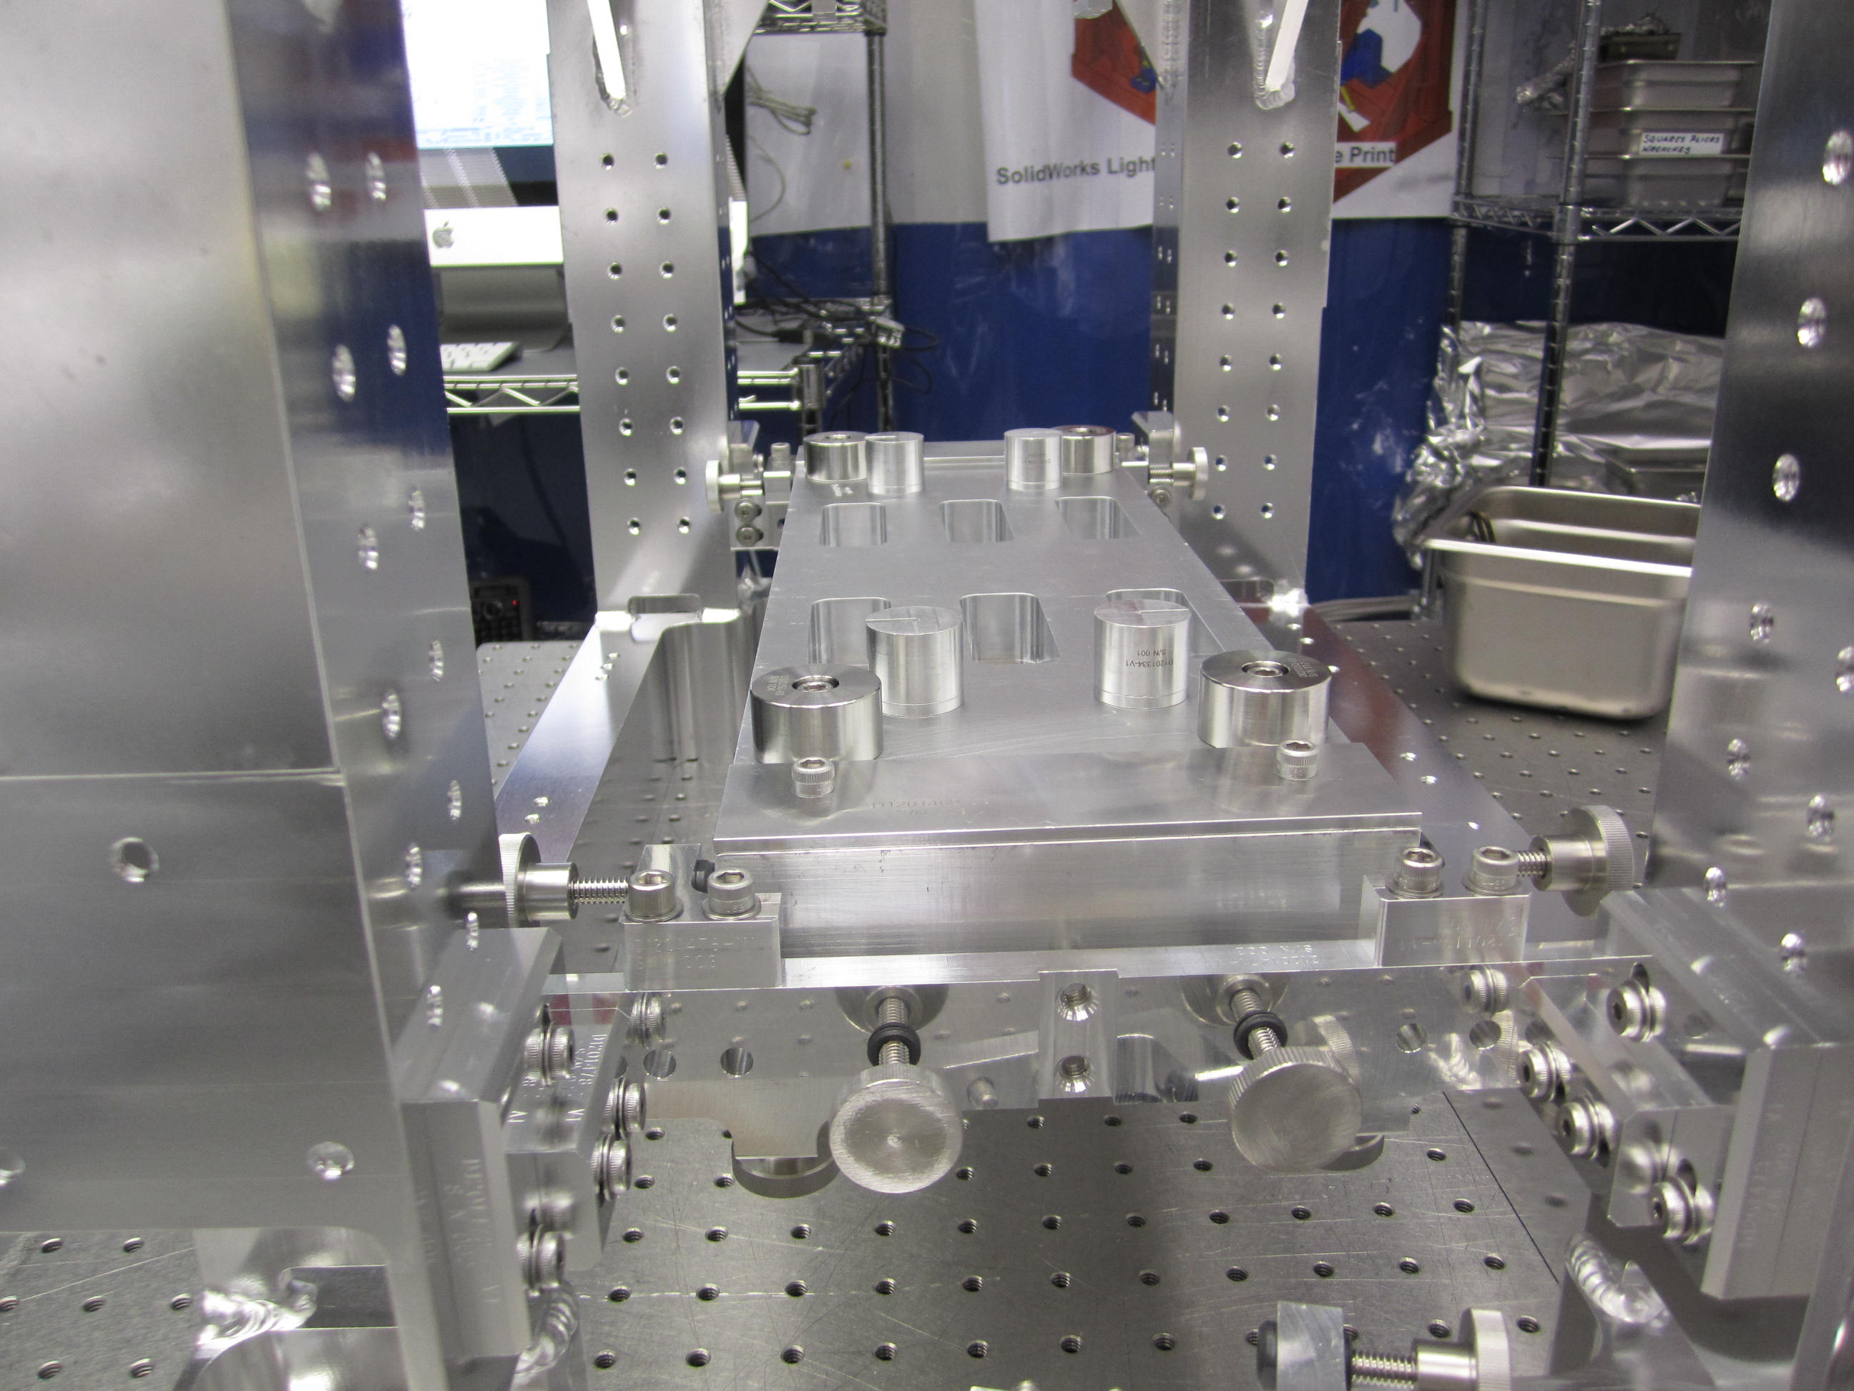  Installed EQ Stop Assembly with Metal Bench

Installing the Metal Bench

Related Document
D070035 OMC Metal Bench Assembly

Materials
Qty | Unit | Part Number | Description
1 | Each | D070035 | OMC Metal Bench Assembly

Procedure:
Remove the 2 Top EQ Brackets (D1201475) from Earthquake Stop Assemblies.  Adjust the bottom EQ Stop brackets and bumpers into their highest positions.  Fully retract the side EQ bumpers and the face EQ bumpers.  Slide the OMC Metal Bench Assembly (D070035) into the Weldment from the back (-X) side, approximately centering the Metal Bench Assembly in the Weldment and lower it onto the bottom EQ Stops.  Adjust the side and face EQ bumpers so they center and secure the Metal Bench Assembly. | Metal Bench Installed in Weldment
Reinstall the 2 Top EQ Brackets and turn down the bumper to vertically lock the Metal Bench Assembly in place. | Note: It may be necessary to adjust the EQ Assembly (D1201441) brackets to fully clamp the Metal Bench Assembly in place.

Installing the Upper Mass & Coil Holder Assembly

Related Documents
D1201213 OMC Coli Holder Assembly
D0900295 OMC Overall Assembly
D060533 OMC Coil Holder Mounting Bracket

Materials
Qty | Unit | Part Number | Description
1 | Each | D060533 | Coil Holder Assembly (without BOSEMs)
2 | Each | D060533-1 | Coil Holder Mounting Bracket Assembly
2 | Each | D060533-2 | Coil Holder Mounting Bracket Assembly
1 | Each | D060502 | Upper Mass Assembly (installed in the Coil Holder Assembly)
16 | Each | NA | 8-32 x 0.5” SHCS
16 | Each | NA | 8-32 x 0.5”, Ag SHCS
16 | Each | NA | #8 Flat Washers
16 | Each | D1100785-359 | #8 x 0.395” N-60 Flat Washer

Procedure:
Position one of the Coil Holder Mounting Brackets (D060533-1 or D060533-2) on the inside of the Weldment, (the cutout for the EQ Stop facing the center of the Weldment), with the two alignment pins in the longer center slot cut into the Weldment Top Plate (D0900347).  Secure the Coil Holder Mounting Bracket to the Weldment with 4 8-32 x 0.5” Ag SHCS and 4 D1100785-359 #8 N-60 Flat Washers.  Adjust the Coil Holder Mounting Bracket to the lowest position the vertical slots will allow. Snug the 8-32 x 0.25” Ag SHCS so the Coil Holder Mounting Bracket cannot move.  Repeat steps 1 through 3 for the remaining 3 Coil Holder Mounting Brackets.  Remove the Flags from the Flag Mounts and set them aside where they cannot be damaged. | 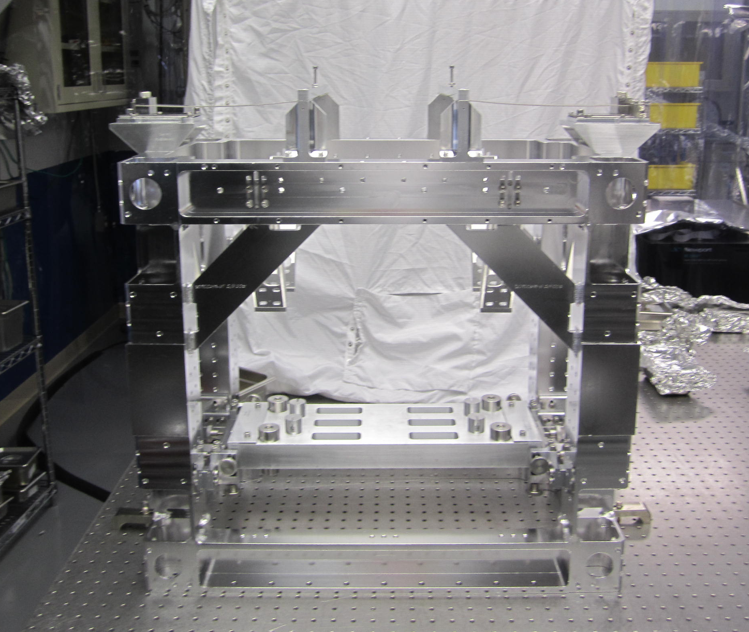  Weldment ready for Coil Holder Installation
Secure the Top Wires by tucking their loose ends into the BOSEM cutouts in the top of the Coil Holder, to keep them from flopping around during installation of the Coil Holder/Upper Mass assembly. Be careful not to kink the Top Wires during the installation process.  From one side, and with an assistant positioned on the opposite side of the Weldment, slide the Coil Holder/Upper Mass assembly into the Weldment. The Coil Holder/Upper Mass Assembly may need to be angled upward so the top of the Coil Holder passes below the side gussets on the Weldment and above Tablecloth Bracket Wings (D060533-3).  Have the assistant reach into the center of the Weldment and from the side to help guide the Coil Holder/Upper Mass Assembly as it is being slid into the Weldment.  Pay extra attention to the Lower Wires while the Coil Holder is being moved into the Weldment so they don’t snag on the Metal Bench or the EQ Stop Assembly.  It may be necessary to slightly loosen one or more Coil Holder Mounting Brackets to allow clearance while the Coil Holder/Upper Mass Assembly is being moved into the Weldment.  Tighten any of the Coil Holder Mounting Brackets loosened in the above step and allow the Coil Holder to rest on the Tablecloth Bracket Wings.  Position the Coil Holder so the 4 8-32 mounting holes in the Coil Holder line up with the center of the horizontal slots in the Coil Holder Mounting Brackets.  Attach the Coil Holder to the Coil Holder Mounting Brackets with 4 8-32 x 0.5” SHCS and 4 #8 Flat Washers.  Repeat steps 10 and 11 for the 3 remaining corners. | 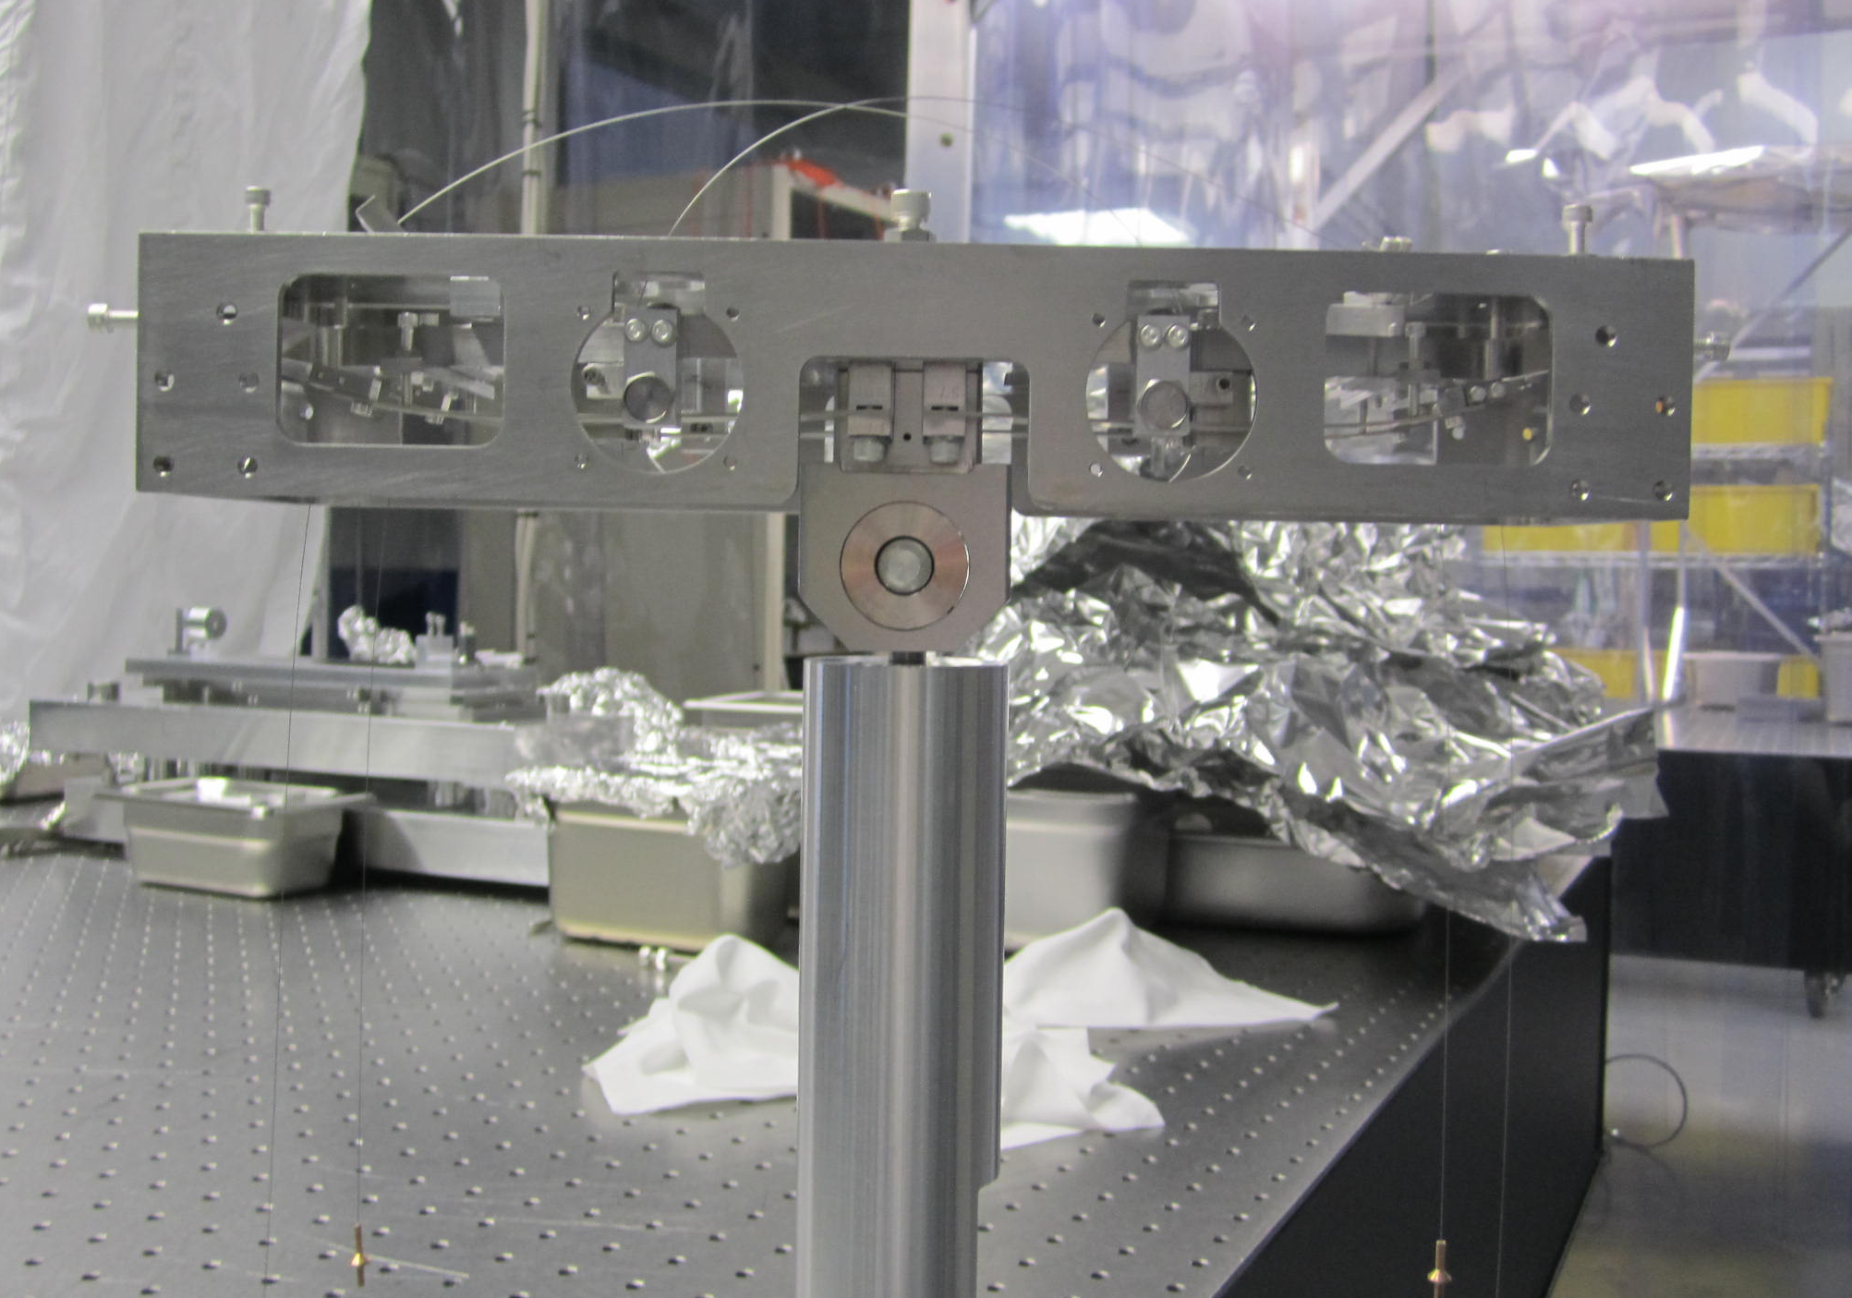  Upper Mass/Coil Holder ready to Install

Attaching the Wires to the Blades

Procedure: Attaching the Upper Wires to the Upper Blade

With a finger, gently push down on the tip of the Upper Blade to relieve the pressure of the blade against the EQ Stop screw, while turning the EQ Stop screw to push the blade tip down.

Carefully maneuver the Top Blade Wire Clamp assembly so the clamp is on top of the Blade. Coming up from the bottom of the blade, secure the clamp to the blade using:
- 2 4-40 x 0.75” Ag SHCS

- Repeat steps 1 and 2 for the other Upper Blade.

If the Top Blade Wire Clamp will not lay flat on the top of the Upper Blade, push the Upper Blade down further, or lift the Upper Mass Assembly using the EQ Stops.
Tighten the 4-40 Blade Clamp SHCS. Do not use a Torque Wrench.
If the wire becomes kinked during assembly, replace with another Wire Assembly.

Procedure: Attaching the Lower Wires to the Metal Bench
- Verify the Lower EQ Stops are in their full up position, lifting the Metal Bench to its highest position. The Metal Bench should also be centered within the Weldment.  - If the Lower Wire Clamp cannot engage the slots in the Metal Mounting Bracket (D1201334), the Upper Mass will need to be lowered and/or the Lower Blades will need to be lowered.  - To Lower the Upper Mass, back off the 2 1/4-20 x 1.125” Ag SHCS holding the Upper Mass into the Coil Holder until the Top Wires come taut. DO NOT remove these SHCS at this time.  - To lower the Lower Blades, with a finger on the Lower Blade Wire Clamp, lightly push down on the blade tip while turning down the 4-40 x 0.75” Ag SHCS Blade EQ Stop until the Lower Wire Clamp can engage the slot in the Metal Mounting Bracket.  - With fine tweezers, carefully align the flat sides of the Lower Wire Clamp with the slot in the Metal Mounting Bracket and insert the Lower Wire Clamp all the way into the Metal Mounting Bracket. Note: The wire may twist Lower Wire Clamp in the Metal Mounting Bracket. This is OK, as long as this does not interfere with the seating of the Lower Wire Clamp.  - While holding the Lower Wire Clamp in place, slowly release the Blade EQ Stop until there is enough tension on the wire to hold the Lower Wire Clamp in place.  - Repeat steps 3 and 4 until the remaining three Lower Wires Clamps are tensioned. | 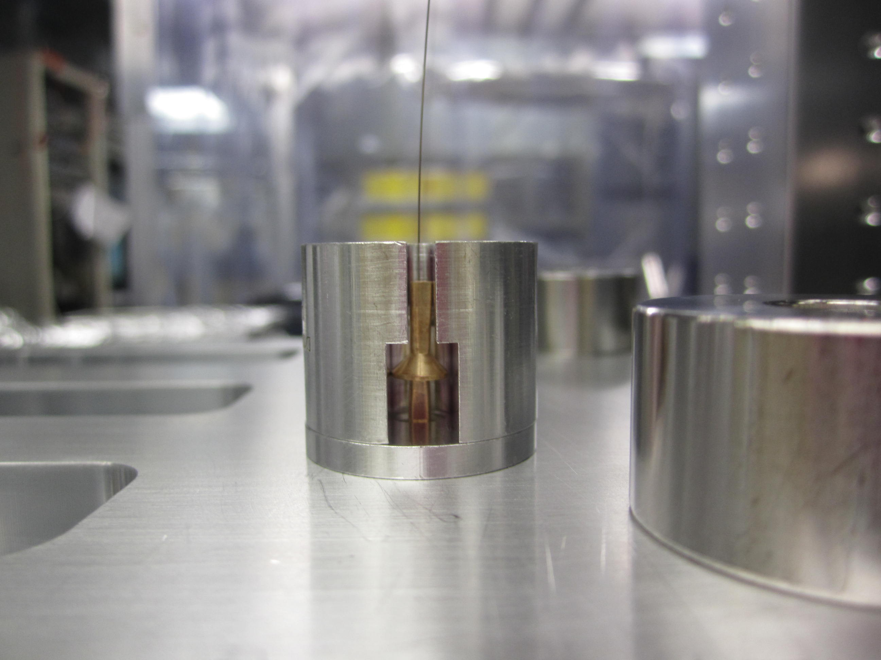  Lower Wire Clamp in Metal Mounting Bracket

Suspending the Masses

Procedure:
Remove the Top EQ Stop assembly above the Metal Bench. Ensure the side and face EQ Stops are fully retracted. The Metal Bench should be freely resting on the Lower EQ Stops with the Lower Wires should be under tension.  Retract the Lower Blade EQ Stops until the EQ Stop are free of the Lower Blades by at least 1 to 2mm.  Mount the 9 Flag/Magnet Assemblies. Position of the flags and polarity of the magnets are not important at this stage. The correct position of the Flags and the polarity of the magnets will be described in section 28.3 Install Magnets and Flags.  Retract the 12 EQ Stops, holding the Upper Mass, so the mass is free. Pay attention to the 4 top EQ Stops, so they do not restrict the Upper Mass from rising as the Upper Blades are released.  With a finger applying light pressure on the Upper Blade tip, retract the Upper Blade EQ Stop SHCS until Upper Blade is free to lift the Upper Mass. Repeat for the other Upper Blade EQ Stop.  Remove the 2 1/4-20 x 1.125” Ag SHCS holding the Upper Mass in the Coil Holder.  Fully retract the 4 Lower EQ Stops from the bottom of the Metal Bench.  Both masses should now be suspended. Check there are no EQ Stops or Blade Stops touching. Pay particular attention to the EQ Stops in the Coil Holder as they are difficult to see.  If the Metal Bench is not suspended, lower or remove the entire Lower EQ Stop Assembly. | 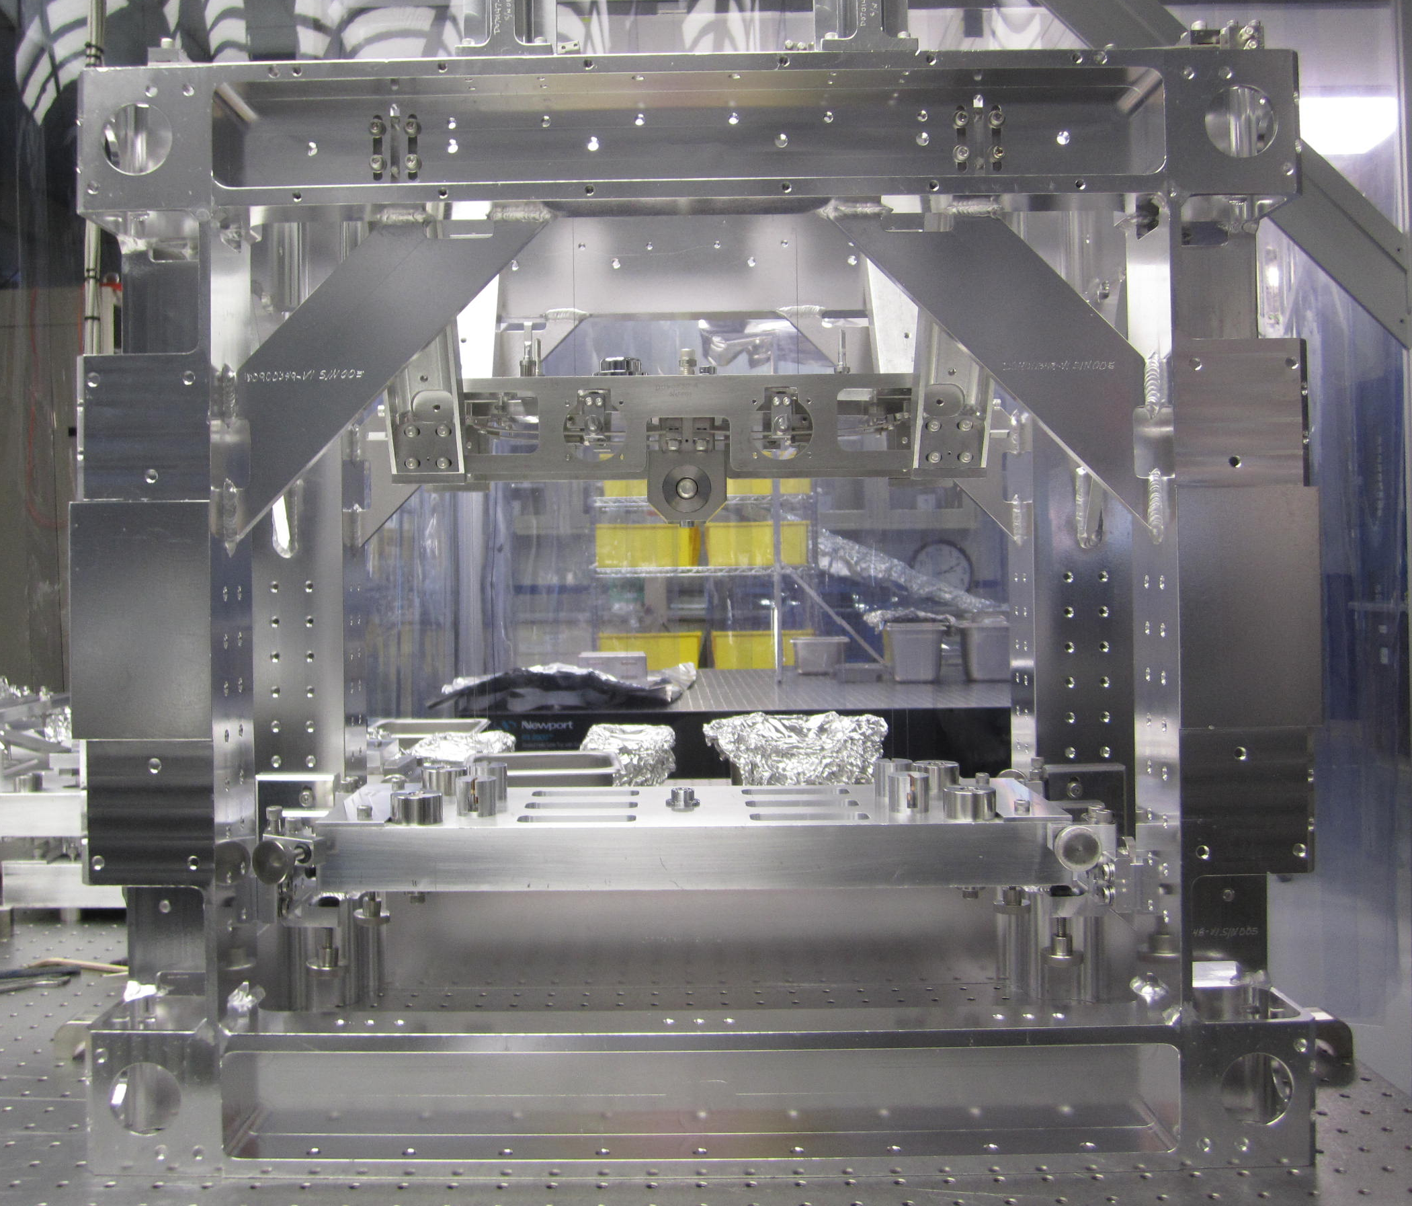  OMCS Suspended masses

Balancing the Suspended Masses
The Magnet and Flag Assemblies must be installed during all balancing and measuring procedures. If not the pitch, roll, and height of the suspension will not be correct.

Related Documents
T0900060 OMC Suspension Final Design Document
E1200254 Tolerances for Height Measurements of the HAM Suspensions During Assembly
T070189 Design Specifications for the OMC Suspension
F1300022 OMC Build Sheet Template

Special Tools
Optical Level and Tripod | Tripod must be able to go low enough to measure the Metal Bench heights.
Height gauge or stiff millimeter ruler | Scaled to at least 0.5mm

Procedure: Balancing and Measurement Requirements
The process of balancing an OMC suspension can be thought of as a series of stepwise refinements with the goal of producing a suspension conforming to a set of key attributes. These key attributes are:
- Upper Mass and Metal Bench pitch and roll are 0.25mm or less.
- The 4 Lower Blade Tip breakoff points are coplanar within 0.5mm of each other.
- The breakoff point is the intersection of the wire and the bottom of the clamp.
- The height of the top (measured at the center) of the Metal Bench is 154.59mm ±1mm above the Optics Table.
There are several secondary attributes which should be considered while balancing the OMC suspension but do not have the tight tolerances of the key attributes. These secondary attributes are:
- Top Blades should be roughly coplanar and the tip breakoffs are approximately to 647mm above the Optics Table.
- The Lower Blade tip breakoffs are approximately 397.25mm above the Optics Table.
- The top of the Upper Mass T-Block is approximately 341.9mm above the Optics Table. The height of the Upper Mass is constrained by the centering of the Flags in the BOSEMs.
- The total weight of the Upper Mass is kept as close to 2900g as possible.
- The total weight of the Metal Bench is kept as close to 7200g as possible.
During balancing and measurement the OMC suspension must be rigidly clamped to a level Optics Table using several Dog Clamps. If using a height gauge to measure the suspension, it must also be rigidly clamped to the Optics Table in close proximity to the OMC suspension. If using a millimeter ruler to measure the suspension, it must be stiff enough so as not to flex or rock back and forth and it must be rigidly clamped perpendicular to the Optics Table. If a flexible millimeter ruler is being used, it must be attached to a solid vertical flat surface, parallel to the vertical legs of the OMC suspension. It cannot be moved during a measurement cycle. If this method is used, the millimeter ruler must be normalized to the top of the Optics Table, as all measurements are made WRT the top of the Optics Table.

Procedure: Level the Metal Bench and Upper Mass
The first step before taking any measurements of the OMC suspension is to level the suspended masses. The level of a mass will affect the coplanar alignment of the blades in the mass(es) above it. When working on a metal build of the suspension the Metal Bench and Upper Mass should have less than 0.25mm end-to-end difference in pitch and roll. Yaw is adjusted at the Upper Mass level and is not that critical at this point. However, it may be necessary to remove the face and side EQ Stops to ensure the Metal Bench if free in pitch, roll, and yaw.
- With the Metal Bench freely suspended, using a bubble level, stop the Upper Mass so that it is level in pitch and roll.
- Place a bubble level in the center of the Metal Bench to get a reading on pitch and roll.
- Shift the Add-on Mass(es) between the 8 positions (4 on top and 4 on bottom) on the ends of the Metal Bench as necessary until the bubble is nicely centered in the level. This will get the Metal Bench close enough to level to proceed to the next step. DO NOT increase or decrease the total amount of Add-on mass, as this will change the Lower Blade tip deflection and the height of the Metal Bench. To shift weight around split the existing Add-on Mass into smaller units of the same total amount, (ex. A 100g Mass can be split into 2 50g, or 4 25g masses). Also take into account, as you shift weight from corner to corner there is a doubling effect. So moving a 20g Add-on Mass from one side to another is equivalent to adding 40g to one corner.
- When stacking several Add-on masses, it may be necessary to use different length SHCS. The weight difference between the SHCS lengths will be documented when the final weight distribution is recorded in the build sheet and in ICS.
- When the Metal Bench is level in pitch and roll, release the stops on the Upper Mass and the Top Blades, allowing it to hang freely. Several of the EQ Stops in the Coil Holder are very difficult to see, therefore pay extra attention to ensure these EQ stops are not touching the Upper Mass.
- Check the yaw of the Upper Mass by centering the side Flag Mount to the edges of the BOSEM mounting cutout in the side of the Coil Holder. To adjust the yaw:
  - Loosen the 3 1/4-20 SHCS on the Top Blade Rotational Adjuster.
  - Turn the pusher or puller screw to slew the Blade Tip. Before pushing make sure to first loosen the puller bolt and vice versa when pulling.
  - When the Flag Mount is centered, tighten the 3 1/4-20 SHCS on the Rotational Adjuster.
  - Check the yaw alignment of the other side and adjust as necessary using the same above procedure.
  - Repeat these steps until both side Flag Mounts are centered. While adjusting the yaw of the Upper Mass, check that the Metal Bench is not constrained by the Metal Bench face or side EQ Stops. Note: These stops can be removed until the alignment is finished.
- With the Upper Mass freely suspended, place a small bubble level on top of the Upper Mass as close to the center as possible to get a reading on pitch and roll.
- To adjust for pitch:
  - To correct for gross amounts of pitch, adjust the Upper Wire attachment point on the Upper Mass by:
    - Loosen the 4 8-32 x 1” Ag SHCS holding the Upper Mass Wire C-Clamp to the Upper Mass Top Plate.
    - Using the 4-40 x 1” SHCS in the Screw Drive System (D020482) move the Upper Wire attachment point towards the LOW side of the Upper Mass.
    - Be sure to adjust BOTH of the Upper Mass Wire C-Clamps to prevent inducing cross coupling. Moving the Upper Wire attachment point is a very effective pitch control. Adjustment should be made in no more than 1/4 turn increments of the 4-40 x 1” SHCS; by loosening the two SHCS on the low side of the mass and turning in the high side SHCS until the Upper Mass Wire C-Clamp contacts the low side screws.
    - When satisfied with the gross pitch adjustment, tighten the 4 8-32 x 1“ Ag SHCS to secure the Upper Mass Wire C-Clamp to the Upper Mass Top Plate.
  - To correct for small amounts of pitch:
    - Loosen 2 4-40 x 0.625” Ag SHSS holding the Pitch Insert (D060503) in the T-Block (D070032) and slide the Pitch Insert towards the high side of the mass. When satisfied small pitch adjustments, retighten the SHSS to lock the Pitch Insert into the T-Block.
    - Note: If you need to use more than 20% of the Pitch Insert range to correct the pitch, reset the Pitch Insert to its neutral position and make additional gross pitch adjustments as described in the previous steps.
  - To make fine adjustments in pitch:
    - Turn the 1/2-20 x 2” SHSS in the center of the Pitch Insert.
- To adjust for roll:
  - As there is no functional roll adjustment controls on the Upper Mass; changes to roll are made by changing the effective lengths of the Upper Wires, which can be done by:
    - Changing the Upper Blade Clamps to raise or lower the Upper Wire breakoff point. The Upper Blade Clamps (D020677) are sized in 0.5° angle increments, with each 0.5° yielding approximately 1mm change in the breakoff point. As the amount of angle change is not consistent between clamps, it may take several tries to get a clamp combination that results in the required height change. Sometime simply swapping the existing clamp with another of the same angle will provide the necessary change.
    - Adding or removing shims (D020679, D020680) from under the Blade/Clamp assembly.
  - After changing an Upper Blade Clamp assembly, recheck the Upper Mass for yaw, roll, and pitch. Correct as necessary repeating the steps listed above until all the suspended masses level in pitch, roll and yaw.

Procedure: Measuring the Suspension
After leveling of the masses using a bubble level, the suspension will be ready to be measured using the optical level and height gauge. The height gauge should be dog clamped to the optics table to one side of the suspension so the pointer can be viewed from both the front and back side of the suspension. The height gauge pointer must be zeroed to the top of the optics table as measurements of the suspension are WRT the height above the table top. The optical level should be positioned far enough back from the suspension so both ends of the Weldment and the height gauge pointer are clearly visible. Be sure to level the optical level before taking any measurements.
All measurements of the Blade breakoff points, pitch, and roll are made WRT the back side (+X, the face with the BOSEMs) of the suspension. When measuring the Blade breakoff points from the front side (-X, non BOSEM face) of the suspension be sure to adjust the left/right designations of the Blade. Example: When looking at the front side of the suspension the Blades on the right side are labeled as the left side.
By convention, pitch and roll are measured with the left side as zero. Either side can be used as zero, but you must be consistent with which side is to be the zero side. If not, balancing the masses and making Blade Clamp launch angle changes will be more difficult.
- Open the OMC Build Sheet Template (F1300022) to the Measurement before CB worksheet. If not already done, fill in the Mass Distribution and Weights cells with the information recorded during the assembly process.
- Measure the height of the center (put a small scribe mark at the top edge center of the Optics Bench to aid with centering) of the Optics Bench by placing the crosshairs of the optical level so the horizontal line is aligned with the top edge and the vertical line is aligned on the centering scribe mark of the Optics Bench. Pan the optical level over to the pointer of the height gauge. Have an assistant adjust the pointer of the height gauge until the bottom edge of the pointer is aligned with the horizontal line of the optics level. Record the measured height in the appropriate cell of the OMC Build Sheet Template.
  - The cell of the worksheet will calculate the difference between the measurement and target value of the mass. The sign will indicate if the measurement is above or below the target measurement. The color will indicate if the measurement is within or outside the tolerance of the measurement.
- To measure the roll of the Optical Bench, pan the optical level to the left side of the Optical Bench and align the crosshairs to the corner. Then pan across to the right side of the Optical Bench to the same point on the Optical Bench as was measured on the left side. The difference between the corners is the roll of the mass.
  - If there is roll in the mass, use left side measurement as the zero point. Pan the optical level to the height gauge and align the pointer to the horizontal line on the optical level. Zero the height gauge to this point. Next measure the height of the right side of the Optical Bench. Pan back to the height gauge pointer and align it to the horizontal line on the optical level. Enter this value in the O.B. Roll cell on the OMC Build Sheet Template. Take care to note the sign of the measurement as, this will be needed when adjusting the roll of the mass.
- Measure the height of the Upper Mass by centering the Optical Level crosshairs on the top side center of the T-Block (D070032). With the height gauge zeroed to the optical table top, bring the pointer up to the level of the T-Block, (use the target measurement from the worksheet to preset the pointer), and pan the optical level over to the pointer and align the pointer to the horizontal line in the optical level. Record the measured height in the appropriate cell of the OMC Build Sheet Template.
- To measure the roll of the Upper Mass, Site the optical level to the left side of the Upper Mass and align the crosshairs to the intersection of the Lower Blade Cover (D070045) and the bottom of the Upper Mass Main Section (D060491). Pan across to the same point on the right side of the Upper Mass, any difference between these two points is the roll of the mass. If there is roll in the Upper Mass, use the procedure described for the Optical Bench to measure the difference and record the values T.M. Roll cell on the OMC Build Sheet Template.
- Measure the height of the of the Lower Blade breakoff point by aligning the horizontal line in the optical level with the intersection of the wire and the bottom face of the clamp. With the height gauge zeroed to the optical table top, bring the pointer up to the level of the Lower Blade breakoff point, (use the target measurement from the worksheet to preset the pointer), and pan the optical level over to the pointer. Align the pointer to the horizontal line in the optical level and record the measured height in the appropriate cell of the OMC Build Sheet Template.
- Repeat this measurement for the other blade and record the information in the appropriate cell of the OMC Build Sheet Template.
  - The other two Blades will be measured from the opposite side of the suspension.
  - Record the Blade Clamp launch angle and direction in the column labeled Clamp. For example a 2 degree down facing Blade Clamp would be entered as 2.0D.
- Measure the height of the of the Upper Blade breakoff point by aligning the horizontal line in the optical level with the intersection of the wire and the bottom face of the clamp. With the height gauge zeroed to the optical table top, bring the pointer up to the level of the Upper Blade breakoff point, (use the target measurement from the worksheet to preset the pointer), and pan the optical level over to the pointer. Align the pointer to the horizontal line in the optical level and record the measured height in the appropriate cell of the OMC Build Sheet Template.
- Move the optical level to the opposite side of the suspension and repeat the measurements, as described above, of the other Upper and Lower Blade breakoff point. Enter the measurements in the appropriate cells on the worksheet, making sure to adjust the left/right side labeling of the Blades WRT the back side of the suspension.
  - The worksheet is setup to calculate the coplanar differences between the Blade breakoff points in the cells labeled Gap. Breakoff points within the 0.5mm tolerance will be displayed in green; non-compliant breakoff points will be displayed in red. These values are used when deciding the changes needed to balance the masses.
- To measure the pitch of the Upper Mass, move the Optical Level and the height gauge to the left side (to the right side if the orientation was changed) of the suspension and align the crosshairs with a fixed point on the side of the Upper Mass Main Section (D060491) that is visible through the cutouts on both sides of the Coil Holder (D060530). Use measurement points that are as far from the center of the Upper Mass Main Section as possible, ensuring the same point is used on both sides. Any difference between these two measurements is the pitch of the mass.
  - If there is pitch in the mass, use left side measurement as the zero point. Pan the optical level to the height gauge and align the pointer to the horizontal line on the optical level. Zero the height gauge to this point. Next measure the height of the right side of the mass. Pan back to the height gauge pointer and align it to the horizontal line on the optical level. Enter this value in the T.M. Pitch cell on the OMC Build Sheet Template. Take care to note the sign of the measurement as, this will be needed when adjusting the pitch of the mass.
- Measure the pitch of the Optics Bench, by aligning the crosshairs to the outer left corner of the Optics Bench. Pan across to the outer right corner of the Optics Bench. Any difference between these two measurements is the pitch of the Optics Bench.
  - If there is pitch in the Optics Bench, use left side measurement as the zero point. Pan the optical level to the height gauge and align the pointer to the horizontal line on the optical level. Zero the height gauge to this point. Next measure the height of the right side of the Optical Bench. Pan back to the height gauge pointer and align it to the horizontal line on the optical level. Enter this value in the O.B. Pitch cell on the OMC Build Sheet Template. Take care to note the sign of the measurement as, this will be needed when adjusting the pitch of the Optics Bench.
The first set of suspension measurements establish the starting point for balancing the suspension and all subsequent adjustments will flow from these measurements. When all measurements are recorded into the appropriate cells on the OMC Build Sheet Template, proceed to the balancing process.

Procedure: Balancing the Measured Suspension
The measurements of the suspension are now used to decide what changes are needed to balance the suspension. Keep in mind that the balance of a component affects to a greater or lesser degree the components above and below that component. Also keep in mind that balancing a suspension is an iterative process that should be done in small steps and changing only one or two parameters at a time. When deciding a course of action, you must take into consideration the other masses, their measurements, and the overall goals of the balancing process.
If, for example, one of the Lower Blade breakoff points is higher than the other three and the Optical Bench has pitch and roll. To correct this pitch and roll weight can be moved on the Optical Bench to pull the breakoff point down or change the Lower Blade Clamp launch angle to lower the breakoff point. The correct approach will depend on how much change is needed the height of the Optics Bench WRT to the target height, and the pitch and roll of the Upper Mass.
The balancing of the suspension follows the same process as described in the above sections (25.3 and 25.4), except the bubble level is replaced by the height gauge, as the bubble level is not accurate enough. While balancing a mass you must keep in mind that changing that mass will affect the other masses and blade breakoffs to a greater or lesser degree. Make one change at a time and remeasure the related suspension parts to ensure that change has not caused a problem to another part of the suspension. Each change should be made to gradually bring all key and secondary measurement parameters to conformity with the tolerances found in the OMC Build Sheet (F1300022).
- The Measurement/Balancing Process:
- Correct any pitch or roll problems with the Optical Bench and Upper Mass as described in the above sections.
- Correct any yaw problems with the Upper Mass as described in the above sections. While working on Upper Mass yaw problems, check the Optical Bench is not constrained by its earthquake stops. During the early stages of balancing it may be necessary to completely remove the Optical Bench earthquake stops.
- Remeasure the Lower Blade breakoffs and the height of the Optical Bench.
- Record any changes and the measurement values in the OMC Build Sheet.
- Check the key attribute measurements against the tolerance values for additional problems needing attention.
- After making changes to the suspension, repeat the above steps of adjustments, balancing, alignment, and measurements until all key attributes are within tolerances.
- When the key attributes are within tolerances, remeasure all the key and secondary attributes and record the data in the OMC Build Sheet.
- Repeat these steps until all key and secondary attribute measurements are within tolerances or in acceptable ranges if there is no fixed tolerances for that attributes.
- For Example: The height of the Upper Mass should be as close to 341.9mm (the top of the T-Block) as possible. However, deviation from this parameter is OK as long as the BOSEMs can be correctly aligned.
- When the suspension is completely balanced and aligned take and record a full final set of measurements in the OMC Build Sheet.

Removing Components for Creak/Creep Baking

When the OMC suspension have been aligned, balanced, all measurement parameters are within tolerance, and the OMC Build Sheet has been updated with the current data the Rotation Adjusters and the Upper Mass can be removed for creak/creep baking. All Blades (2 Upper, 4 Lower) are exposed to 120°C @ 168 hr. air bake, accelerating the microscopic yielding of the Blade material, to reduce mechanical noise of the Suspension when in operation.

Related Documents
T1100289 Notes on Creep/Creak Bakes for Blades
E0900023 Process for Manufacturing Cantilever Spring Blades

Materials
Qty | Unit | Part Number | Description
1 | Each | D1002440 | Upper Blade Baking Fixture
2 | Each | D980184 | LOS Dog Clamp
1 | Each | D040259 | Upper Mass Table Jig
6 | Each | NA | 1/4-20 x 0.375” SHCS
6 | Each | NA | 1/4” Flat Washer
1 | Each | NA | Clean air bake oven capable of 120°C with a timer

Procedure:

Remove the Rotational Adjusters

Using the EQ screws on the Top Blade Guards, push the Upper Blades down to lower the Upper Mass.

Install the 2 1/4-20 x 1.125” Ag SHCS through the Coil Holder into the Upper Mass. Using the 1/4-20 Ag nuts, evenly lift the Upper Mass. When there is enough slack in the Upper Wires, disconnect the wires from the Upper Blades.

Push down on the tip of the Upper Blade to reduce the pressure of the blade against the EQ stop and retract the EQ stop until the Upper Blade is almost touching the Top Blade Guard.

Remove the 2 inside 8-32 x 0.625” SHCS from the Upper Blade Guard.

With an assistant holding the blade tip down clear of the EQ stop, remove one of the 8-32 x 0.625” SHCS from the Top Blade Guard. Loosen the remaining 8-32 x 0.625” SHCS and swing the Top Blade Guard out of the way of the Upper Blade.

Slowly allow the blade to curl (rise) until it is in its relaxed position.

Repeat this process for the other blade.
- Remove the 3 1/4-20 x 0.375 SHCS holding the Rotational Adjuster assembly to the Blade Platform (D070028). Note which side of the suspension the Rotational Adjuster was install, so it can be replaced on the same side.  - Secure the Rotational Adjuster to the Upper Blade Baking Fixture (D1002440) using 3 1/4-20 x 0.375” SHCS and 1/4 FW.  - Repeat this process for the other Rotational Adjuster. | 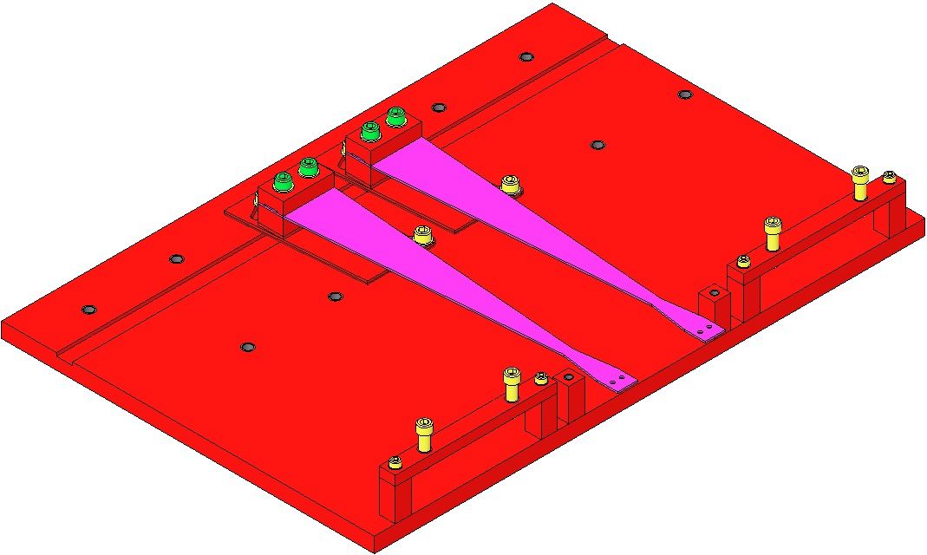  Fig 1: Upper Blade Baking Fixture

Clamp the Upper Blade Baking Fixture to a clean optics table. It helps to have blade tips slightly overhang the edge of the table.

Set the D030023 Stop screws in the Upper Blade Baking Fixture Crossbar to hold the blade 15 to 20mm below the Crossbar.

Remove one of the 8-32 x 0.625” SHCS from the Crossbar and rotate the Crossbar 180° so it is out of the way.

Have an assistant pull the blade tips down; rotate the Crossbar back into position over the blades and reinstall and tighten the 8-32 x 0.625” SHCS holding the Crossbar in place.

Adjust the Rotational Adjusters so the Upper Blades are centered on the Stop screws and the blades are flat.
 | - Remove the Upper Mass
- Using the lower EQ Stops lift the Metal Bench assembly as high as can be, and clamp it in place with the rest of the EQ Stops.
- Lower the Lower Blade EQ Stops until they touch or are close to the blades.
- Loosen the 1/4-20 Ag nuts holding up the Upper Mass, lowering the Upper Mass until there is enough slack in the Lower Wires to disengage the Lower Wire Clamp from the slots Metal Mounting Bracket.
- Tighten the 8 (4 on top 4 on ends) 8-32 x 1” Ag SHCS in the Coil Holder to lock the Upper Mass in place in the Coil Holder.
- Remove the 4 8-32 x 1” Ag SHCS from the sides of the Coil Holder.
- Remove the 16 8-32 x 0.5” Ag SHCS holding the Coil Holder from the 4 Coil Holder Mounting Brackets, allowing the Coil Holder to rest on the Tablecloth Bracket Wings.
- With an assistant, slide the Coil Holder/Upper Mass assembly out of the Weldment.
 | - Secure the Coil Holder/Upper Mass assembly to the Upper Mass Table Jig (D040259). Locate the Upper Mass Table Jig close to the edge of the Optics Table to assist in removing and attaching the Lower Wires.  - Remove the Lower Wires from the Lower Blades and put them in a safe place. Note the location of each wire so they can be returned to the same blade during reassembly.  - Remove the Upper Wires from the Upper Mass and put them in a safe place. Note the location of each wire so they can be returned to the same blade during reassembly.  - Loosen the Coil Holder EQ Stops, remove the 1/4-20” x 1.125” SHCS from the top of the Upper Mass, and remove the Magnet Holder assembly from one end of the Upper Mass. Remove the Coil Holder from over the top of the Upper Mass.  - Remove the remaining Magnet Holders and the 4 Screw Drive assemblies from the Upper Mass.  - Separate the Upper Mass from the Upper Mass T-Section by remove the 2 1/4-20 x 0.5” Ag SHCS from the top of the Upper Mass. | Pay close attention that the Lower Wires do not snag when removing or installing the Coil Holder/Upper Mass assembly from the Weldment.
 | - Creek/Creak Bake the Blades
- Wipe down the inside of the air bake oven.
- Preheat the air bake oven to 120°C.
- Put the Upper Blade Baking Fixture with the blades in the oven.
- Put the Upper Mass on a small piece of clean foil in the oven.
- Bake these assemblies for 168 hours (7 days).

Reinstalling the Components
When the 168 hour (7 day) creek/creak bake has finished, allow the oven and the masses to cool for 24 hours before removing from the air bake oven.

Procedure:
- Reassemble and Install the Upper Mass
- Reattach the Upper Mass to the Upper Mass T-Section using the 2 1/4-20 x 0.5” Ag SHCS removed above.  - Reattach the Screw Drive assemblies and 8 of the Magnet Holder assemblies (leave off one end for Coil Holder installation) to the Upper Mass Main Section. Use a machinists square, to align the Screw Drives and Magnet Holders to the Upper Mass Main Section.  - Reattach the Lower Wires to the same blade they were originally connected.  - Reattach the Upper Wires to the same side of the Upper Mass Main Section they were originally connected.  - Reinstall the Coil Holder, taking care not to damage the Upper Wires during the installation. Secure the Upper Mass in the Coil Holder using the EQ Stops and reinstall the remaining side Magnet Holder.  - Reinstall the Coil Holder/Upper Mass assemble by reversing the steps outlined in Section 23.6.2 above. |  | Note: The Magnet and Flag Assemblies must be installed during all balancing and measuring. If not the pitch, roll, and height of the suspension will not be correct.
- Reinstall the Rotational Adjusters
- Reinstall the Rotational Adjusters by reversing the steps outlines in Section 23.6.1 above.  - Adjust the lateral position of the blade so the center of the blade makes contact EQ Stop.  - Adjust the EQ Stops screws to push down so as to aid in reattaching the Upper Wires to the Upper Blades. |  | Be sure to install the Rotational Adjusters on the same side they were originally connected.
- Reattach the Wires and Suspend the Masses
- Reinsert the Lower Wire Wire Clamps into the slots in the Metal Mounting Brackets and suspend the Metal Bench by reversing the steps outlined in Section 23.6.2 above.  - If still attached, remove the Top EQ Stop assembly.  - Using the 1/4-20 Ag nuts, as outlined in Section 23.6.1 above, lift the Upper Mass (and the suspended Metal Bench) until the Top Blade Wire Clamp lay flat on the top of the Upper Blade.  - Secure the Top Blade Wire Clamp to the Upper Blade as outlined in Section 23.1 above.  - Applying light pressure with a finger, relieve the Upper Blade from the EQ Stop and retract the EQ Stop screw until it is free of the Upper Blade.  - Repeat for the other blade.  - If the Lower Blades are in contact with the Upper Mass EQ Stops, retract the EQ Stops until the Lower Blades are free.  - Slowly loosen the 1/4-20 Ag nuts holding the Upper Mass in the Coil Holder until the Upper Mass is suspended. Completely remove the 1/4-20 x 1.125 SHCS from the Upper Mass Assembly. Note the top, side, and face EQ Stop SHCS should be retracted part way before lowering the Upper Mass.  - At this point all masses should be suspended; all EQ Stops retracted so as not to constrain the masses, and all blades free from their EQ Stops. |  | While lowering the Metal Bench, check that the Lower Wire Clamps are fully engaged in the seats in the Metal Mounting Brackets and not cocked or jammed in the Metal Mounting Bracket slots.  While lowering the Metal Bench, ensure the side and face EQ Stops do not constrain the mass. It can be helpful to completely remove these stops during installation and suspension of the mass.
 | Rebalance and Measure

The suspension will now need to be rebalanced, aligned, and measured. Follow the steps outlined in Section 25 above, with these exceptions:

After creep/creak bake the Lower Blade Clamps cannot be changed. To do so would negate the creak bake.
  - Weight can be moved between suspension levels and corners of the masses. Weight should not be added or removed without carefully considering how this weight change will affect the other masses and the height of the Optics Bench.

The measurement data is entered on the Measurement after CB tab on the OMC Build Sheet Template (F1300022).

Preparing the OMCS for Electronics Testing
After the OMC suspension has been rebalance and aligned and all measurements conform to the tolerances defined in (E1200254) Tolerances for Height Measurements of the HAM Suspensions During Assembly, it is ready for final assembly and electronics testing. The electronics testing will take the suspension through Phase 1b, as defined in (G1200070) Ideal Order/Content of aLIGO Triple SUS Testing/Commissioning. The actual testing process is outside the scope of this document however it is the responsibility of the assembly team to prepare the suspension for testing. In addition to the balancing and alignment work outlined above, the BOSEMs must be installed, properly configured in MEDM, adjusted to 50% light, and all cabling is connected and properly dressed for the suspension to be ready for testing.

Related Documents
D060218 BOSEM Assembly
D1001695 Magnet and Flag Assembly, BOSEM
D1300240 HAM6-H1 XYZ Local CS for Output Mode Cleaner Suspension (OMC)
D1300122 Cable Harness Routing Configuration HAM6
E1100109 HAM Suspension Controls Arrangement Poster
E1200343 OSEM Chart
D1300033 Cable Table Bracket Assembly
E1200254 Tolerances for Height Measurements of the HAM Suspensions During Assembly
G1200070 Ideal Order/Content of aLIGO Triple SUS Testing/Commissioning
E1000434 aLIGO SUS OMCS Testing and Commissioning Documentation

Materials
Qty | Unit | Part Number | Description
6 | Each | D060218 | BOSEM Assembly
9 | Each | D1001695 | Magnet and Flag Assembly, BOSEM
1 | Each | D1001346 | D1001343 5 Port Cable Bracket Assembly
1 | Each | D1001346 | D1001343 3 Port Cable Bracket Assembly
1 | Each | D0902462 | UHV Compatible Cable Clamp Assembly
2 | Each | D1000234 | Custom Cable DB25 to DB9 Quad-o-Puss 60”
1 | Each | NA | Magnet Polarity Tester
5 | Each | NA | 1/4-20 x 1” SHCS
4 | Each | NA | 1/4” Flat Washers
24 | Each | NA | 4-40 x 1.0” Ag SHCS
24 | Each | NA | #4 Flat Washer
24 | Each | NA | #8 Flat Washer

Procedure:
- Install Magnets and Flags
- Install the Magnet and Flag assemblies on the Magnet Holders attached to the Upper Mass. The polarity of the magnet must be set as defined in (E1100109) HAM Suspension Controls Arrangement Poster.
- Use the magnet polarity tester to check the magnets sign before installing.
- Set the Flat Flag orientation so the flag edge is parallel to the LED/PD of the BOSEM.
- Turn the Flags clockwise so as to tighten the FHCS holding the BOSEM Flat Flag Dish. Turning the flag counterclockwise will loosen the FHCS.
- Install the BOSEMs
- Select 6 BOSEMs that have tested open light values between 31K and 20k counts.  - Stack a #4 FW and a #8 FW on each of the 4 4-40 x 1.0” Ag SHCS and attach the BOSEM to the Coil Holder. Center the Flag in the BOSEM and tighten the 4 mounting SHCS.  - Install the BOSEMs so that when facing the Left and Right BOSEMs the 2 top BOSEMs (T2 & T3) are on right and the side BOSEM in on the left.  - The 3 Magnet and Flag assemblies that do not get BOSEMs are left in place to maintain the balance of the Upper Mass. | 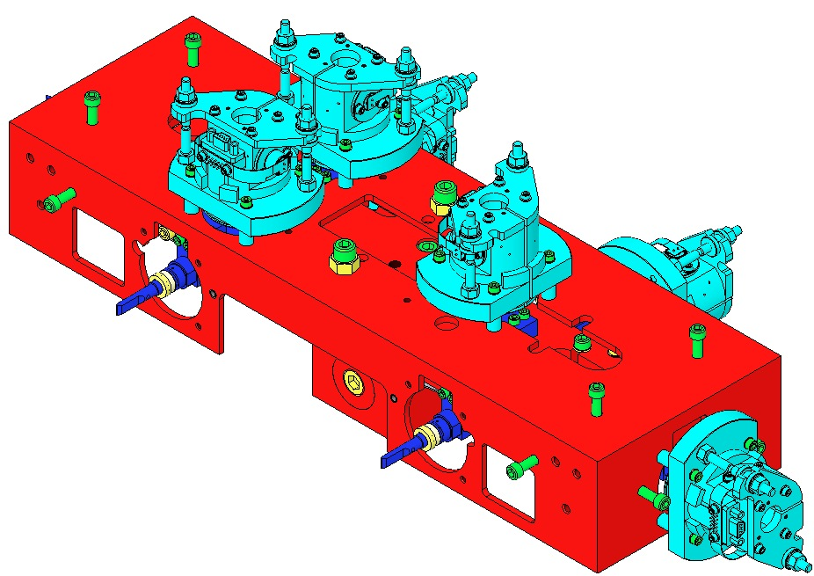  Each OMCS must contain 1 fully-characterized BOSEM, which is mounted on the side position.
- Install and Connect Cabling
- Connect the DB9 ends of the two D1000234-60 cables to the BOSEMs as listed on sheet 11 of D1300122 Cable Harness Routing Configuration.
- On the second cable the A leg connects to the Right BOSEM and the B leg connects to the Side BOSEM. The C and D legs are not used.
- Install the Cable Bracket assemblies, D1001346, to the top of the Weldment using 2 1/4-20 x 1” SHCS and 1/4” FW. The 5-Port bracket is installed on the back side of the Weldment and the 3-Port bracket is installed on the front side of the Weldment.
- Secure the 2 DB25 ends of the cables to the top 2 ports of the 5-Port Cable Table Bracket. Leave an open port between the 2 DB25 connectors.
- Secure the cables to the inside of the Weldment with a D0902462 UHV Cable Clamp Assembly. Do not crush the cables in the clamp to prevent grounding shorts. Tuck the excess cable into the upright leg of the Weldment.
- Connect the suspension cabling to a test stand.
- Prepare BOSEMs for Testing
- Pull back the BOSEMs so there is no occulting of the light by the Flags.  - Using MEDM screens display the open light (OL) values for the BOSEMs.  - On the OMC work sheet of the E1200343 OSEM Chart enter the serial number of the BOSEM and the OL value in the appropriate cells of the work sheet. The work sheet will calculate the Offsets and Gains for the BOSEMs. Change the version number of the E12000343 OSEM Chart and upload it to the DCC.  - In MEDM, open the OSEM Input Filters screen; enter the gains and Offsets in the appropriate fields.  - In MEDM, open the OSEM Centering screen; adjust the BOSEMs so the flag is blocking 50% of the light. (The speed dials pointing straight up.) |  | 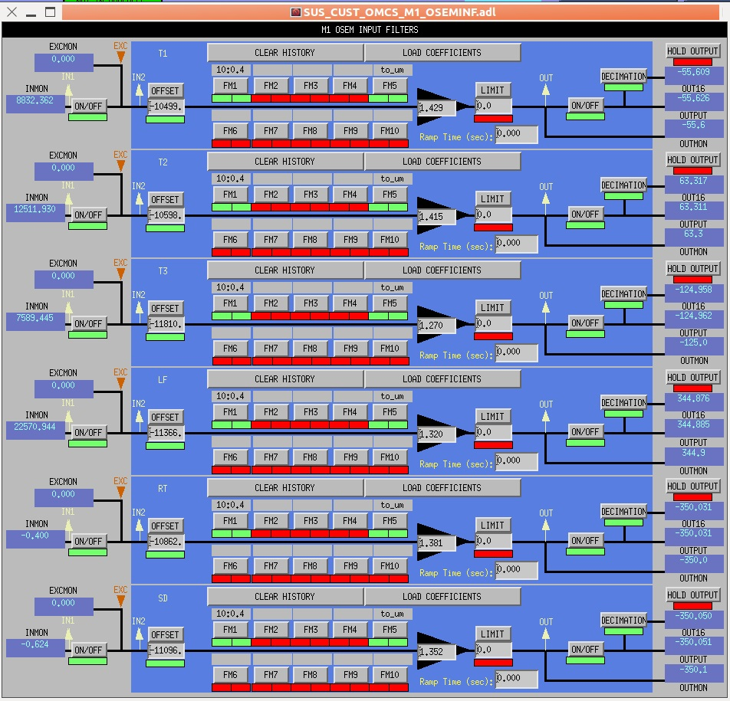  Offsets  Gains

Metal Build Testing

Related Documents
E1000434 aLIGO SUS OMCS Testing and Commissioning Documents
G1200070 Ideal Order/Contents of aLIGO Triple SUS Testing/Commissioning
E1100109 HAM Suspension Controls Arrangement Poster

The actual testing of the OMC suspension falls outside the scope of this document; therefore it will not be covered in detail. Even if the assembly team is not doing the actual testing, they will be closely involved with the testing team during the process. The assembly team will be tasked with making any mechanical changes or adjustments to the suspension. They will also be responsible for BOSEM adjustments and stopping/unstopping the OMC suspension. Questions concerning testing or the testing process should be addressed by the Suspensions Testing Group.

Final Assembly, Transportation, & Storage

Related Documents
D1201502 Bracket and Preamp Assembly
D1001346 aLIGO Cable Bracket Assembly
D1002424 aLIGO SUS Vibration Absorbers
D1002222 SUS Quad Upper Storage Container
D0900295 OMCS Overall Assembly
D1300240 aLIGO SUS HAM6-H1 XYZ Local CS for Output Mode Cleaner Suspension

Materials
Qty |  | Unit | Part Number | Description
2 |  | Each | D1002424 | Vibration Absorber Assembly
1 |  | Each | D1002081 | OMCS Vibration Absorber Mounting Kit
1 |  | Each | D1001346 | D1001343 3 Port Cable Bracket Assembly
1 |  | Each | D1201501 | OMC Preamp Bracket
1 |  | Each | D1201502 | OMC Preamp Assembly
1 |  | Each | D1002222 | Quad Upper Storage Container
2 |  | Each | NA | 1/4-20 x 1.0’” SHCS
6 |  | Each | NA | 1/4” Flat Washer
4 | Each |  | D980184 | LOS (or equivalent) Dog Clamp
4 | Each |  | N/A | 1/4-20 X 1.5” Ag SHCS

When the OMC suspension Phase 1b testing results have been approved by the SUS Testing Group, the suspension is ready for transportation to the LVEA for final pre-installation tasks. If the OMC is not to be installed for some period of time it will need to be stored in a clean environment until needed. The preparation for either of these activities is the same.
Procedure:
- Mount the Preamplifiers
- Assemble the Preamp (D1201502) as described in Section 9 above.  - Attach the Preamps to the mounting bracket (D1201501) using the M3 x .5 Ag FHCS.  - Put the modified peek washer on the 1/4-20 x 0.75” SHCS. Wrap the Kapton sleeve around the SHCS and insert the SHCS into the hole in the mounting bracket. Rotate the peek washer so the cut side faces the side of the Preamp.  - Put the unmodified peek washer on the 1/4-20 x 0.75” SHCS so that it will be between the mounting bracket and the weldment.  - Attach the Preamp assembly to the inside top crossbar on the Front side of the weldment using the 1/4-20 x 0.75” SHCS, (D0900295). | Preamps & 3 port Cable Bracket  Vibration Absorber  Vibration Absorber
- Mount the Vibration Absorbers
- Attach the 2 Vibration Absorbers Mounting brackets (D1002081) to the corners of the Weldment, as shown on D1300240, aLIGO SUS HAM6-H1 XYZ Local… using the 4 1/4-20 x 0.625” CHCS provided in the Mounting Kit.  - Attach the 2 Vibration Absorbers (D1002424) to the Mounting brackets using the 4 1/4-20 x 1.25” SHCS and 1/4" FW, provided in the Mounting Kits. Note: Do NOT remove the Locking Pins from the Vibration Absorbers until after the OMC suspension has been installed in its final in-chamber position. | The Hanford Suspension team has the assembled Vibration Absorbers and prepared Mounting kits. Contact the Hanford Suspension team with any questions or requests related to the Vibration Absorbers.
- Mount the Preamp Cable Bracket Assembly
- If not already installed, mount the 3 port Cable Bracket Assembly (D1001346) to the top crossbar on the front side of the Weldment using 2 1/4-20 x 1” SHCS and 1/4" FW.
- Weigh and Stow the OMCS
- Securely stop the OMC Suspension so that neither of the installed masses can move. Check all the Blade Stops are in contact with the blades. The blades should not be depressed too far beyond horizontal. The wires should have a bit of slack but not so much that the Lower Wire Clamps (D1200971) can come out of the (D1201334) Metal Mounting Brackets.  - Weigh the suspension using a load cell or large floor scale. Record the weight for the OMC suspension in the F1300022 OMC Build Sheet Template.  - Place the OMC suspension on the base of a clean (D1002222) Quad Upper Storage Container. Rotate the OMC suspension on the Quad Upper Storage Container base so the top cover can be fit without touching the sides of the OMC. Make sure the OMC is positioned so that at least 2 Dog Clamps can be used to secure the suspension to the base.  - Secure the top cover to the base of the Quad Upper Storage Container. |  | When stopping the Upper Mass do NOT allow the Flags to come into contact with the LED/PD in the BOSEM.  Before sealing the Quad Upper Storage Container make sure any unused mounting holes in the base are plugged with clean 1/4-20 SHCS.  One of the Vibration Absorbers may need to be removed to get the cover on the Storage Container. If removed, Secure the Vibration Absorber to the suspension or the Storage Container base, before closing the container.

When the assembly, testing, and storage of the OMC suspension is completed, all the data recorded in the (F1300022) OMC Build Sheet Template is used to create the ICS OMC Assembly Record. It does not matter if the data is entered into the ICS Assembly Record as the OMC is being built or after the assembly is complete, however the ICS Assembly Record must be created before the assembly process is considered finished.

Replacing the Metal Bench with the Glass Optics Bench

Related Documents
D1000342 ISC HAM6 Assembly
D1201439 aLIGO Breadboard Layout
G1200070 Ideal Order/Contents of aLIGO Triple SUS Testing

The installation of the OMC Glass Optics Bench follows the same procedure as the installation of the Metal Optics Bench. After removing the Metal Optics Bench, follow the installation steps outlined in Section 21 Installing the Metal Bench and connect the wires following the steps outlined in Section 23.2 Attaching the Lower Wires to the Metal Bench. Suspend the Glass Optics Bench following the steps outlined in Section 24 Suspending the Masses. When the Glass Optics Bench is suspended, the suspension should be balanced, aligned, and measured as with the Metal Optics Bench before proceeding to the Phase 3a testing.

Appendix

Personal Protective Equipment:
The following items of personal protection equipment must be work when working with wire:
- Safety Glasses (available in all clean room garbing areas) must be worn at all times when working with wire or near Wire Assemblies under load.
- Glove Liners (also available in all clean room garbing areas) must be worn under UHV Gloves at all times when working with wire to avoid puncture injuries by providing an additional layer of protection.

Safe Handling of Suspension Wire:

The wire used in all stages of the OMCS is a hard temper carbon steel, delivered and stored on large spools. When unspooled for cleaning, cutting, and preparation for assembly, safety precautions must be followed so that the large amount of potential energy stored in the coiled wire and sharp wire ends do not cause injury.

Cleaning Suspension Wire:
Follow the steps listed below to cut a section of wire from a spool and clean it for use in producing a Wire Assembly. Two people are needed to cut and clean a section of wire.
- After removing the spool from its bag, remove the protective layer of paper and set it aside so that it can be replaced after cutting the wire.
- Unspool a short length of wire and bend the wire over approximately 3” from the end. This helps to make the wire easier to hold and to avoid puncture injury.
- Unspool the proper length of wire needed for the Wire Assembly, including extra for handling.
- (Person 1) Hold on to the wire near the free end and the section to be cut so that the loose ends do not spring out of control away from the spool.
- (Person 2) Cut the wire using dirty wire cutters.
- (Person 2) Bend the cut end of the wire over approximately 3” from the end.
- (Person 1) Hold on to both ends of the wire, keeping it from touching the floor.
- (Person 2) Change gloves.
- (Person 2) Spray a clean wipe with Methanol. Take one end of the wire from Person 1 and wipe the entire wire starting from that end. When finished, take the other end from Person 1.
- (Person 1) Change gloves.
- (Person 1) Spray a clean wipe with Acetone. Take one end of the wire from Person 2 and wipe the entire wire starting from that end. When finished, take the other end from Person 2.
- (Person 2) Change gloves.
- (Person 2) Spray a clean wipe with Isopropanol. Take one end of the wire from Person 1 and wipe the entire wire starting from that end. When finished, take the other end from Person 1.
- Repeat Steps 8-13, alternating holding the wire between Person 1 and Person 2, until nothing is left on the wipe after cleaning.
- The wire is now considered to be clean and should only be handled with clean gloves. Transfer the wire to the Assembly Jig. Use the Wire Clamps on the Assembly Jig to hold the wire in place.
- After using the wire spool, tape the free end of the wire to the spool with the small piece of tape on the spool. Replace the protective layer of paper and place the spool back into its bag.

Changing an OMC lower blade clamp with the Top Mass mounted in the weldment:

- Stop the Top Mass securely. If the BOSEMs are installed, stop the mass so the flags remain centered in the BOSEM and not touching the LED or photo diode.
- Bring down to lower blade EQ stop screws until they touch the lower blades.
- Raise the Optics Bench until there is enough slack in the lower wires to remove the copper ferrule from its mounting bracket. You may need to push the lower blades down with the EQ stop screws if there is not enough slack to free the lower wires.
- Remove any addable mass from the top of the Top Mass to expose the T-Block mounting screws.
- Remove the T-Block from the bottom side of the Mass.
- Carefully remove the wire clamp from the end of the blade and put it aside. Be very careful when handling the clamp-wire-ferrule assembly. It is fragile and is easy to break or kink the wire.
- With an assistant supporting the center of the blade and pushing down on the blade tip, remove the two 8-32 SHCS holding the clamp/blade assembly from the base of the top plate.

After completing the clamp or blade change, reinstall the clamp/blade assembly by:

- Assemble the new clamp/blade assembly with the two 8-32 SHCS through all three parts.
- While the assistant supports the center of the blade and pushes down on the blade tip, start the two 8-32 mounting SHCS into their respective holes.
- With the assistant supporting the center of the blade and centering the blade tip on the EQ stop screw, draw in the two 8-32 mounting SHCS until the clamp/blade assembly is almost tight.
- Square the two clamp halves and the blade, while the assistant keeps the blade tip centered on the EQ stop screw.
- Finish tightening the two 8-32 mounting SHCS, and torque to 6 In-Lbs.
- Carefully reattach the wire to the lower blade tip.
- Reconnect the lower wires to mounting brackets on the Optics Bench and lower the Optics Bench.
- Release the remaining stops.
- Balance the suspension per normal procedures.

